HIGHER EDUCATION SUPPLY AND DEMAND TO 2020
Robbie Coleman and Bahram Bekhradnia

- This is the sixth report on demand for higher education produced by HEPI, each updated in the light of the most recent information on demographic and other relevant data, as well as changes in the policy environment. The purpose of these reports is not to provide firm projections of numbers into the future, but rather to discuss and shed light on issues that will impact on future demand and to provide an indication of the uncertainties and likely developments that will shape demand in the future.
- This present report is produced in a very different policy environment to that in which earlier reports were produced, with substantial evidence of an increasing level of unmet demand. This report assesses the extent of that unmet demand and its nature, and considers how this might develop in the future in the light of the possible economic constraints under which the sector will operate and the government's plans for expenditure.
- It should be noted that this report is largely concerned with the interactions between universities and students, and although it does touch on the impact of changes in the labour market on demand, that question is not fully treated. Nor does it discuss the possible impact of changes in the fee regime. Through the fees they pay and supported by loans from the government, students will in most cases pay the full cost of their education. There may well be an impact on demand, with the greater cost tending to dampen demand to an extent that it is not at present possible to quantify, but this is not considered further here.
- The new regime will have another effect as well. The Browne Committee, anxious to establish a market in higher education fees if for no other reason than to ensure that a lid is kept on the cost of the loans that the government has to make to support fees, recommended that eligibility for loans – and so effectively eligibility to participate in higher education – should be determined by the government setting a minimum "pass mark" in terms of UCAS tariff points. Applicants failing to achieve this "pass mark" would not be eligible. The government has not yet said how it intends to respond to this recommendation, and it could well be that it concludes that the disadvantages of such a approach outweigh the advantages. So it may be prepared – for the time being at least – to take the risk that the absence of a market may lead to a larger than anticipated number of universities to charge fees towards the top of the range, as has been predicted separately by HEPI, leading to greater costs than have been budgeted. This report for the first time assesses the feasibility of setting "pass marks" at different levels.
- As a result of the developing mismatch between supply and demand – and because of the changing nature of demand – the relationship between demand for higher education and student numbers is more complex than has previously been the case. In the past it was a reasonable assumption that all who were qualified to enter higher education could expect to have a place available somewhere within the system and that the number of students in the system more or less equated to demand. It is difficult to say when the Robbins principle – that all who are qualified should be able to enter higher education if they wish – broke down. Analysis of UCAS data reveals that throughout the last decade there was a significant number of applicants with more than 80 UCAS tariff points (the equivalent of 2 E grades at A-level, the minimum requirement for entry to University) who were not offered places or who failed to enrol for other reasons, but this may always have been the case. For the purpose of this report, a significant policy change is taken to have occurred in 2008, when the government’s explicit squeeze on student numbers began.
- With this policy change, and also with the increasing number of applicants with no formal qualifications (analysed further below), – an increasing number of whom may reasonably be assumed to lack the intellectual attributes needed for higher education – it can no longer be assumed either that those failing to obtain a place are not qualified for higher education nor that those who fail to get a place represent qualified but unsatisfied demand. If the government decides to implement the Browne Committee's recommendation that it should each year set a threshold of UCAS tariff points beneath which applicants are deemed ineligible for loans (and therefore, effectively, ineligible to enter higher education), then that will add a further layer of complication to the concept of "demand": applicants previously deemed eligible but who may not be able to find a place will in future be deemed "ineligible". This complication informs, but does not negate, the attempt in this report to form a view about possible future demand.
- Because it is trends rather than absolute numbers that are generally of interest, for consistency and because of the availability of data, the discussion in this report is restricted to English domiciled students attending English universities. This may mean that some of the discussion is not as refined as it might be, but such considerations are marginal in terms of their overall impact on demand.
Recent trends
- Numbers in higher education have risen consistently over the past two decades, and the January 2011 HESE revealed 1.033 million home and EU full-time undergraduate students at English higher education institutions and 1.225 million full time equivalent undergraduate students (i.e. including part-time and sandwich year students) – the highest number ever. Considering only new entrants for full-time undergraduate study, Figure 1 shows that with the exception of 2006-07 these rows consistently each year until 2009 and 2010 when they reached 360,000.
Figure 1. English Domiciled Full-time Undergraduate Entrants
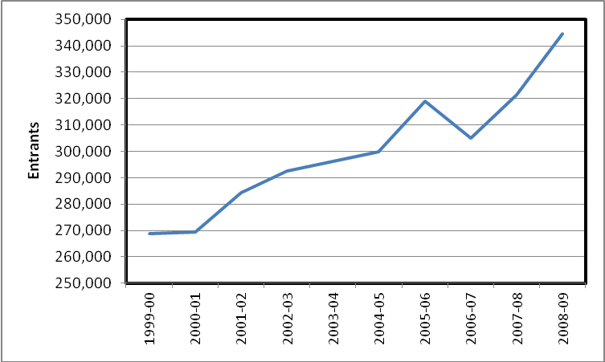
Source: Higher Education Statistics Agency (HESA)
- What is curious is that whereas in the past higher education numbers went hand-in-hand with A-level numbers, in recent years the rate of increase in higher education entry has been about twice that of the number of A-level passes. The explanation for this discrepancy becomes apparent later in this report.
- As can be seen from Figure 2, the number of part-time and mature (21 and over) entrants to higher education has also increased over the last ten years, though there was a small decrease in both numbers in 2009. The two numbers are closely related, with 68.4 per cent of mature entrants in 2009 entering part-time study.
Figure 2. Part-time and Mature Entrants
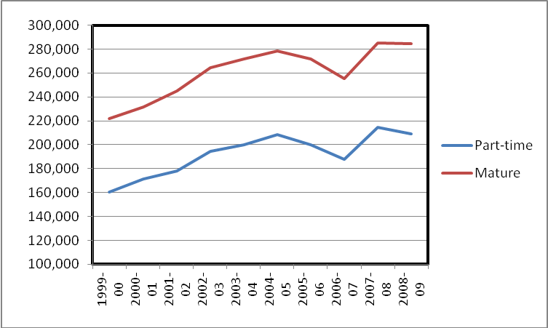
Source: Higher Education Statistics Agency (HESA).
- Reference was made above to the fact that there is unmet demand, and this is returned to later in this report. Here it is sufficient to note that the growing number of entrants to higher education has in the last two years been marked by an even faster growing number of applicants. What has fuelled this increase in applicants has not been investigated in this paper, but it is very likely to be related to changing labour market demands, as it becomes increasingly difficult to obtain "good" jobs without a degree. Figure 3 shows graphically the accelerating number of applicants through UCAS (full-time applicants only – this does not include part-time applicants or those applying direct to a University). Whereas until 2008 the number of applicants and of entrants rose more or less in parallel, it is clear that there has been a divergence in the last two years with the number of applicants rising more rapidly than the number of acceptances.
Figure 3: Applicants and enrolments to higher education through UCAS
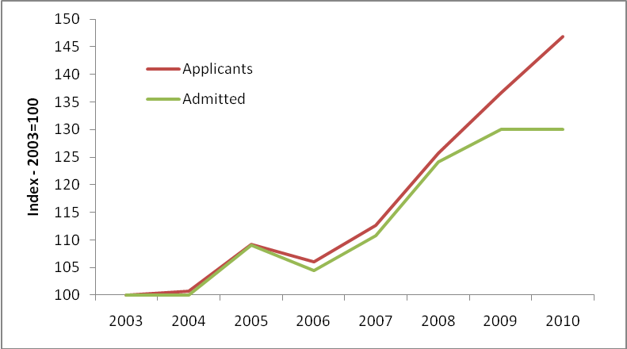
Source: UCAS ad hoc analysis Figures relate to England domiciled applicants
- The number of applicants has increased in the past six years at a rate more than 50 per cent faster than the number of acceptances (and therefore, for the purpose of this report it is assumed the number of places available), and in 2010 there were more than 135,000 applicants who failed to enter higher education (not all of these will have failed to receive offers, but that is the case with over half – over 68,000 of the 135,000). At this stage it is sufficient simply to note this fact. The implications and the characteristics of the increasing demand are considered further below.
- One of the reasons for the growing gap between supply and demand is the cap on numbers imposed by this and the previous government. Caps have been in place since 1994, , and there has been some control over student numbers since then. However, since 2008 when the government removed 10,000 planned funded places the cap has been set at a level explicitly and significantly below demand, leading to much greater levels of unsatisfied demand.
- Figure 4 below shows how in recent years an increasing proportion of applicants have failed to receive offers. Undoubtedly, some of these include applicants whose application was unrealistic as well as those who were qualified but for whom sufficient places simply did not exist. It is nevertheless of note that the proportion receiving no offers increased from 6 per cent of applicants in 2003 to 10 per cent in 2009 to the 2010 level of nearly 14 per cent
Figure 4: The increasing number of, applicants with no offers by year of entry
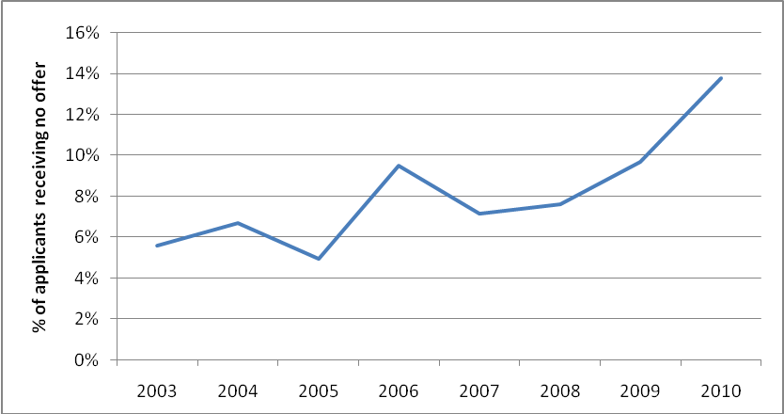
Source:: UCAS ad hoc analysis Figures relate to England domiciled applicants
- The data shown here relate only to full-time applicants. No information is available on unsatisfied demand from part-time applicants, but given the financial and other incentives that universities have to recruit full-time students over part-time, there is no reason to believe that there is less unsatisfied demand from part-timers.
Future demand
Demography
- Students under 21 years old remain the dominant group in higher education, and so the changing size of this population remains by far the most important influence on higher education demand. Table 1 below shows that this dominance has not changed in recent years, the proportion of younger students having stayed around 74% of the total.
Table 1. Proportion of full-time initial undergraduate entrants under 21
 | 1999-00 | 2000-01 | 2001-02 | 2002-03 | 2003-04 | 2004-05 | 2005-06 | 2006-07 | 2007-08 | 2008-09
% under 21 | 74.5% | 74.8% | 73.8% | 73.3% | 72.8% | 73.2% | 74.1% | 74.3% | 74.0% | 73.9%
Source: BIS using HESA data

- As can be seen in Figure 5, though the overall population of England is projected to increase steadily - by 7.4 per cent between 2010 and 2020 - the 18-20 population is projected to fall 13 per cent, after peaking in the current academic year. On the face of it, this would appear to indicate a reduction in demand.
Figure 5. Population projections until 2020
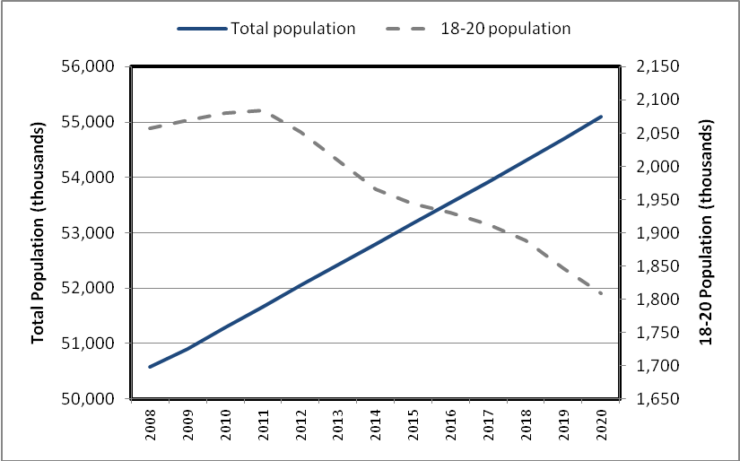
Source: ONS, Population Estimates Unit.
- However, as has been discussed in previous HEPI reports, participation rates differ between social groups. As Table 2 below illustrates, the full-time young participation rate (18-20-year olds) for lower socio-economic groups is approximately half that of higher socio-economic groups, though the gap has narrowed in recent years. As a result, even if the size of the total population declines, the changing social mix of the population – discussed in earlier HEPI reports – and in particular a growing middle class, together with greater fertility among the more affluent social groups, will lead to greater demand for higher education than there would otherwise have been
Table 2. Full-time Young Participation Rate by Socio-Economic Group
 | 2005-6 | 2006-7 | 2008-9
Participation rate for NS-SECs 1, 2, 3 | 43.8 | 40.6 | 41.2
Participation rate for NS-SECs 4, 5, 6, 7 | 20.3 | 19.5 | 21.0
Gap | 23.5 | 21.1 | 20.2
Source: BIS - Full-time Young Participation by Socio-Economic Class (FYPSEC) 2009 Update

- Table 3 sets out the changes in full time undergraduate student demand that would occur between 2007-08 and 2020-21 arising purely from different rates of population growth by sex and social group, and accounting for the different levels of participation of these groups. It shows that based on demographic change alone (i.e. if all else were equal) there would be an estimated 4.2 per cent fall in demand. As in previous years the decline has been dampened by over 40 per cent as a result of the higher birth rate of higher socio-economic groups. That is to say, if it were not for the fact that the better off groups have been having more babies and that their numbers are increasing relative to others, instead of a 4.2 per cent decline the decline in demand from the 18-21 population would be 7.0 per cent.
Table 3. Estimated change in full-time undergraduate demand due to demographic change
 | Estimated demand in 2007-8 (2007-8 student numbers) | Change in demand by 2020-21 (without social class effect) | Change in demand by 2020-21 allowing for social class effect | Total demand by 2020-21 allowing for social class effect
All males | 375,043 | -28,980 | -18,179 | 356,864
All females | 482,405 | -31,126 | -17,723 | 464,682
All | 857,448 | -60,106 | -35,902 | 821,546
Source: HEPI calculations, refer to Technical Annexe for detailed calculations.
- Part-time demand is also susceptible to demographic changes, though to a lesser extent. Table 4, below, illustrates the estimated change in part-time undergraduate demand, again, due solely to demographic changes. An increase of 5.2 per cent in part-time demand is projected, largely resulting from projected increases in the 25-34 population over this period. No separate projection has been made for mature students, as the majority of mature students study part-time.
Table 4. Estimated change in part-time undergraduate demand due to demographic change
 | Estimated demand in 2007-8 FTE (2007-8 student numbers) | Change in demand by 2020-21 arising from demographic change | Total demand by 2020-21 arising from demographic change
All males | 64,077 | 4,152 | 68,229
All females | 106,969 | 4,745 | 111,714
All | 171,046 | 8,897 | 179,943
Source: HEPI calculations, refer to Technical Annexe for detailed calculations.
- So taking full-time and part-time demand together, and based only on demographic change, there would be demand for just over 1 million FTE higher education places in 2020-21, compared to about 1,028,000 in 2007–8 - a reduction of about 2.8 per cent.
Attainment
- Other things being equal, the more qualified the school population, the greater the demand for higher education and an increase in attainment at school will mean that a greater proportion of the young population will participate in higher education. According to the most recent Youth Cohort Study, 81 per cent of students who took A levels having previously obtained 5 A*-C GCSEs had either entered higher education by 18 or had accepted an offer to enter at 19. A further 3 per cent had applied and were awaiting a response from a university. This section examines the levels of attainment of young people and how this impacts on demand.
- Young people with A levels are the critical group when it comes to higher education entry, but more generally previous (mainly school) academic attainment is the most important driver of demand from young people for full-time higher education. This very largely explains why demand rates differ between social groups. For example, the raw data show that 66 per cent of pupils from "higher professional" families applied to higher education, compared to 33 per cent of pupils from "lower supervisory" families. However, as Figure 5 illustrates, when the comparison is made only between those with a level 3 qualification, the difference reduces from a gap of 33 percentage points to just 12.
- This finding is echoed in recent work by the Institute of Fiscal Studies (IFS) , which sought to test HEPI’s previously published conclusion about this. The IFS study examined propensity to enter higher education split by A level points score (rather than simply by whether Level 3 was achieved or not, which had been the basis for the earlier HEPI analysis, so the IFS study took a more refined view) and neighbourhood deprivation. The study found that "if anything, high performing individuals in the most deprived quintile have slightly higher participation rates in HE than those in the top four quintiles". These results do not suggest that class has no impact on demand for higher education, as clearly there is a correlation between social class and school attainment. Nor should they be taken to indicate that social class may not have an impact on demand for higher education in other respects, for example attitudes to funding. However, it does imply that efforts to improve participation by disadvantaged groups should be targeted predominately at school attainment – something that is increasingly understood by policy makers and practitioners.
Figure 6. Higher education attendance at age 18 and attainment of Level 3 by parental occupation
, 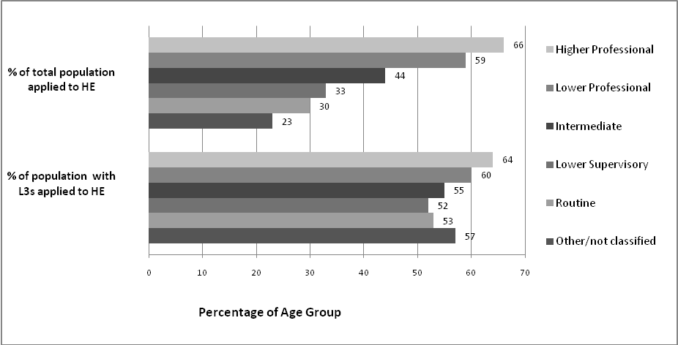
Source: Table 4.4.1 ‘Youth Cohort Study and Longitudinal Study of Young People in England: The Activities and Experiences of 18 year olds: England 2009’ DCSF
- The most significant attainment indicator for the purposes of projecting higher education demand is the proportion of the population achieving Level 3 qualification through A levels. Although there are other Level 3 qualification, A levels are by far the most popular, and the one most commonly possessed by English higher education entrants, as well as a reliable predictor of whether or not a student will go on to higher education. However, Figure 7 shows that despite an increase between 2008 and 2009, achievement at this key point in the higher education supply chain has decreased marginally in four of the past five years.
Figure 7. Proportion of 19-year olds attaining Level 3 via A levels
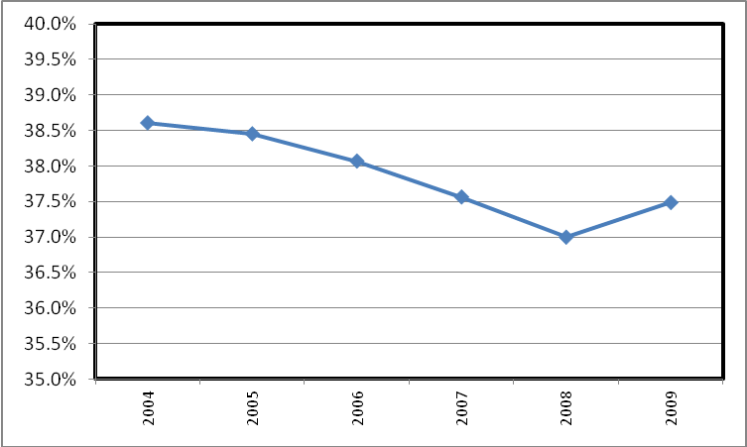
Source: DfE Statistical First Release 18.03.10 Table 4.
- This is not to say that other qualifications do not produce demand for higher education. The nine percentage point increase in the proportion of 19-year olds with Vocationally Related Qualifications (VRQs), shown in Table 5, may have increased higher education demand by around 16,000. However, conversion rates from VRQs to higher education are lower than – less than half that of - A levels, which combined with the much higher numbers taking A levels means that A levels remain overwhelmingly the most important qualification route into higher education.
Table 5. Proportion of 19 year olds in England qualified to Level 3, by qualification type at which Level 3 was achieved and cohort
Year in which aged 19 | AS, A-Levels, AVCEs or Advanced GNVQs | Advanced Apprenticeship | NVQ Level 3 | VRQ Level 3 | International Baccalaureate | Total Population with a Level 3 by age 19* | Proportion achieving a Level 3 by age 19*
2004 | 38.60% | 0.50% | 0.90% | 2.20% | 0.00% | 259,000 | 42.10%
2005 | 38.50% | 0.50% | 0.90% | 5.60% | 0.00% | 281,000 | 45.40%
2006 | 38.10% | 0.70% | 1.00% | 6.80% | 0.20% | 295,000 | 46.70%
2007 | 37.60% | 0.80% | 1.20% | 8.30% | 0.30% | 314,000 | 48.10%
2008 | 37.00% | 0.90% | 1.30% | 10.30% | 0.30% | 321,000 | 49.80%
2009 | 37.50% | 0.90% | 1.40% | 11.20% | 0.30% | 337,000 | 51.40%
Source: DfE Statistical First Release 18.03.10. Table 4.
- Although possession of level 3 qualifications – and in particular A-levels – remains the strongest indicator of propensity to apply for and enter higher education, analysis of information provided by UCAS reveals that a strong recent trend has been the increasing number of applicants without any formally recognised qualifications (or at least not recognised by UCAS in its tariff system). Figure 8 below shows the number of applicants and entrants in 2010 with different UCAS tariff scores in bands. It will be seen that by far the largest group of entrants are those with no tariff points at all. This goes a long way towards explaining how it is that, despite the trend in A-level uptake, applications to University – and the number of unsuccessful applicants – have increased recently. Nearly half of the increase in applicants through UCAS between 2008 and 2010 was accounted for by people with no tariff points at all, and such people accounted for nearly 70 per cent of the increase between 2007 and 2008.
- Unfortunately, the nature of these students with no UCAS tariff points are not known. Some will have overseas qualifications and some will have other, often professional, level 3 equivalent qualifications not recognised by UCAS; but it is reasonable to suppose that in large part they represent able people who left school with few qualifications, and who are seeking to improve their life chances. It is one of the strengths of the UK's higher education system – and a feature that sets it apart from most others in Europe – that such second chance higher education is possible.
Figure 8: UCAS tariff points of all applicants and enrolments through UCAS
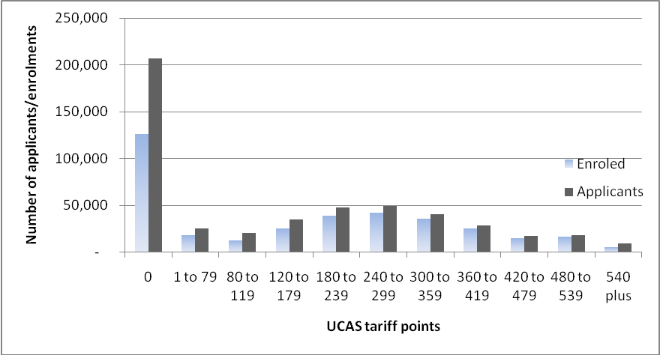
Source: UCAS ad hoc analysis 2010 data. Figures relate to England domiciled applicants
Latent demand
- On the face of it, with demography suggesting a small decline in demand if all else were equal, and with no increase in the achievement of A-levels in recent years, there would be likely to be little if any growth in demand. However, previous reports have pointed to disparities that are likely to lead to a level of demand well above that suggested by population alone – effectively, these represent areas where there is clear "room for improvement". One such area, identified in the last HEPI report on supply and demand, is the high level of non-progression by pupils who have achieved good GCSE results. Table 6 shows for example that 55 per cent of students from the 2003-4 Key Stage 4 cohort who obtained 8 GCSEs did not progress to higher education by 19, and that 26 per cent even of those achieving 10 or more GCSEs did not progress to higher education.
Table 6: Nonprogression to higher education by number of GCSEs
GCSEs (A*-C) at 16 | Number not in higher education by 19 as a % of relevant group
0 | 99%
1-4 | 91%
5 | 79%
6 | 73%
7 | 65%
8 | 55%
9 | 38%
10+ | 26%
Total | 69%
Source: DfE, matched administrative data
- A major factor in this non-progression to higher education is that many of those concerned did not progress to Level 3. As Table 7 below illustrates, in 2009 29 per cent of students who obtained 8 GCSEs did not progress to Level 3 by age 19, nor did 10 per cent of pupils who obtained 10 or more GSCEs, despite being among the most highly qualified of their cohort. If some of these apparently able and well-qualified young people were to continue with their education, then this would have a significant impact on higher education demand.
Table 7. Non-progression to Level 3 from GCSE, by number of GCSEs held
GCSEs (A*-C) at 16 | % of relevant group - all | % of relevant group - males | % of relevant group - females
0 | 96% | 96% | 95%
1-4 | 76% | 79% | 74%
5 | 56% | 41% | 54%
6 | 50% | 52% | 45%
7 | 40% | 41% | 38%
8 | 29% | 30% | 28%
9 | 16% | 17% | 14%
10+ | 10% | 11% | 9%
Total | 51% | 66% | 45%
Source: DfE, matched administrative data
- Previous reports have shown how A-level attainment varies according to gender, social background and region, Among the many measures of social disadvantage, take up of free school meals (FSMs) is one for which there are good data. Table 8 below illustrates the attainment gap between those on free school meals and those not, where FSMs can be taken as a proxy for social deprivation. Those on FSMs are less than half as likely to reach A level compared to those not.
Table 8. Proportion of 19-year olds attaining Level 3 via A Levels by FSM status
 | FSM pupils | Non-FSM pupils | All (maintained)
2005 | 15.2% | 38.5% | 35.1%
2006 | 15.3% | 37.8% | 34.6%
2007 | 14.8% | 37.1% | 34.0%
2008 | 14.6% | 36.4% | 33.4%
2009 | 15.3% | 36.7% | 33.9%
Source: DfE analysis of matched administrative data
- There is some evidence that participation in higher education by more disadvantaged social groups may be accelerating, although it is still well short of the better off. There is no sign though that other groups are catching up their peers (males and females, for example, where as, Table 9 below shows, male A-level achievement continues to lag well behind that of females with no recent improvement), but nevertheless these discrepancies undoubtedly represent a potential for growth, and should be regarded as an indication of latent demand.
Table 9. Proportion of 19-year olds attaining Level 3 via A Levels by sex
 | Male | Female | All
2005 | 34.3% | 42.8% | 38.5%
2006 | 33.7% | 42.7% | 38.1%
2007 | 33.3% | 42.1% | 37.6%
2008 | 32.6% | 41.5% | 37.0%
2009 | 33.0% | 42.2% | 37.5%
Source: DfE analysis of matched administrative data
- All of these discrepancies suggest that there are substantial numbers of able young people who do not at present continue with their education or achieve the educational outcomes of their equivalently qualified peers. If and when these discrepancies begin to be resolved, then there will be a substantial increase in demand for higher education.
- Perhaps the most important recent development that will undoubtedly impact on demand concerns the policy – introduced by the last government, and maintained by this -- that from 2013 young people may not leave education and training until the age of 17 and from 2015 until the age of 18 – the first rise in the age for leaving education and training since 1972. This means that from 2015 some of those identified above who leave school at present after their GCSE exams will have to remain in some form of education or training until 18. This is likely to mean increased numbers of students taking Level 3 qualifications, and certainly some of those will be candidates for higher education, though the extent to which this will impact on demand cannot at present be assessed.
Supply and demand – a growing gap
- Earlier sections of this report have shown how in recent years a growing number of applicants have failed to obtain places at University. The majority of these are students without any UCAS tariff points, but at 35 per cent of all entrants those with no UCAS tariff points also represent the largest single group of those who are accepted. Table 10 below summarises the UCAS tariff point profile of applicants who do not enter university either because they fail to obtain an offer, or because they decline the offers they receive or because they withdraw from the process or for "other" reasons. It will be seen that although in 2010 39 per cent of applicants with no tariff points failed to enter higher education, so did 13 per cent of applicants with 300 tariff points or more, which in terms of GCE A-levels equates to 3 grade Bs and above.
Table 10: 2010 applicants to UCAS by tariff points
Tariff Points | No offers/Reject | Declines | Withdraw | Other | Total Non-enrolled applicants | Enrolled | Enrolled as proportion of all acceptances | Enrolled in as % of applicants with this tariff score
0 | 51,273 | 15,975 | 4,685 | 8,456 | 80,389 | 126,326 | 35% | 61%
1 to 79 | 3,329 | 3,073 | 688 | 239 | 7,329 | 18,217 | 5% | 71%
80 to 119 | 2,609 | 4,100 | 606 | 118 | 7,433 | 12,626 | 4% | 63%
120 to 179 | 2,899 | 5,585 | 1,154 | 109 | 9,747 | 24,865 | 7% | 72%
180 to 239 | 2,309 | 5,006 | 1,368 | 100 | 8,783 | 38,977 | 11% | 82%
240 to 299 | 1,616 | 4,124 | 1,308 | 66 | 7,114 | 41,886 | 12% | 85%
300 to 359 | 1,138 | 2,546 | 1,167 | 29 | 4,880 | 35,245 | 10% | 88%
360 to 419 | 773 | 1,500 | 884 | 15 | 3,172 | 24,957 | 7% | 89%
420 to 479 | 485 | 722 | 545 | 9 | 1,761 | 15,122 | 4% | 90%
480 to 539 | 415 | 591 | 597 | 7 | 1,610 | 16,472 | 5% | 91%
540 plus | 1,402 | 1,698 | 288 | 70 | 3,458 | 5,515 | 2% | 61%
Grand Total | 68,248 | 44,920 | 13,290 | 9,218 | 135,676 | 360,208 | 100% | 78%
Source: UCAS ad hoc analysis Figures relate to England domiciled applicants
- This discussion is complicated by the fact that more than two thirds of the increase in the number of applicants who fail to receive offers, is among those with less than 80 UCAS tariff points – that is to say, less than the equivalent of two grade Es at A level, some of whom will have failed to receive offers because they were deemed unsuitable for higher education study. However, a significant majority of such applicants did succeed. Until 2007-08 the proportion of those applying with less than 80 tariff points who were rejected, withdrew their applications or did not enrol for other reasons was at or a little below 20 per cent each year. This is taken for the purpoe of this calculation to represent the ‘normal’ proportion of such applicants who can be assumed to have failed to enrol not because of the unavailability of places but because they were deemed unqualified. On the other hand, it is assumed that all those who received offers but declined them – but not those who withdrew or did not enrol for "other" reasons – were deemed qualified by the university that made the offer. So it is unhelpful to consider all applicants who fail to enrol as representing "unmet demand", and an attempt is made here to distinguish between qualified and unqualified demand, and to treat only the former as "unmet demand.
- For the purpose of estimating qualified demand among students with fewer than 80 tariff points since then, it is assumed that the ratio of qualified to unqualified has remained the same. On this basis, unsatisfied qualified demand among those with fewer than 80 tariff points in 2010 was over 22,000. It is assumed also that all those who applied with more than 80 points but did not receive offers, who withdrew or who declined offers that they received, of whom there were more than 40,000 in 2010 (up from 30,000 in 2009), also represent unsatisfied demand. So there was demand from 62,000 unsatisfied qualified applicants in total in 2010, (up from 38,000 in 2009) – equivalent to about 17.3 per cent of those who entered higher education through UCAS, and an increase of over 60 per cent from the previous year.
- In passing, it is worth noting that the Browne Committee recommended that the number of entrants to University should be controlled by setting a minimum UCAS tariff score, and that just 10 per cent of places should be reserved for those who fall below this minimum. Browne did not say what the minimum tariff score should be – that would be left to the government, and adjusted from year to year depending on how many places the government could afford. But considering that 360,000 full-time applicants were accepted through UCAS, this suggests that only 36,000 places would be available for such applicants in total. Considering also that there were 126,000 accepted applicants without any UCAS tariff points at all in 2010, this would imply, if the minimum tariff score was set at more than zero (and it is difficult to see how it could be set below this), that there would be 90,000 further rejections among full-time applicants through UCAS, over and above those that were unable to gain entry anyway. And these calculations do not take any account of part-time applicants without any tariff points. It is not surprising that the government has not so far accepted this proposal. It appears to be unworkable, and indeed the Browne Committee acknowledged that it could not be implemented unless the tariff system became much more comprehensive, encompassing both many more qualifications and also part-time students.
- So the present level of unsatisfied "qualified" demand – at about 17 per cent of entrants - is significant, and appears to be growing rapidly, though there has always been a number – even of well-qualified applicants – who have failed to obtain places. And on top of this, as discussed above, there is a substantial amount of latent demand that may well emerge in the near future
- Looking forward, the previous HEPI report on demand – HEPI report number 39 – suggested that even on modest assumptions about future catching up of males with females and without making any assumptions about disadvantaged social groups improving their participation rates towards those of more privileged groups, there could be demand for as many as 100,000 more places in 2020–21 than in 2008–09 when that report was written, an increase of 10 per cent. There are indications that some catching up by disadvantaged social groups may have begun already. It remains to be seen whether males also begin to improve their performance relative to females, but it is not unreasonable to assume that at some point in the future they will. And it should be noted also that this projection of demand assumes only a partial catching up by males, and that the gap with females will be reduced only by half. So 100,000 is taken here to represent a reasonable assumption about the possible increase in total demand for places that there would be in 2020–21 if demand were not constrained – about 30,000 new places per year, and 8.5 per cent more than the number of entrants through UCAS in 2010 .
- In 2010 there were 360,000 places available for new entrants through UCAS, and unsatisfied demand of about 62,000. The government has announced that 10,000 entrant places will be cut in 2012. Unless these places are reinstated, and a substantial number of additional places provided over and above these, there could be as many as nearly 100,000 disappointed applicants in 2020 –over 20% of the number of applicants to UCAS in 2010 . This is a very large number, and could have profound implications. It would represent a large scale retreat from the Robbins principle, the early signs of which are already apparent, and would be particularly ironic in light of the imminent rise in the statutory age for leaving education and training. These two policies combined run the risk of raising expectations and ensuring that these expectations cannot be met.
- It is difficult to see how this growing demand can be satisfied. One approach that has been canvassed by both the present and the previous government has been to increase the number of shorter courses – both accelerated two-year, degree courses and sub-degree courses like Foundation Degrees and Higher National Diplomas.
- The problem with the former is that when these have been attempted in the past, they have proved not to be successful other than for a limited group of highly motivated, generally more mature, individuals in specific subjects where the degree programme focuses on the acquisition of a defined and specific, generally technical, body of knowledge. And while such courses will save the government money with regard to the maintenance budget, because maintenance loans of only two years rather than three will be required, the cost of teaching these programmes remains similar to – or even slightly more than – a conventional programme. So universities are likely to wish to charge annual fees up to 50 per cent higher than for a three-year programme – something which the £9000 limit on fee levels will not in most cases allow. Moreover, such programmes imply a highly instrumentalist view of the purpose of higher education. While it is possible that a specific corpus of knowledge and skills may be learned in two years rather than three, it is unlikely that the same degree of maturation, development of analytical capacity and depth of understanding will be acquired.
- As far as sub-degree programme is concerned, if the supply of three-year courses is choked off and nothing other than sub-degree programmes are available, then it is possible that those who fail to obtain places to study full degrees will take up such places in increasing numbers. That is something that it may be worth pursuing, but will need substantially greater intervention by HEFCE, which will need to control the nature and length of courses that universities offer. But it is anyway equally possible that increasing the supply of such places will simply lead to empty places. Demand for sub-degree programmes has barely increased in the last 20 years, while demand for degree programmes has increased greatly. And the reaction of applicants who fail to obtain a degree place cannot be taken for granted.
- The most likely response of the government is likely to be to find ways of enabling additional numbers but without any increase in cost to itself. This is likely to mean increasing yet further the cost of higher education to the student – or rather the former student in work – either by increasing the rate of interest on their loans or by increasing the rate of "tax" on their income (currently 9 per cent), or by adjusting the salary threshold at which repayments begin (which can easily be done by changing the basis on which the threshold is indexed) or by extending the period over which repayments must be made from the presently proposed 30 years.
- There seems little doubt that demand is set to increase strongly for the foreseeable future, and that present policies imply that there will be large numbers of disappointed applicants.

“ The government's proposals for higher education funding and student finance - an analysis” – HEPI 2010
Higher Education Funding Council for England (HEFCE), Recreation of 2008-9 HESES/HEIFES columns 1 plus 2. On average HEFCE counts a part-time student as 0.41 of a full-time student.
As discussed in previous reports, this jink in the series is thought to be a result of students taking advantage of the pre-2007 fee arrangements before tuition fees were altered.
It could be that part of the apparent growth in applications is a result of more people applying through UCAS, and fewer direct to institutions. But even if that is the case, it does not significantly affect the overall pattern.
for a discussion of this see "Does Education Matter" by Professor Alison Wolf, 2002, written nearly 10 years ago, but still relevant in its analysis, indeed increasingly so.
This is considerably lower than the 200,000 referred to in newspaper headlines, the majority of the difference being accounted for by international and EU students who failed to secure places
For a full discussion of these effects, see HEPI report number 39, December 2008
2007 – 8 is used as the baseline figure, because that is taken to be the last year in which demand for higher education was fully met.
Longitudinal Study of Young People in England (LSYPE) and Youth Cohort Study (YCS) Cohort 13 data. 61% had entered HE by 18, 20% had accepted an offer to start at 19. Tthe cohort studied was 18 in 2009
Institute of Fiscal Studies (2008), Understanding the determinants of participation in higher education and the quality of institute attended: analysis using administrative data, p.20
To attain Level 3 via A Levels, a candidate must achieve at least two A*-E grades. The distinction between General ("GCE") and Applied ("AVCE") A levels should also be noted. In previous years, attainment of GCE A levels has been a stronger predictors of higher education demand than AVCE A levels. However, due to the way HESA and Government data are now collected, separating these qualifications has not been possible in this report.
In 2008/9 A levels or equivalents (including NVQs) were the highest qualification of 70% of English higher education entrants. Source: HESA Student Record.
HEPI calculation based on the assumption that all VRQs had the BTEC conversion rate of 41% (2007 figure).
Data on progression rates to higher education from other Level 3s is limited. HEFCE research indicates that the progression rate from BTECs (a major form of VRQ) is 41%, while the progression rate from Advanced Apprenticeships is 6%, but figures for VRQs overall, NVQ Level 3 were unavailable. HECFCE (2007, 9) Pathways to Higher Education.
Numbers are rounded to the nearest thousand. GCSE scores include GNVQ equivalents and cohorts include students at independent schools.
Numbers are rounded to the nearest thousand. GCSE scores include GNVQ equivalents and cohorts include students at independent schools.
It should be noted that the figures in Table x do not include pupils outside the maintained sector, which accounts for the apparently discrepant final column figures.
See HEFCE report “Trends in young participation in higher education: core results for England" – HEFCE 2010
N.B. "Not enrolled" includes all those who failed to receive offers, rejected them or withdrew from the applications process space or did not take up places other reasons.
Assuming that each year new entrants represent about 30% of the total student body you think
Letter from the Secretary of State to the Chairman of HEFCE, 20 December 2010

