Male and female participation and progression
in Higher Education
- This report reflects on research about differences in aspects of participation in higher education between men and women.
- The clearest and most striking difference between men and women concerns their participation in higher education. As far young participation is concerned, in 1992-93 the participation rate for women, as measured by the Age Participation Index, exceeded that for men for the first time. Since then the difference in participation rates has increased. Figure 1 shows the young higher education initial participation rates (HEIPR) for men and women from 1999-2000.
Figure 1: Young (17 to 20) HEIPR by sex 1999- 00 to 2007-08
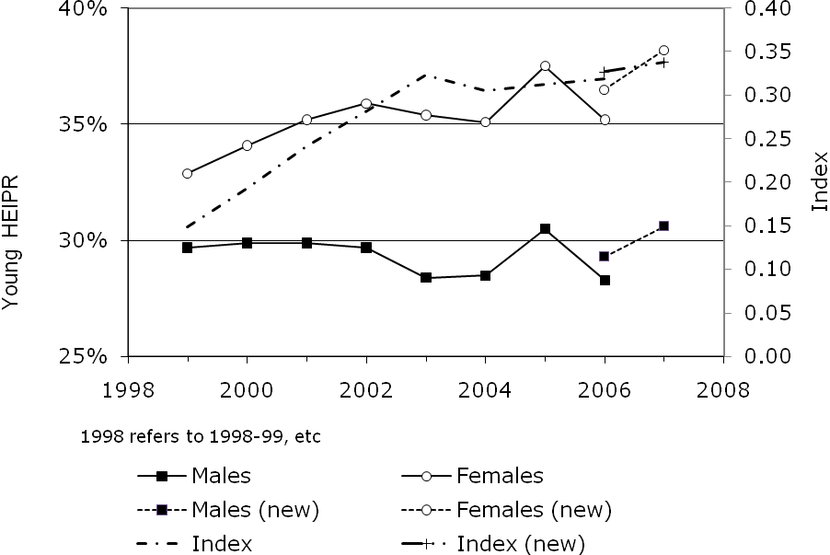
- Figure 2 shows the participation rate of all entrants aged 21 to 30, and shows that women also have a higher mature participation.
Figure 2: Mature (21 to 30) HEIPR by sex 1999-00 to 2007-08
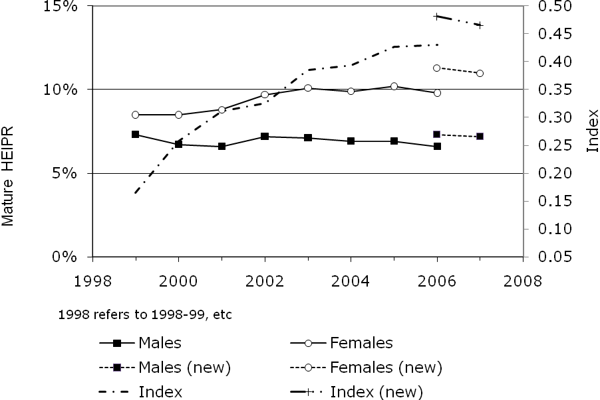
- Some commentators have said that the dominant position of females suggested by the general participation figures is misleading, and that while women may now be in a numerical majority in higher education they tend to attend less prestigious institutions and do less well in their studies. For example, Dr Penny Jane Burke, a sociologist of gender and education, summarised this viewpoint as follows:
“Many women are studying in lower-status universities; many are mature or part-time students. The university continues to be a space where class privilege is maintained and women’s participation is limited to the bottom of a hierarchical continuum.”
- None of this is so. As shown above, participation rates by mature women are higher than for men, but the young participation rate is also higher. Indeed women have a higher participation rate for each single year of age from 17 to 30.
- There is a similar picture with mode of study. Table 1 below shows the full- and part-time participation rates for men and women. It shows that though women do have a higher part-time participation rate than men, they also have a higher full-time participation rate.
Table 1: HEIPR (2007-08) components for men and women by mode
Mode | Men | Women
Full-time (including sandwich) | 32.4% | 41.4%
Part-time | 5.5% | 7.8%
Full- and part-time | 37.8% | 49.2%
Source: HEFCE, unpublished analysis
- There are marked differences between men and women in the subjects studied, details of which are shown in the full report. Women have higher subject specific participation rates for all subjects apart from Physical Sciences; Technologies; Architecture; Building and Planning; Mathematical and Computer Science and Engineering. Apart from ‘Architecture’ and ‘Building and Planning’ these are ‘strategic subjects’ for which government believes there is insufficient student demand, and where there is less competition for places. In other words, men are overrepresented in the less popular subjects. Nevertheless, these are among those that command the highest graduate salaries, so while women have higher subject specific participation rates in a number of subjects which can lead to high salaries, in particular the clinical subjects and law, overall the profile of subjects taken by women is a factor in reducing their average graduate salaries.
- The idea that women’s participation “is limited to the bottom of a hierarchical continuum” seems to have gained wide acceptance. Assessing these claims is difficult because the ‘ranking’ of institutions is a question of judgement. Table 2 shows the components of the HEIPR by institution type according to a commonly assumed hierarchy of prestige.
- We can see from Table 2 that for all the types of institution identified, women have an equal or higher institution type specific participation rate. Given the differences between men and women in their choices of subjects, for individual institutions that specialise in particular subjects women may be poorly represented, but there is no evidence that women are under-represented in what is often perceived to be the top of the hierarchy of institutions.
Table 2: HEIPR (2007-08) for men and women by type of institutions
Type of institution | Men | Women
FE College | 2.5% | 3.1%
College of Higher Education | 1.4% | 2.2%
‘Post-92’ university | 18.0% | 23.8%
‘Pre-92’ HEI (not Russell group) | 8.6% | 11.3%
Russell group (not Oxford or Cambridge) | 6.5% | 8.0%
Oxford and Cambridge | 0.7% | 0.7%
All types of institution | 37.8% | 49.2%
Source: HEFCE unpublished analysis
- For all types of institution, apart from Oxbridge, women have higher participation than men. For Oxbridge the participation rates are equal. The high participation rates of women in post-92 higher education institutions and further education colleges (presumably these are what are meant by ‘lower ranked’) does mean that the proportion of women students attending the ‘higher ranked’ institutions will be slightly lower than the corresponding proportion of male students, even though women also have equal or higher participation rates than men in those institutions. 40.8 per cent of women who went into higher education entered pre-92 and 17.8 per cent entered Russell group universities (including Oxford and Cambridge). This compares with 42.2 per cent and 19.4 per cent of men who entered higher education. This may be what misleads some to believe that women are disadvantaged with respect to participation at high status institutions.
- However, just as a high mature participation rate does not cancel out high young participation, and a high part-time rate does not cancel a high full-time rate, so the higher participation rates at further education colleges, non-university higher education institutions and ‘new’ universities does not mean that women do not also have a higher participation rate at ‘higher ranked’ institutions. Their performance is superior in all types of institution.
- One detail considered is whether there are class or ethnic exceptions to the general picture of higher female participation than male. There are many different ways of showing class-related distinctions - among them, social class, the take-up of free school meals and socio-geographic characteristics. Whatever the measure, all show participation of males is lower than females in all social groups.
- Taking one of these approaches in detail, HEFCE has undertaken a study that divided the student population into five area classification groups, from those areas with the lowest to those with the highest higher education participation. This analysis showed that women had higher participation rates than men in each of the five categories. The proportional sex inequality was found to be greatest in the lowest participating quintiles. Over the six years of the study, the proportional sex inequality is shown to be growing for each of them, with the fastest growth in the lowest participation group. There is a similar pattern when other measures are used. It appears that the poorer performance of men is common to all social groups, but is getting worse among the poorest.
- There is some uncertainty about participation rates by ethnic group, but recent work has shown that among all the main groups, rates of participation of young women from state schools are higher than for young men from state schools. These findings apply to those identified as Pakistani and Bangladeshi as they do to others, whereas previously it was thought that women from these communities did not perform as strongly as men.

Beyond entry to HE
- Once within higher education, women are more likely to succeed and obtain a degree. Table 3 below sets out the non-continuation rates following the year of entry, and shows that among both young and mature entrants men have a very much higher dropout rate than women.
Table 3: Non-continuation rates from year of entry: (2005-06 home entrants to full-time first degree programmes at UK HEIs)
 | Men | Women | Difference
Young entrants | 7.9% | 6.5% | 1.4%
Mature entrants | 17.0% | 12.3% | 4.7%

- For those who graduate, differences in performance are observed with regard to the class of degree obtained, with women obtaining 56 per cent of all first-class degrees, even though they make up less than 50 per cent of the population for the relevant ages. Table 4 presents the degree class data in a different way, and looks separately at the likelihood of obtaining different classes of degree between males who graduate and females who graduate. 13.9 per cent of males graduating obtained a first-class degree compared to 13 per cent of women who graduated. However, 63.9 per cent of women graduates obtained firsts and upper seconds (generally regarded as ‘good’ degrees), compared to 59.9 per cent of males and the proportion of men obtaining lower seconds, thirds and pass degrees was also higher.
Table 4: Degree class profiles (2007-08) (home graduates from UK HEIs)
Class of degree | Men | Women
Firsts | 13.9% | 13.0%
Upper seconds | 46.0% | 50.9%
‘Good’ degrees – firsts or upper seconds | 59.9% | 63.9%
Lower seconds | 31.6% | 29.3%
Thirds or pass degrees | 8.4% | 6.8%
All classified first degrees | 100.0% | 100.0%

- Finally we looked at progression out of university and into employment. Here the data are less good, and we had to look at surveys beyond the HESA information, but these too indicate sex differences. In general it appears that males are more likely to be unemployed after graduation, but that those who are in work tend to have higher salaries than women (partly but not entirely reflecting the different subject mix, referred to above). It could be that males are more likely to be rejected for the jobs that they apply for, and are at some form of disadvantage here, and it could be that females are experiencing discrimination in the salaries they are paid. These are matters that need further investigation

Reasons for higher female participation rates
- There is an extensive literature on the lower achievement of boys in school. Table 5 below shows the differing levels of GCSE and A level attainment.
Table 5: Participation and achievement at levels 2 and 3 (England, 2006)
 | Male | Female
Per cent with five or more A*-C GCSEs | 54 | 63
Average GCSE and equivalent point score | 282 | 346
Per cent in full time education at 16 | 72 | 82
Per cent achieving 2+ A levels or equivalent at 17 | 30 | 39
Per cent of A level entries passed | 97 | 98
Per cent of A level awards at grade A | 24 | 26
Average tariff points per A level awarded | 86 | 89

- Are these differences in achievement sufficient to explain the differences in young HE participation rates? The answer, at least for pupils at state schools, is ‘yes’. The difference in achievement at GCSE has been shown to be sufficient to explain the differences in HE participation. What is more, there are strong indications that the nature of the GCSE assessment (and the nature of the teaching and curriculum that feed it) is part of the reason for the relatively poor performance of boys. Figure 3 below shows that the differences in performance began to be apparent around the time of the introduction of GCSEs in 1988.
Figure 3: Percentage of school leavers with five O-levels or A*-C GCSEs
- It is not simply that the differences in HE participation rates began to occur at around the time (but not exactly the same time) that GCSEs were introduced – coincidence of timing would not be sufficient to deduce a causal relationship. An indication that boys would perform better under a different testing regime is provided by the results of the OECD 2006 Programme for International Student Assessment (PISA) study. This involved assessment of 15 year olds in reading, mathematics and science. The UK component involved 502 schools and over 13,000 pupils. In England, as well as in the UK as a whole, girls scored better on the reading assessment, but boys got more correct answers on both the mathematics and science questions. What is more, the boys’ higher overall science score was mostly due to their better results in “explaining phenomena scientifically”, the competency which is closest to traditional science learning and assessment. These results contrast with GCSEs – taken just a few months later - where girls did better in both mathematics and science, apart from the very small advantage for boys in the percentages gaining A* and A grades in mathematics.
- An ongoing study into the SAT tests used in the USA for university admissions has shown that boys also do better with this test than they do with GCSEs. This study, in contrast to the PISA study, was based on a sample of students who were taking A-levels, and therefore is not suitable for making a simple direct comparison with GCSEs. However, the researchers modelled SAT scores carefully controlling for GCSE and A-level attainment, allowing for subject-specific effects like A-level mathematics grade on the SAT mathematics score. They found that boys did better on mathematics and critical reading components of the test when compared with girls with equivalent GCSE and A-level results. There was no difference in the writing component, though when the score for the essay question was removed, the boys appeared to do better on the remaining SAT writing score, after allowing for GCSE and A-level achievement.
- Although there is evidence that the introduction of GCSEs contributed to the deterioration in the relative participation of boys, it is highly unlikely that this provides the entire reason for the gender differences in HE participation, which is an international phenomenon. Figure 4 below, from the OECD, shows how female participation in higher education exceeds that of males in almost every country in the OECD area, and this pattern is repeated in other countries too across the world. So although there are undoubtedly country-specific reasons for the differences, the relatively poorer performance of men is a global phenomenon.
Figure 4: Differences between entry rates for men and women by country
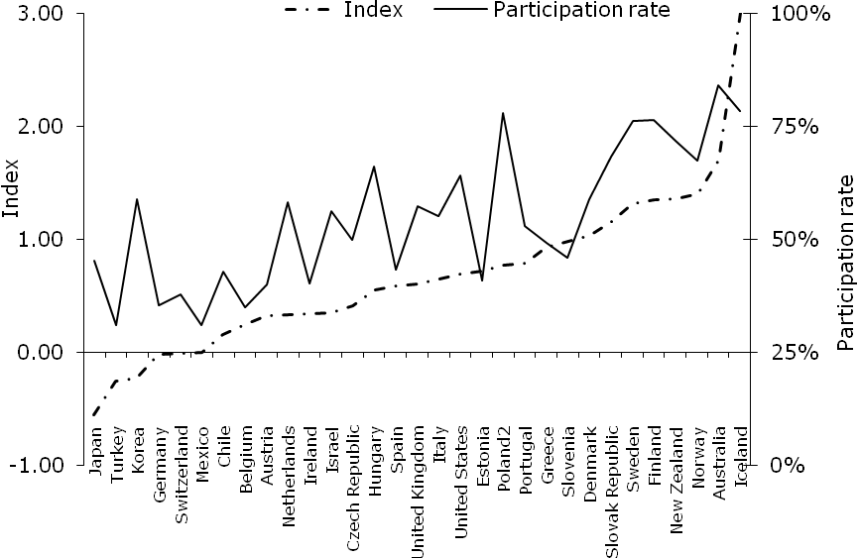
Source: OECD, Education at a Glance (2008), table C2.1
- Other - not mutually exclusive - reasons have been suggested for the poorer and deteriorating performance of males, in particular changes resulting from improvements in family planning and the increased opportunities for women to combine having a family with progressing in a career. Two others that are suggested are the economic drivers which may provide a greater incentive for women to invest in higher education and changes in childhood experience which may have a different impact on the intellectual development of girls and boys.
- As far as economic drivers are concerned, most estimates of the returns to higher education show higher returns for women than men. The arguments are complex, and not yet conclusive, but if, as seems reasonable to assume, economic considerations play a part in decisions to pursue education, then this may contribute to the greater motivation and achievement of females.
- With regard to cognitive development, over a period of nearly 30 years the same science reasoning test, developed by the Piagetian school, has been given to 11 and 12-year-olds. The test assesses children's understanding of the concepts of heaviness and volume. Unlike IQ tests the results show a decline in competence for both sexes. Table 6 reports the results for one of the 15 questions put to the children and shows how the success rate has declined much more for boys, so that the advantage they had in 1975 has now gone. Results for other questions show a similar trend. The reasons for these changes are not established, and may never be, but the researchers speculate that, at least up to 2000, these may be in part to do with changes in play. As the researchers put it:-
“Passive exposure to many hours of television a week has increased since the 1960s when 1975 CSMS students entered primary school. Computer games may have usurped what might have been, for boys, many hours playing outside with friends with things, tools and mechanisms of various kinds rather than virtual reality.”
Table 6: Success rates for displacement volume question
Year | Boys | Girls
1975-76 | 54% | 27%
2003-04 | 17% | 17%

Does it matter?
- If the gap at the end of compulsory education came about largely because of the move from O levels to GCSEs – and there is evidence that that change was at least part of the reason - then for 20 years boys have been needlessly achieving less than they might, and that has affected their lives subsequently. To the extent that their results at GCSE shape decisions by pupils, their parents and teachers about whether and what they continue to study, this matters greatly.
- The causes of the differences in achievement need to be identified and addressed. In the same way as the relatively poor performance of females previously gave rise to concerns that large numbers were being excluded from the benefits that follow from fulfilling their potential (not just employment and economic benefits, but also the benefits for health and social capital that higher levels of education have been shown to bring), so the same concerns now arise in respect of males.
- But the important thing first is to recognise the issue, and that means changing a mindset that continues to see males as advantaged and females as disadvantaged. Whatever the truth in society at large - and that is not argued here – that is emphatically not the case in higher education. It is not good enough, for example, for the QAA to criticise Foundation Degrees on the grounds that
“Despite the providers' enthusiasm for widening participation … many programmes continue to mainly attract men aged 18 to 24 with traditional entry qualifications who study full-time.”
suggesting that action to attract males is somehow unacceptable. On the contrary, any actions that help to rebalance the poor performance of males is greatly to be encouraged.
- And it certainly is unacceptable to suggest, as was recorded in a report published by DfES (not necessarily the government’s view, but one that they reported), that
“it could be argued that the widening gender gap” [in educational achievement] “does not matter if this advantage either disappears by the time the girl enters the labour market or if it helps to ensure greater equality for women in the labour market” (Emphasis added.)
implying that male education disadvantage may be acceptable because there is female disadvantage in the workplace. It does not help one disadvantage to perpetuate another. We all need to recognise that the poor education performance of males – now shown to extend comprehensively into higher education – is a real problem. That recognition on the part of policy makers will be a first step towards addressing the problem.

The review of the evidence in this report was carried out by John Thompson, formerly data analyst at HEFCE, to whom HEPI is greatly indebted. To save space, sources, references and citations are not included in full in this summary report, but can be found in the full report on www.hepi.ac.uk.
The index (right hand scale and broken line) is an index of inequality. Positive values reflect a higher participation by women, negative a higher participation by men. For a full description see the full report on www.hepi.ac.uk.
Quoted in “Class rifts eclipsed by sex divide”, a report by Paul Hill in the Times Higher Education Supplement, 21 January 2005.
For example see “Academe still male bastion, assert female scholars”, report of a seminar on the impact of feminism on higher education (Times Higher Education, 10 July 2008).
For 2007-08 the Oxbridge participation rate for women was very slightly lower than for men. However about another extra 14 women entrants would have given them a higher rate than men. The difference is not significant, being smaller than the expected year on year fluctuations. In 2006-07 the participation rate for women was very slightly greater than that for men, by a similar non-significant number.
It will be observed from Table 5 above that most of the differences occur at GCSE stage or in progression to A level and that there is little further change by the time A levels are taken
In 2006 the percentages of male candidates in England gaining A* in mathematics was 4.2 per cent compared to 4.0 per cent for girls, and gaining A* or A was 13.2 per cent compared to 13.1 per cent for girls. The cumulative proportions of boys gaining other grades or higher were lower than for girls. Boys did do better at additional mathematics but there were very small numbers of candidates (JCQ, 2008).
The question follows other items in the test which lead up to it. The pupils are asked whether a metal block would displace more or less water than a plasticine block of identical dimensions when lowered by a thread to just beneath the surface of a cylinder filled with water, having first handled the blocks so that they are aware that the brass block is heavier.

