Oxford and Cambridge: how different are they?
Juliet Chester and Bahram Bekhradnia
- This study looks at Oxford and Cambridge universities and considers the extent to which they are distinctive compared to the rest of the UK higher education sector. It looks at the nature of their undergraduate student bodies, the outcomes of their teaching, the extent and quality of the research done in those universities and finally at the resources at their disposal. It concludes that from all of these perspectives – certainly when all are considered together – these two universities really are different from others in the sector, including the small number of peer institutions with which they are sometimes compared.

Student characteristics and teaching quality
Figure 1: Distribution of accepted UCAS applicants (2008 entry) within institutions by tariff score
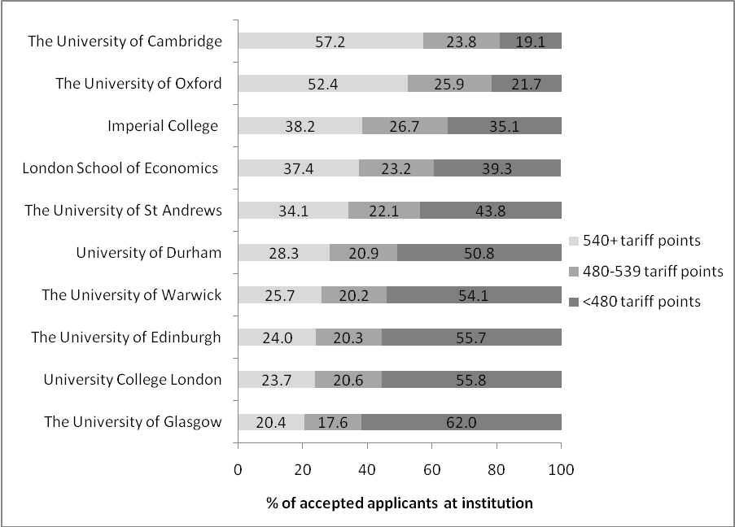
Source: UCAS
- Taking prior school attainment as the measure, Figure 1 above shows that Oxford and Cambridge recruit exceptionally talented students. Compared to other institutions with large numbers of students with very high levels of attainment (540 or more UCAS points), Oxford and Cambridge recruit significantly more of these, and fewer students with less than 480 UCAS points.
- A comparison of Oxford and Imperial, and the GCSE profiles of those accepting offers at those two universities, appears to suggest even more significant differences. That is illustrated in Figure 2 below which shows that, for example, in 2008, the proportion of accepted undergraduates with eight or more A*s at Oxford (58.0 per cent) was around four times the proportion at Imperial (14.4 per cent). More than twice as many accepted applicants to Oxford (87.3 per cent) had 5 or more A*s at GCSE than at Imperial (40.5 per cent).
Figure 2: Distribution of accepted undergraduates at Oxford and Imperial by number of A*s at GCSE
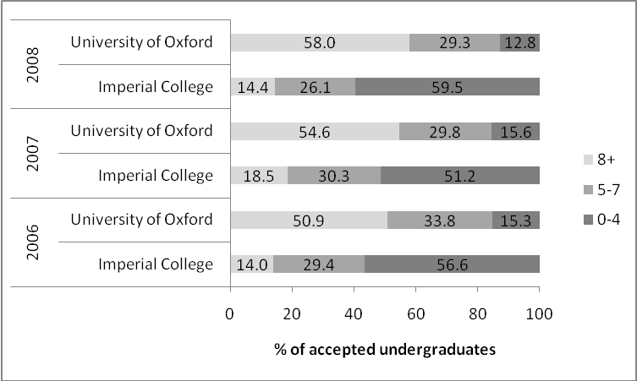
Source: Admissions data provided by the University of Oxford and Imperial College
- Maintaining the comparison between Oxford and Imperial, a broader issue (not shown here, but discussed at greater length in the main report) is the difference between Imperial and Oxford with regard to the level of certainty they have that an offer made will translate into a place accepted. The conversion rate of offers to acceptances at Imperial was 41.1 per cent for entry in 2008. For all UK students applying to Oxford for entry in 2008 the conversion rate was 92.5 per cent, and for all of Cambridge’s admissions (including overseas students) the conversion rate was 86.8 per cent. The strong implication of this (although there can be no certainty) is that a student offered a place at Imperial is far more likely to turn it down if offered a place at Oxford or Cambridge than vice versa.
- These data do not necessarily show, however, that the ‘brightest’ students – those with the greatest academic potential – are concentrated at Oxford and Cambridge. This is principally because the UCAS tariff scores used here do not take account of the educational context of these academic achievements. In 2006, for example, the proportion of accepted degree applicants from independent schools with tariff scores of 480 or more (21.5 per cent) was more than twice the proportion of applicants from the maintained sector who had tariff scores of this level (10.3 per cent). So those institutions with larger numbers of independent school entrants are more likely to have a higher proportion with a greater accumulation of tariff points. The proportion of UK entrants from the independent sector in 2006 was rather higher at Cambridge (42.4 per cent) and Oxford (47.0 per cent) than, for example, at Imperial (38.0 per cent), LSE (34.1 per cent) or UCL (33.4 per cent) and this will provide part – but only a small part – of the explanation for the differences. It is difficult, however, to quantify the effect of educational background on a student’s achievement levels, and to disentangle this from other factors, such as parental background, which affect educational achievement. It is perhaps even more difficult to assess and compare levels of academic potential – the likelihood of a student succeeding on a particular course at a particular institution.
- Despite these caveats, it does appear that the students who go to Oxford and Cambridge really are exceptionally able, at least as measured by prior qualifications. However, quality of teaching in higher education is an altogether more difficult thing to measure using the available data.
- Many of the measures used in league tables will not do for this purpose – staff-student ratios, for example, and expenditure on facilities and services – because they are ‘input’ variables that may help to achieve good outcomes but do not measure them. However, alongside these ‘input’ variables, national league tables also make use of ‘output’ variables, including completion rates, the proportion of students with good degrees and graduate career prospects. Oxford and Cambridge are the first and second ranked institutions in these league tables with respect to the first two of these. Even these output variables are nevertheless unsatisfactory indicators of teaching quality, since they do not allow for differences in ‘inputs’ such as prior qualifications, social capital or institutional resourcing.
- The National Student Survey is another measure that purports to reflect the quality of teaching. In that survey, students at Oxford and Cambridge express far greater satisfaction across a range of measures than their peer institutions (institutions which had at least 25 per cent of their research activities classified as ‘world-leading’ (4*) in the 2008 RAE – Oxford, Cambridge, Imperial, UCL and the LSE). Table 3 below shows that either Oxford or Cambridge had the highest percentage score for seven of the 22 questions (and one of the two was second for nine of the questions), whereas the other three institutions did not rank first or second for any question. The number of questions where Oxford and Cambridge scored above the average for the sector was also significantly higher than the number where the other three institutions did so.
Table 3: Scores in NSS questions (2007/8) relative to whole HE sector
 | Ranked 1st | Ranked 2nd | Above sector average
 | Number of questions (out of 22 in total)
University of Oxford | 4 | 2 | 21
University of Cambridge | 3 | 7 | 19
University College London | 0 | 0 | 12
Imperial College | 0 | 0 | 8
London School of Economics | 0 | 0 | 8
Source: Unistats
- Students at Oxford and Cambridge also have a great deal more expected of them than students at other universities: they spend more hours studying during term time than students elsewhere, including those at other Russell Group institutions. Table 4 below compares the total weekly workload (both teaching and private study) for subjects offered by both Cambridge and Oxford with the average weekly workload at other Russell Group institutions, and, in relevant subjects, at Imperial and LSE. It shows that students at Cambridge invest, on average, over 40 per cent more hours per week – and those at Oxford over 30 per cent more hours per week – than those at other Russell Group universities.

Table 4: Total weekly workload for undergraduate students at Cambridge and Oxford in comparison with the sector
Subject | Rank |  | Hours invested per week |  | % above Russell Group average |  | % above Imperial |  | % above LSE
Subject | Cam | Ox | Cam | Ox | Cam | Ox | Cam | Ox | Cam | Ox
Medicine | 3= | 3= | 42.1 | 42.1 | - | - | 14.4 | 14.4 | - | -
Biological sciences | 1 | 2 | 41.9 | 36.8 | 56.9 | 37.8 | 40.1 | 23.1 | - | -
Physical sciences | 1 | 2 | 44.8 | 39.7 | 47.9 | 31.0 | 50.8 | 33.7 | - | -
Mathematics | 1 | 2 | 36.6 | 34.4 | - | - | 20.4 | 13.2 | - | -
Engineering & Technology | 1 | 2 | 41.1 | 36.0 | 36.1 | 19.2 | 21.2 | 6.2 | - | -
Social studies | 1 | 2 | 34.7 | 33.6 | 46.4 | 41.8 | - | - | 43.4 | 38.8
Law | 1 | 2 | 41.4 | 40.1 | 31.8 | 27.7 | - | - | 48.4 | 43.7
Historical & Philosophical Studies | 1 | 2 | 36.1 | 32.9 | 46.2 | 33.2 | - | - | 63.3 | 48.9
Average % difference across comparator subjects | - | - | - | - | 44.2 | 31.8 | 29.4 | 18.1 | 51.7 | 43.8
Source: HEPI
- In terms of their student outcomes, while there is no evidence that Oxford and Cambridge are distinctive in terms of degree classifications (for what those are worth) or initial career destinations, there is evidence that over a lifetime, graduates from these two universities perform exceptionally when compared with others. High-status professions remain dominated by those who were educated at Oxford and Cambridge, although the available analyses do not allow us to conclude that this effect exists independent of other student attributes: one recent study of 500 leading individuals in the fields of politics, law, journalism, medicine and business showed that nearly half of these individuals (47 per cent) were educated at either Oxford or Cambridge.
- Oxford and Cambridge graduates born between 1949 and 1966 are three times more likely than graduates from other Russell Group institutions (excluding those in London) to feature in Who’s Who, whilst those born between 1902 and 1916 are twice as likely to do so, suggesting that if anything the hold of Oxford and Cambridge tightened after the expansion of the university system in the 1960s. A closer analysis of Who’s Who entries highlights the particular pre-eminence of Oxford and Cambridge graduates among the elite within knowledge and professional performance based careers. Similarly, of the 14,088 professorial level staff currently employed at UK institutions, 13.4 per cent had at least one degree from Oxford and 13.2 per cent had at least one degree from Cambridge. Around a quarter (25.4 per cent) held at least one degree from either Oxford or Cambridge. Only 2.9 per cent of these staff hold degrees from Bristol, or from Edinburgh, and similar proportions from other research-intensive universities.
- In summary, Oxford and Cambridge attract a significant proportion of the highest-achieving students, which makes the profile of their undergraduate student body stand out against other comparable institutions. Their students are significantly more likely than their peers at other institutions to be satisfied with their teaching, and in particular with the formative feedback that they receive, and to work longer hours during term time. The extent to which the institutions themselves are distinctive in terms of the value they ‘add’ to these students is difficult to judge using the available evidence, but there are a number of indications that Oxford and Cambridge graduates have sustained, or even improved, their position among high-status and high-influence professions.
- With this in mind, it is easy to see how the question of fair access to Oxford and Cambridge has influenced – some might say disproportionately – the rhetoric of the widening participation and fair access debate and the conditions placed on institutions wishing to charge higher fees.
- The congruence of the academic and social elite in Oxford and Cambridge’s undergraduate student intake – and enduring suspicions about the extent to which admissions decisions are based on the latter rather than the former – help explain why a great deal of the focus is directed at these institutions rather than the apparent inequities in the English secondary education system that lead to some schools outperforming others to such a significant extent.
- There is no evidence that Oxford and Cambridge are socially discriminatory in their admissions – their social profiles are largely the result of their academic demands, and the relative performance of pupils attending independent and maintained schools (which itself is in part indicative of social and economic differences).
- Nevertheless, there is some evidence to suggest that Oxford and Cambridge admit more independent school pupils than is warranted by their subsequent achievement while at university, and in any case, their insistence that they will not engage in social engineering but will make decisions about admissions on purely academic grounds leaves them vulnerable to the charge of social elitism. Given that very many more extremely able young people apply for places than they can admit, the increasingly fine academic distinctions that they attempt to make between highly gifted applicants is, even by the admission of some of those involved in the process, largely futile. There is no doubt that among those who are rejected are applicants no less able than those who are admitted. That being the case, there seems no reason why Oxford and Cambridge should not take a leaf out of the book of some of the great American universities which are explicit that they aim to achieve the best social and ethnic mix they can while always insisting on the highest academic standards. While Oxford and Cambridge do take ‘contextual’ factors into account in making their decisions, that falls short of an explicit aim to achieve a better social balance in their student populations.

Research quality
- Conclusions about the performance of Oxford and Cambridge relative to the rest of the sector in the 2008 Research Assessment Exercise (RAE) depend on the way in which these data are interpreted. For example, where institutions are ranked solely on the grade point average of the quality profiles for all submissions at each institution among multi-faculty universities, Cambridge is ranked first and Oxford second, with LSE, Imperial and UCL in third, fourth and fifth places respectively. The ‘Power’ rankings produced by Research Fortnight, which take both the volume of staff submitted and the quality profile of institutions into account, however, place Oxford and Cambridge first and second respectively, whilst UCL is third, Imperial sixth and LSE twenty-seventh. In all cases, though – no matter what the method of the ranking – Oxford and Cambridge occupy the first two positions.
- This combination of volume and quality is also illustrated by the proportion of Oxford and Cambridge staff in submissions of the highest quality. Staff from Oxford and Cambridge accounted for over a third (34.3 per cent) of all submitted FTE staff in submissions with at least 35 per cent of activity rated world-leading (4*). These staff were working in a wide range of subject areas: Oxford had 24 units of assessment with at least 35 per cent of world-leading research activity, and Cambridge had 25. No other university came close to matching this.
- One indicator of research impact that is not incorporated directly in the 2008 RAE profiles is bibliometric analysis, specifically citation analysis for research papers. As will be seen from Table 5 below, the proportion of highly cited papers (that is, papers cited at least four times as often as the relevant world average) at both institutions is 2.2 percentage points (30 per cent) higher than the whole Russell Group and 2.7 percentage points (52 per cent) higher than the sector as a whole. The Russell Group on the other hand has only a 0.5 percentage point (10 per cent) advantage over the sector as a whole, and if the ‘Golden Triangle’ institutions are excluded actually performs less well than the UK sector average.
Table 5: Extract of citation data for papers published 2002-2006 – comparison of Oxford and Cambridge with the sector and the Russell Group
Articles and reviews published by: | At least world average |  | Highly cited papers |  | Total papers
Articles and reviews published by: | % of total papers | No. of papers | % of total papers | No. of papers | Total papers
University of Cambridge | 44.2% | 10,633 | 7.9% | 1,900 | 24,056
University of Oxford | 44.1% | 9,957 | 7.9% | 1,784 | 22,578
Russell Group | 38.9% | 79,475 | 5.7% | 11,645 | 204,307
UK higher education sector | 36.6% | 112,238 | 5.2% | 15,946 | 306,661
Source: Evidence Ltd

- Limiting the comparison to Imperial College, UCL and the LSE the differences are smaller but still significant – ranging from 0.8 percentage points (11 per cent) compared to the LSE to 1.2 percentage points (18 per cent) compared with UCL. The available data suggest that although outstanding quality is to be found in depth at the comparator institutions, when scale and quality are combined Oxford and Cambridge stand out among the leading research institutions in the UK.

Resources
- In terms of mainstream public funding for teaching and research, the proportion of UK government funding from which Oxford and Cambridge benefit is comparable to others. Indeed one of the distinctive features about these two universities is the relatively very high proportion of UK and EU undergraduates that they provide for – higher than most other comparator institutions in the UK and far higher than, for example, Harvard and Yale. At Oxford 67 percent of students are undergraduates and at Cambridge 69 per cent (the great majority of them from the UK and EU) whereas at Harvard only 34.5 per cent of students are undergraduates. One of the impressive things about these two universities is the way they succeed in building an outstanding research capacity on top of a largely undergraduate substructure.
- Beyond mainstream public funding, Oxford and Cambridge have other sources of income that increase the funds available to them to a far greater extent than is the case with their peer institutions.
- The first of these relates to the funding they receive associated with the collegiate teaching system. The funding benefit they receive from this source has reduced substantially over the last 10 years (although not as substantially as was first thought), and may reduce further following the outcome of a HEFCE consultation on these allocations that was in progress at the time of the writing of this report. Until 1999-2000 college fees were funded directly by the government. Since 1999-2000 those direct payments have been replaced by payments in respect of old and historic buildings, small specialist institutions and College staff participating in the RAE. In principle other institutions are eligible to participate in these funding streams, but these were effectively introduced to compensate Oxford and Cambridge for the loss of the college fee, and these two universities are by far the greatest beneficiaries.
- The income provided through these ‘college fee substitute’ payments amounted to £29.8 million, or an additional £1,189 per FTE HEU undergraduate per year at Cambridge and £1,469 per FTE HEU undergraduate per year at Oxford in 2008-09. Were the original funding of college fees to have stayed in place, these figures would have been £1,996 and £2,219 at Cambridge and Oxford respectively.
- The second exceptional source of income from which Oxford and Cambridge benefit is from their large endowments. In 2006-07, the combined value of the endowment and investment assets of Cambridge University and its Colleges was £4.1 billion, of which two thirds belonged to the Colleges. The equivalent figure for Oxford was £3.3 billion, of which around 80 per cent belonged to the Colleges. In 2006-07 Oxford’s total income from endowments was £117.7 million, of which three quarters was College endowment income, whilst Cambridge’s total income from the same source is likely to have been around £130 million. This total income dwarfs the endowment income of other institutions: the next richest English institution in absolute terms is the University of Manchester, with an endowment income of £15.6 million in 2006-07 – less than 10 per cent of Cambridge’s income and less than 15 per cent of Oxford’s or Cambridge’s income from this source.
- Related to their endowment income, the amount Oxford and Cambridge raise from donations significantly exceeds the average for the sector and even the average for other prestigious institutions – something like 10 times the amount per student FTE of other Russell Group institutions. However, although they benefit considerably in comparison to other UK universities, neither Cambridge nor Oxford is yet in anything like the position of the private American universities with respect to their endowment levels. In June 2006, Harvard’s endowment was worth $29.2 billion (£17 billion at current exchange rates, and over four times Oxford’s endowment) whilst Yale’s total endowment was worth $18 billion (£10.7 billion). These endowments have reduced considerably in the past year or so, but so have those of Oxford and Cambridge.
- A third source of income, that benefits Oxford in particular, comes from the University presses that they own. Whilst the income Cambridge receives from its endowment is significantly higher than Oxford’s, Oxford receives significantly more than Cambridge in annual transfers from its University Press. The regular annual subvention from the Oxford University Press (OUP) to Oxford University amounts to around £25 million each year and is complemented by ‘special transfers’ which can substantially exceed this amount. This was the case, for example, in 2009, meaning that the combined transfers (including a small transfer accounted for as benefits in kind) were worth around £100 million. No other university has anything like this level of income from a single associated source.
- Of course it is not enough simply to consider resources without considering the additional expense that Oxford and Cambridge incur, in particular, through the collegiate teaching system (though another way of looking at this of course is that it is precisely their higher income that permits the collegiate teaching system, and tutorials in particular). Undoubtedly Oxford and Cambridge incur considerable costs because of their unique arrangements, but it is extremely difficult to assess these using the information publicly available – the cost of undergraduate teaching at Oxford and Cambridge is by no means clear and there are some very different calculations about this. For example, one Cambridge college estimates that it subsidises home and EU undergraduate teaching to the tune of £1,750 per year, whilst an Oxford college estimates that its subsidy for ‘teaching and non-academic provision’ is nearly four times that amount – £6,000 per year. Whatever the true figure, it is clear that students attending Oxford and Cambridge enjoy a far higher level of resource than students elsewhere.
- Whilst it is therefore difficult to be precise about the benefit of these additional resources when balanced against additional costs, they certainly help Oxford and Cambridge to sustain the scale of their research activity and the resource-intensiveness of their teaching in an environment of relatively scarce resources with respect to both activities. It is clear that the exceptional nature of Oxford and Cambridge – in both research and teaching – is enabled by the significantly greater resources they enjoy, both public and private.

In order to save space, references and footnotes in this summary report are kept to a minimum, but are provided in full in the main report, which is available on www.hepi.ac.uk.
However, it should be noted that Imperial has a higher proportion of undergraduates studying science subjects, for which the cross-disciplinary skills required for students to attain multiple A*s may not be considered so important.
A secondary factor is that the average tariff score differs substantially by subject.
It is true that term length at Oxford and Cambridge is shorter than at other universities, but that is to some extent offset by the fact that students at these universities are expected to study during vacations, and in any case the extent of the differences are so great that the different lengths of term would not be sufficient to account for them.
Oxford and Cambridge accounted for 8.7 per cent of all submitted FTE staff in the 2008 RAE.

