Postgraduate Education in the

United Kingdom

Higher Education Policy Institute

and

The British Library

Ginevra House

January 2010





Contents

Section |  | Page
Introduction | Purpose and arrangement of this study | 1
Section 1 | What is postgraduate education? | 3
Section 2 | Who studies for postgraduate qualifications? | 9
Section 3 | Trends in postgraduate study | 24
Section 4 | Institutional differences and regional disparities | 40
Section 5 | Costs and benefits | 47
Section 6 | International standards and quality | 59
Section 7 | Future demand | 63

Introduction: Purpose and arrangement of this study
- The purpose of this study is to provide an overview of the postgraduate education sector in the UK, bringing together published data and reports in a convenient format and highlighting areas that may be of interest to policymakers. It provides a continuation and extension of the Higher Education Policy Institute’s (HEPI) previous report on postgraduate education in the UK published in 2004.
- This report mostly looks at the sector from a UK-wide perspective, unless dealing specifically with regional differences. However, since the large majority of the students in higher education are registered in English universities, this only gives us a clear picture of what is happening in England and does not necessarily reflect the situation in Scotland, Wales and Northern Ireland, or indeed any one of the nine English regions. The reader should bear in mind that many of the discussions focus mainly on the situation in England yet deal with issues, such as funding, which are not uniform throughout the country. As a result, the analysis may not be applicable elsewhere.
- Most of the raw data used in this report comes from the Higher Education Statistics Agency (HESA). Some of it is available in their published annual reports Students in Higher Education and Destination of Leavers from Higher Education, but much of it was provided on special commission from HESA. The figures in HESA’s official publications do not generally differentiate between specific postgraduate qualifications, but sometimes give a breakdown of ‘Higher degree (research)’ which includes doctorates and masters by research, ‘Higher degree (taught)’ which refers to taught masters courses and ‘Other postgraduate’ which includes PGCEs, postgraduate diplomas and certificates, professional qualifications and other short courses. The specially commissioned data requested numbers of first year postgraduate students only, disaggregated according to the level of qualification being undertaken as well as other factors such as domicile, mode, age, ethnicity and socio-economic class. In order to provide a comparable time series, recent changes in HESA population definitions are not reflected in this dataset, and may therefore differ from those in their published reports. The most significant difference is the way that students who are writing up but not actively studying are counted – such students (over 50,000) are excluded from the latest published volume Students in higher education 2007-8 but included in the data provided to HEPI for this report. As this report uses both sources, figures are not always comparable throughout: the reader is advised to note the source of each table and chart before attempting to make comparisons.
- Information on higher education leavers’ average salaries (Table 41) and income and expenditure of institutions (Table 44) were also provided on commission from HESA. Data on the source of fees for students, used in Tables 39 and 40, and Figures 16, 17 and 18, were provided by the Higher Education Funding Council for England (HEFCE), for which we are very grateful. Thanks are also due to Public Goods for provision of data on course fees and the Association of Graduate Recruiters for sharing their survey of their members. Any subsequent analyses of raw data used in this report are the responsibility of the author and not those who supplied it.
- Thanks are due to the following people for their help and advice: Mark Jones at the Higher Education Statistics Agency (HESA), Mark Gittoes, Elizabeth Edwards, Suzanne Wilson and Tom Sastry at the Higher Education Funding Council for England (HEFCE), Gary Argent at the Association of Graduate Recruiters, Charlie Ball at the Higher Education Careers Services Unit (HECSU), Mark Moreira at Prospects and Mike Reddin, creator of the Public Goods website. Thanks also to Fiona McCarthy at the British Library and Richard Bellamy for proofreading and Frank House for statistical advice and proofreading. Special thanks are due to Joanna Newman and the Higher Education Team at the British Library for support and advice from beginning to end.

Section 1: What is postgraduate education?
This section provides an overview of the postgraduate sector and defines the terms used to describe different types of postgraduate qualifications.
- There is no single definition of the term ‘postgraduate’ although it is often used to describe further study undertaken by those who already have a first degree. It is frequently used to refer to master or doctoral studies, but it also includes certificates and diplomas which are taught to a more academically demanding standard than undergraduate certificates and diplomas.
- A distinction is sometimes made between courses which are postgraduate in level - which is to say that they are more advanced than undergraduate courses with similar subject matter - and courses which are postgraduate only in the sense that they are studied by people who already hold degrees (‘postgraduate in time’). This report focuses on postgraduate level courses only.
- The Quality Assurance Agency (QAA) Framework for Higher Education Qualifications in England, Wales and Northern Ireland defines qualification types according to eight levels, the first three of which are secondary level qualifications, the next three refer to undergraduate level and the highest two correspond to postgraduate study. The QAA definitions are based on the ‘achievement of outcomes and attainment, rather than years of study’. This means that masters degrees - which generally require at least one full year of study - sit at the same level as shorter postgraduate courses, such as professional qualifications, which demand a comparable level of intellectual attainment but less time.
- As well as defining qualification levels, the framework provides guidance as to qualification nomenclature, promoting ‘a shared and common understanding of the expectations associated with typical qualifications by facilitating a consistent use of qualification titles across the higher education sector.’

Table 1: QAA Framework for Higher Education Qualification
Typical higher education qualifications within each level | 2008 FHEQ* level | Former (2001) FHEQ* level descriptors
Doctoral degrees (e.g. PhD, DPhil (including new-route PhD), EdD, DBA, DClinPsy) | 8 | Doctoral (D)
Masters degrees (e.g. MPhil, MLitt, MRes, MA, MSc)  Integrated masters degrees (e.g. MEng, MChem, MPhys, MPharm)  Postgraduate diplomas  Postgraduate Certificate in Education (PGCE) – masters level  Postgraduate certificates | 7 | Masters (M)
Bachelors degrees with honours  Bachelors degrees  Professional Graduate Certificate in Education (PGCE) – honours level  Graduate diplomas  Graduate certificates | 6 | Honours (H)
Foundation degrees (e.g. FdA, FdSc)  Diplomas of Higher Education (DipHE)  Higher National Diplomas (HND) | 5 | Intermediate (I)
Higher National Certificates (HNC)  Certificates of Higher Education (CertHE) | 4 | Certificate (C)
* Framework for Higher Education Qualification
Source: Quality Assurance Agency

- Scotland has a parallel higher education qualifications framework which reflects the features of its different education system, whilst aligning it with the framework for England, Wales and Northern Ireland. At the postgraduate level, the frameworks have common structures, qualification titles and qualification descriptors, using the older (2001) level descriptors of Masters and Doctoral.

Table 2: First year postgraduate students by qualification aim
 | 2002-3 | 2007-8 | Percentage change  2002-3 to 2007-8
Doctoral research | 16,112 | 20,866 | 30
Doctoral taught | 607 | 820 | 35
Masters research | 10,237 | 7,816 | -24
Masters taught | 122,402 | 155,074 | 27
PG diplomas and certificates (not PGCE) | 43,892 | 36,830 | -16
PGCE | 29,851 | 26,102 | -13
Professional qualifications | 10,095 | 6,158 | -39
Other postgraduate | 15,921 | 24,606 | 55
Total | 249,117 | 278,272 | 12
Source: Special data request to HESA by HEPI

Doctoral degrees
- A doctoral degree is awarded for the creation of original research which extends the boundary of knowledge or practice within a particular discipline. Typically, study for a doctoral degree would require the equivalent of at least three years full-time study. It is a globally recognised qualification, and considered to represent the highest level of academic qualification in most countries.
- While doctoral degrees have traditionally focused on research, in recent years there has been a noticeable growth in courses which incorporate a substantial taught element, although the fundamental requirement for a doctoral candidate to carry out a substantial body of original research remains. For example, professional doctorates aim to develop an individual’s professional practice and support them in producing an original contribution to professional knowledge. Such degrees often have the name of the discipline in their title, for example, EdD for Doctor of Education or DClinPsy for Doctor of Clinical Psychology. Another example of taught doctorates is the New Route PhD, a four year programme which provides doctoral students with taught courses and practical experience alongside advanced research. Such qualifications are aimed at bridging the gap between the skills and knowledge acquired through doctoral study and their application in a non-academic work environment.
- In some instances, higher doctorates may be awarded in recognition of a substantial body of original research conducted over many years. Such awards are usually restricted to graduates or academic staff who are well-established in their fields.

Masters degrees
- A masters degree typically requires a minimum of one year full-time equivalent study. Students are expected to have shown originality in the application of knowledge and in problem-solving and demonstrated understanding of how the boundaries of knowledge are advanced through research. Masters are usually distinguished from other postgraduate qualifications, such as diplomas or certificates, by an increased complexity and depth of study. They may involve the completion of taught courses, research modules or a mixture of both. Typically, they involve a planned course which progresses from taught elements to research for a dissertation. These elements are generally set as a series of ‘units’ with a dissertation representing the equivalent of several taught units.
- Masters courses vary enormously in terms of their function and intended outcomes. Many courses aim to extend students’ depth of knowledge in a particular field, building on an area in which they already have expertise, usually gained at undergraduate level. Others are essentially conversion courses, open to those with little or no prior knowledge of the subject, offering an education similar in knowledge to that of a final year undergraduate course but broadening students’ academic abilities and engagement with research. Others are specifically designed to provide the skills necessary to pursue independent research and mirror the research training provided to research students in their first year (such as MRes courses). This study does not cover those courses which are specifically designed to carry professional accreditation or to fit in with credit frameworks external to the UK HE sector and whose content reflects these aims.
- There are some longer taught postgraduate courses (such as the Oxford MLitt) which, whilst distinct from research degrees, require a longer period of study than the normal one year full-time taught masters degree. These are comparatively rare.
- Another class of masters degrees (MPhil or MSc by research) are examined by research whilst not requiring candidates to produce research of sufficient weight to merit a doctoral qualification. These qualifications are sometimes used to recognise the achievement of doctoral candidates who discontinue their studies having already produced a significant piece of research. Many universities register students intending to achieve doctoral qualifications as MPhil students: this does not necessarily imply that either party assumes that the MPhil is the ultimate objective of the student. This phenomenon has the potential to distort analyses based upon reported qualification aims (because a student may be recorded as aiming for an MPhil whilst in fact pursuing study with the intention of achieving doctoral status). For this reason, many analyses in this report consider numbers of students studying for doctorates and masters by research together in a single categorisation. This distinction is standard in HESA publications, which disaggregate postgraduates according to those studying for ‘higher degree (taught)’ and ‘higher degree (research)’, the latter grouping including both doctoral and research masters students.
- A notable exception in nomenclature involves first degrees in medicine, dentistry and veterinary science. The final outcomes of these qualifications typically involves a level of achievement commensurate with masters level standards, but for historical reasons, the qualifications may retain their historical titles of Bachelor of Medicine, Bachelor of Dental Surgery et cetera,
- Conversely, there are exceptions where degrees are labelled ‘masters’ but do not represent postgraduate level study. A number of universities in Scotland have a tradition of labelling certain first degrees as ‘MA’; this degree descriptor does not represent study to a postgraduate level but refers only to undergraduate benchmarks. Cambridge and Oxford grant a Master of Arts (MA) which is not an academic qualification: it can be applied for by first degree graduates after certain amount of time has elapsed. It requires no further assessment (although there may be a fee involved) and is not counted amongst postgraduate qualifications. There are a number of other anachronisms in Oxford and Cambridge qualification nomenclatures, but the statistics used in this report register students by the level of qualification attained rather than the name of the degree awarded.

Postgraduate diplomas and certificates
- Postgraduate diplomas and certificates generally require a shorter period of study, with certificates typically being the shortest and requiring fewer credits than diplomas. The QAA framework requires that in order to be designated as ‘postgraduate’ qualifications they must offer a level of study that goes beyond that of undergraduate diplomas and certificates. They are extremely diverse - some are awarded on the basis of the completion of units which can form part of a longer course (usually a taught masters); others, particularly those focused upon professional groups, are designed specifically to provide a grounding in a subject at postgraduate or practitioner level in a relatively short space of time. It is not known how many holders of postgraduate certificates and diplomas began with the intention of studying for longer courses and it is therefore hard to estimate how far numbers of students reflect demand for these qualifications and how far they reflect demand for masters and other courses. Certificates and diplomas often differ from most masters degrees in that they do not include a requirement for a substantial dissertation or piece of original research.

Postgraduate Certificates of Education
- The Postgraduate Certificate of Education (PGCE) is different from other postgraduate certificates and diplomas in almost every respect, and is therefore considered separately in this report. It typically represents a year’s full-time equivalent study and is designed to train teachers. PGCEs are awarded at both undergraduate and postgraduate level. Both awards share the acronym PGCE.
- However, the undergraduate qualification is designated as a Professional Graduate Certificate of Education. A PGCE is essentially a conversion course (it confers upon graduates the same professional status as an undergraduate Bachelor of Education); students are offered substantial bursaries and demand is stimulated and to a great extent controlled by a dedicated government agency. PGCE students are overwhelmingly full-time (in marked contrast to other certificate and diploma students) and a large majority are female (the sexes are more equally represented in other postgraduate studies). As a result, there are very few meaningful generalisations which can be made about other postgraduate certificates and diplomas which apply fully to PGCEs.

Professional qualifications
- Not all postgraduate courses which lead to professional accreditation lead to the award of postgraduate qualifications or credits. There are, therefore, students on professional courses who are categorised as postgraduates even though they are not studying for postgraduate academic qualifications. Conversely, many courses lead to the award both of professional qualifications (or credits) and of academic qualifications.

Other students
- A substantial number of students study at postgraduate level with the aim of obtaining credits but without a specific qualification aim being formally named. The accumulation of credits may eventually lead to the award of a formal qualification. A substantial component of this categorisation is Open University students who are registered on modules rather than courses, regardless of whether they have expressed clear qualification aims.

Section 2: Who studies for postgraduate qualifications?
This section provides a snapshot of the 2007-8 population of postgraduate students. It shows that taught masters represents the largest section of the postgraduate sector and that 32 per cent of taught masters and 58 per cent of research postgraduates are studying science, technology, engineering and mathematics (STEM) subjects. It finds that the majority of UK domiciled students (with the exception of PGCE and doctoral students) study part-time, whilst part-time study is rarer amongst international students. It highlights that international students form 50 per cent of the taught masters cohort and 44 per cent of research postgraduates. It goes on to explore how amongst UK domiciled students, women outnumber men in almost every type of qualification except research degrees. It explores how the ethnicity of UK students relates to that of the general population, and attempts to look at the socio-economic makeup of the cohort, as far as the limitations in available data permit. Finally, it examines the increasingly important area of overseas provision to students studying wholly abroad.
- In 2007-8, there were 501,135 full-time and part-time postgraduate students registered in UK higher education institutions (HEIs). Of these, 278,272 or 56 per cent were first-year postgraduates (also referred to as ‘starters’ in this report). The largest group in postgraduate education are undertaking one year, full-time taught masters programmes, representing 37 per cent of all starters in 2007-8. UK domiciled part-time female students represent the largest group overall in postgraduate study, forming 23 per cent of the cohort.

Table 3: First year postgraduates in English HEIs (2007-8)
 |  | UK |  | Other EU |  | Non EU |  | Total
 |  | F | M | F | M | F | M | Total
Doctoral research | FT | 3,779 | 4,405 | 1,117 | 1,227 | 2,468 | 3,638 | 16,634
Doctoral research | PT | 1,629 | 1,560 | 204 | 262 | 234 | 342 | 4,231
Doctoral taught | FT | 381 | 49 | 12 | 5 | 12 | 15 | 474
Doctoral taught | PT | 157 | 134 | 11 | 18 | 10 | 16 | 346
Masters research | FT | 1,338 | 1,386 | 375 | 395 | 1,026 | 1284 | 5,804
Masters research | PT | 831 | 781 | 79 | 92 | 93 | 136 | 2,012
Masters taught | FT | 17,549 | 16,689 | 6,919 | 6,313 | 25,437 | 31,128 | 104,035
Masters taught | PT | 24,907 | 18,536 | 1,480 | 1,209 | 1,842 | 3,037 | 51,011
PG dips or certs (not PGCE) | FT | 3,562 | 2,269 | 303 | 179 | 802 | 778 | 7,893
PG dips or certs (not PGCE) | PT | 17,142 | 9,392 | 469 | 418 | 599 | 913 | 28,933
PGCE | FT | 15,333 | 6,600 | 597 | 189 | 181 | 73 | 22,973
PGCE | PT | 2,114 | 954 | 13 | 4 | 28 | 16 | 3,129
Professional qualifications | FT | 790 | 528 | 27 | 15 | 80 | 59 | 1,499
Professional qualifications | PT | 2,843 | 1,432 | 59 | 49 | 156 | 109 | 4,648
Other postgraduate | FT | 656 | 432 | 159 | 147 | 170 | 279 | 1,843
Other postgraduate | PT | 15,096 | 6,029 | 402 | 269 | 441 | 523 | 22,760
Total | FT | 43,388 | 32,358 | 9,509 | 8,470 | 30,176 | 37,254 | 161,155
Total | PT | 64,719 | 38,818 | 2,717 | 2,321 | 3,403 | 5,092 | 117,070
Total | All | 108,107 | 71,176 | 12,226 | 10,791 | 33,579 | 42,346 | 278,225
Source: Special data request from HESA commissioned by HEPI

Subject of study
- Amongst all students enrolled in postgraduate courses (not just first-years), the largest group (20 per cent) are studying for a qualification in business and administrative studies, usually at masters level, followed by education (19 per cent). Those studying education are mostly listed as ‘other postgraduate’, which includes PGCE. The majority of research degree students - 58 per cent - are studying STEM (science, technology, engineering and mathematics) subjects. Amongst the entire postgraduate cohort, including masters, STEM students account for 35 per cent of the total.

Table 4: All postgraduates studying in UK HEIs (full-time and part-time inclusive) by subject of study 2007-8
 | Higher degree  (research) | Higher degree  (taught) | Other post-graduates | All post-graduates
Medicine & dentistry | 7,870 | 6,470 | 3,490 | 17,830
Subjects allied to medicine | 5,600 | 23,530 | 17,730 | 46,855
Biological sciences | 10,950 | 13,915 | 1,720 | 26,590
Veterinary science | 330 | 135 | 250 | 715
Agriculture & related subjects | 715 | 1,685 | 270 | 2,665
Physical sciences | 10,325 | 6,245 | 1,225 | 17,790
Mathematical sciences | 2,275 | 2,540 | 310 | 5,120
Computer science | 4,350 | 14,275 | 1,315 | 19,945
Engineering & technology | 11,715 | 21,075 | 2,880 | 35,675
Architecture, building & planning | 1,450 | 10,410 | 3,130 | 14,990
Social studies | 8,540 | 26,260 | 4,840 | 39,640
Law | 1,755 | 11,910 | 8,010 | 21,680
Business & administrative studies | 5,090 | 77,730 | 15,715 | 98,530
Mass communications & documentation | 805 | 7,535 | 855 | 9,190
Languages | 5,510 | 8,950 | 580 | 15,045
Historical & philosophical studies | 6,800 | 8,730 | 515 | 16,045
Creative arts & design | 3,205 | 12,800 | 1,360 | 17,365
Education | 5,835 | 22,350 | 64,850 | 93,030
Combined | 45 | 790 | 1,605 | 2,435
Total - all subject areas | 93,165 | 277,340 | 130,635 | 501,135
% STEM | 58 | 32 | 22 | 35
% Non-STEM | 42 | 68 | 78 | 65
Source: HESA Students in Higher Education 2007-8

Figure 1: Assumed full-time equivalent (FTE) students studying in UK HEIs 2007-8
Source: HESA Students in Higher Education 2007-8
- Encouraging British students to undertake science subjects at universities has been an issue for some years. UK domiciled students dominate those studying medicine and related subjects, biosciences and physical sciences; however, international students form the majority of agriculture, mathematics, computer science, engineering and business and administrative studies students.

Figure 2: Number of assumed FTE postgraduates by domicile and subject of study, 2007-8

Mode of study
- Those studying for postgraduate diplomas, certificates and other postgraduate qualifications are most likely to be part-time, suggesting that in many of these cases the qualification may be undertaken whilst working as part of a career development plan. PGCE students remain unlikely to be studying part-time, as has been the case for many years, which could be as a result of the plentiful funding made available in recent years to study full-time for a PGCE qualification. Recent calls from the Panel on Fair Access to make postgraduate study more flexible by making it easier for students undertaking part-time courses to obtain funding may see this situation change in future years.

Table 5: Mode of study amongst UK domiciled first year postgraduate students in English HEIs
 | % full time | % part time
Doctorate or research masters | 69 | 31
Taught masters | 44 | 56
PGCE | 88 | 12
PG diplomas and certificates | 18 | 82
Professional qualifications | 27 | 76
Other postgraduate | 5 | 95
Total | 42 | 58
Source: Special data request from HESA commissioned by HEPI

Domicile
- The UK has shown great success in positioning itself as a global leader in higher education, and UK qualifications are highly valued abroad. Non-UK domiciled students now form an integral part of the higher education system, especially at postgraduate level where other EU and non-EU students represent 35 per cent of all first years.

Table 6: First year postgraduate students by domicile, 2007-8
 | Number of students | Percentage of cohort
UK domiciled | 179,321 | 64
Other EU domiciled | 23,018 | 8
Non EU domiciled | 75,933 | 27
Total | 278,272 | 100
Source: Special data request from HESA commissioned by HEPI
- 50 per cent of the taught masters cohort is from outside the UK, with non-EU students dominating these numbers. International students also represent a significant proportion (44 per cent) of full-time doctoral and research masters students. Other qualifications, such as PGCEs and professional qualifications which may be specific to working in the UK and not necessarily recognised internationally, are studied primarily by UK domiciled students.

Figure 3: Percentage of first year postgraduates by domicile 2007-8
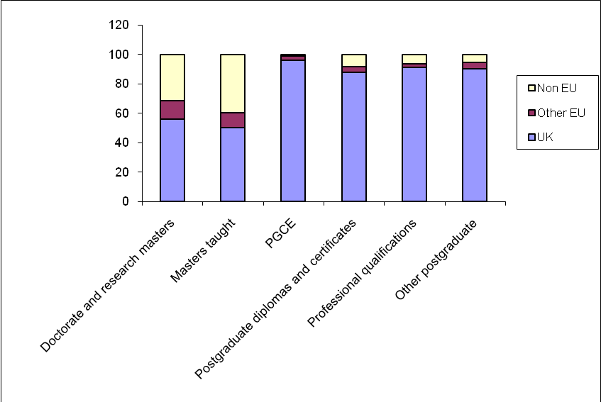
Source: Special data request from HESA commissioned by HEPI

- In every instance, part-time students are more likely to be UK domiciled, although there is a greater proportion of part-time international students studying for doctorates than other qualification types.

Table 7: Qualification type, mode of study and domicile (first year postgraduates 2007-8)
 |  | Total | % UK | % Other EU | % Non-EU
Doctorate or research masters | FT | 22,438 | 49 | 14 | 37
Doctorate or research masters | PT | 6,244 | 77 | 10 | 13
Taught masters | FT | 104,037 | 33 | 13 | 54
Taught masters | PT | 51,037 | 85 | 5 | 10
PGCE | FT | 22,973 | 95 | 3 | 1
PGCE | PT | 3,129 | 98 | 1 | 1
PG diplomas and certificates | FT | 7,893 | 74 | 6 | 20
PG diplomas and certificates | PT | 28,937 | 92 | 3 | 5
Professional qualifications | FT | 1,499 | 88 | 3 | 9
Professional qualifications | PT | 4,659 | 92 | 2 | 6
Other postgraduate | FT | 1,843 | 59 | 17 | 24
Other postgraduate | PT | 22,763 | 93 | 3 | 4
Total |  | 278,272 | 64 | 8 | 27

Qualifications on entry
- Students who go directly from undergraduate to postgraduate research degrees (e.g. doctorates) are much more likely to have attained first class degrees than other entrants. Such students are less likely to go on to study for a postgraduate diploma, certificate or professional qualification. The reverse is true for students who attained a lower second or third class degree at undergraduate level – they are far more likely to go on to study for diplomas or certificates and extremely unlikely to go directly into a research postgraduate course. Progression directly from first degree to a research postgraduate degree generally only happens in STEM subjects and is becoming increasingly rare as a masters degree is now often considered a necessary interim step. In 2002-3 2 per cent of undergraduate qualifiers went straight to doctoral level study within six months of qualifying: in 2007-8 the figure was 1.8 per cent.

Figure 4: Percentage of first degree graduates giving first destination as postgraduate study by first degree result
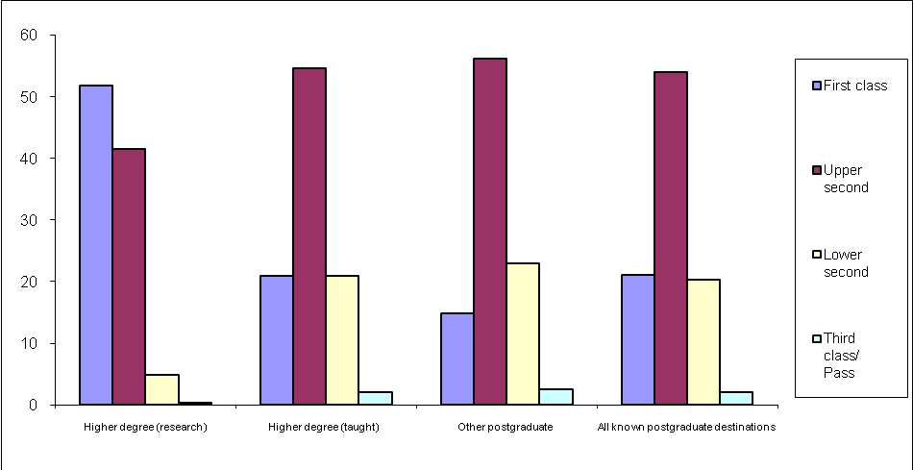
Source: HESA Destination of Leavers from Higher Education 2007-8

Gender
- 55 per cent of first year postgraduates in 2007-8 were female, compared to 59 per cent at undergraduate level. However, looking only at UK domiciled students, women represented 60 per cent of the postgraduate cohort, compared to 53 per cent amongst other EU students and 44 per cent amongst international students. The gender gap is particularly marked amongst those studying for PGCE, indicating that teaching remains a more popular career choice for women than men. The only type of postgraduate qualification where men outnumber women is full-time doctoral and research masters degrees.

Table 8: Percentages of males and females amongst UK domiciled postgraduates 2007-8
 | Female | Male
Doctorate or research masters | 48 | 52
Taught doctorates | 75 | 25
Taught masters | 55 | 45
PGCE | 70 | 30
PG diplomas and certificates | 64 | 36
Professional qualifications | 65 | 35
Other postgraduate | 71 | 29
All full time | 57 | 43
All part time | 62 | 37
Aged under 31 | 61 | 39
Aged 31 and over | 60 | 40
Total postgraduate | 60 | 40
Source: HESA Student Record (re-analysis of data commissioned by HEPI from HESA)

- A recent report by HEPI into male and female participation in higher education highlighted the dangers of letting this kind of increasing gender differential go unchecked. The imbalance has its roots in secondary school education and has implications beyond higher education as students enter the job market, where males are finding it harder to get work and remain unemployed longer than females after graduating (although once in work men do tend to command higher salaries). The only qualification type where this unemployment pattern does not hold true is in ‘other’ postgraduate and undergraduate qualifications, which are more likely to include those, such as Open University students, studying for non-career related reasons.

Table 9: Number of UK domiciled postgraduates assumed to be unemployed six months after graduating
 |  | Female | Male | Total
Doctorate | FT | 55 | 75 | 130
Doctorate | PT | 10 | 10 | 25
Other higher degree | FT | 415 | 575 | 995
Other higher degree | PT | 160 | 170 | 330
Other postgraduate | FT | 320 | 180 | 500
Other postgraduate | PT | 90 | 50 | 140
First degree | FT | 7,545 | 8,690 | 16,235
First degree | PT | 575 | 550 | 1,125
Other undergraduate | FT | 605 | 625 | 1,230
Other undergraduate | PT | 200 | 190 | 390
Source: HESA Destination of Leavers from Higher Education 2007-8

Age
- The earliest age for starting postgraduate education is usually 21, after leaving school aged 18 and spending three years as an undergraduate – there are very few exceptions to this. The predominance of full-time postgraduate starters aged 21-24 indicates that it is still common to progress fairly fast from school to undergraduate to postgraduate degree, perhaps with one year out of education before or after the a first degree. The age profile of part-time postgraduates is more evenly distributed with a far greater proportion of participants aged over 30.

Figure 5: Age band of all first year postgraduates 2007-8
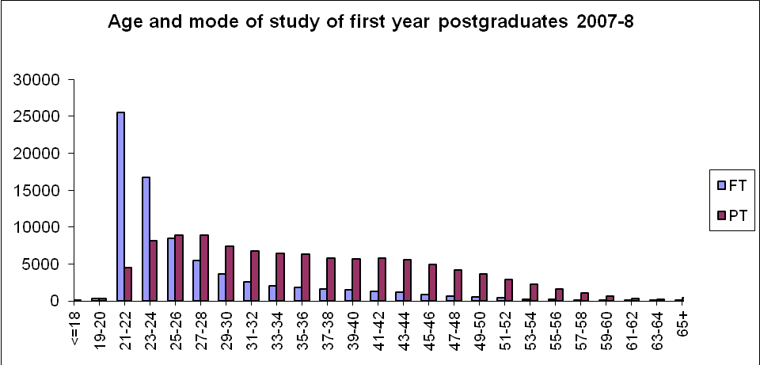
Source: Special data request from HESA commissioned by HEPI

Table 10: Median age amongst full- and part-time first year postgraduates 2007-8
 | FT | PT
Doctorate or research masters | 26 | 37
Taught masters | 24 | 33
PGCE | 24 | 35
PG diplomas & certificates | 24 | 35
Professional qualifications | 23 | 33
Other postgraduate | 26 | 34
Source: Reanalysis of special data request from HESA commissioned by HEPI

- There is little difference in the age profiles of men and women undertaking postgraduate study, although in most cases a slightly larger proportion of men are likely to be over the age of 30. One notable exception is in PGCE, where men studying full-time are significantly more likely to be over 30 than women, suggesting that teaching more often represents a career shift for men than for women.

Table 11: Percentage of UK domiciled first year postgraduates aged 31 or over by gender and mode of study, 2007-8
 |  | % Female | %  Male | Total aged over 30
Doctorate or research masters | FT | 22 | 21 | 21
Doctorate or research masters | PT | 71 | 73 | 72
Taught masters | FT | 18 | 21 | 19
Taught masters | PT | 60 | 63 | 61
PGCE | FT | 19 | 27 | 21
PGCE | PT | 64 | 65 | 64
PG diplomas and certificates | FT | 23 | 22 | 23
PG diplomas and certificates | PT | 63 | 69 | 66
Other postgraduate | FT | 29 | 34 | 31
Other postgraduate | PT | 58 | 63 | 59
All qualifications |  | 44 | 46 | 45

Ethnicity
- 2007 estimates from the Office of National Statistics suggest that 12 per cent of the population of England are of non-white ethnicity, but amongst those of a typical age to undertake postgraduate study (20 – 34 yrs), the ethnic minority population is a little over 18 per cent. HESA’s data on ethnicity suggest that amongst UK domiciled postgraduates, 14.6 per cent are from ethnic minorities, but there are a substantial portion (7.7 per cent) of ‘unknowns’ where people declined to answer ethnicity questions. Given these unknown quantities, it is hard to say for sure whether UK ethnic minorities are better or worse represented in postgraduate education than in the general population. However, it is possible to see that amongst specific ethnic groups, ‘black African’, ‘other Asian’ and ‘other (including mixed)’ are particularly well represented, with the proportion studying for postgraduate education in excess of that in the general population. This does not mean that those populations who appear to be under-represented really are: their numbers may be made up from amongst the substantial proportion of ‘unknowns’.

Table 12: Percentage of first year postgraduates by ethnicity, against the general population of England
 | Population of England aged  20 - 34 | Total  post-graduate | Higher degree (research) | Higher degree (taught) | Other  post-graduate
White | 81.8 | 77.8 | 79.6 | 75.6 | 79.9
Total of ethnic minorities | 18.2 | 14.6 | 12.7 | 17.0 | 12.0
Ethnicity not known |  | 7.7 | 7.7 | 7.4 | 8.1
Black or Black British – Caribbean | 1.2 | 1.1 | 0.5 | 1.3 | 1.1
Black or Black British – African | 2.3 | 2.9 | 1.6 | 4.0 | 2.0
Other Black background | 0.3 | 0.3 | 0.2 | 0.4 | 0.2
Asian or Asian British – Indian | 4.1 | 3.1 | 2.4 | 3.4 | 3.0
Asian or Asian British – Pakistani | 2.8 | 1.5 | 1.0 | 1.6 | 1.6
Asian or Asian British - Bangladeshi | 1.1 | 0.4 | 0.3 | 0.5 | 0.4
Chinese | 3.2 | 1.1 | 1.5 | 1.3 | 0.6
Other Asian background | 1.1 | 1.3 | 1.7 | 1.5 | 0.8
Other (including mixed) | 2.1 | 2.8 | 3.5 | 3.0 | 2.2
Source: HESA ‘Students in Higher Education 2007-8’ and Office of National Statistics Ethnicity Estimate mid-2007

- While the majority of postgraduates across all groups are most likely to be studying for a taught postgraduate degree, there are a greater proportion of Chinese, ‘other Asian’ and ‘other (including mixed)’ students undertaking a postgraduate research degree. This is interesting since despite a relatively small proportion of British Chinese participating in higher education (as seen in table 12) those who do participate do so to a very high level.

Figure 6: Qualification aim by ethnic group amongst UK domiciled students 2007-8
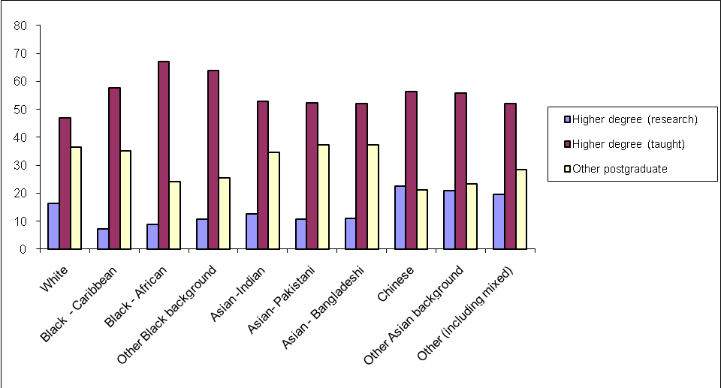

Social and economic class
- HESA have been collecting data on socio-economic class (SEC) from students at postgraduate level since 2002/3. However, before examining these data, there are some considerations that should be taken into account. Firstly, those of known SEC total only around 10 per cent of the cohort. Secondly, SEC is recorded as that of the parent if the student is under 21 but refers to the previous occupation of the student if he or she is over 21. Considering the vast majority of postgraduates are over 21, it is safe to assume these figures give the student’s own background rather than that of their family. Those who have been in work before undertaking a postgraduate qualification may well have already improved their situation as a result of their undergraduate qualification, so a significant proportion of those from a lower SEC family background will be hidden. This means these data will be skewed to suggest that more postgraduates come from a higher SEC than might be the case if we were able to examine that of their families. Furthermore, those whose previous occupation was ‘student’ and over 21 will have been listed as ‘not classified’ in HESA’s data, which eliminates any student who has come straight from undergraduate to postgraduate study unless they are under 21.
- Participation in postgraduate study, especially research degrees, does appear to be heavily skewed towards those from higher socio-economic backgrounds. Those undertaking a PGCE are more likely to come from a diverse range of backgrounds, suggesting that teaching is a more common route into the professions for those from lower socio-economic backgrounds.

Table 13: Percentage of UK domiciled first year postgraduates according to socio-economic class 2007-8
 | Higher managerial & professional | Lower managerial & professional | Intermediate occupations | Small employers & own account workers | Lower supervisory & technical occupations | Semi-routine occupations | Routine occupations | Never worked & long-term unemployed
Research masters | 35 | 31 | 14 | 5 | 4 | 6 | 4 | 1
Taught masters | 24 | 38 | 15 | 5 | 4 | 9 | 3 | 2
Diplomas & certificates | 28 | 38 | 19 | 3 | 2 | 6 | 3 | 1
PGCE | 18 | 30 | 19 | 8 | 5 | 12 | 5 | 4
Professional qualifications | 32 | 31 | 8 | 14 | 5 | 6 | 3 | 1
Other postgraduate | 17 | 44 | 15 | 5 | 4 | 11 | 4 | 1
Total | 24 | 37 | 16 | 6 | 4 | 9 | 4 | 2

- A Higher Education Academy report found that socio-economic class did not appear to have a direct effect on the intention of undergraduate students who took part in the survey to go on to postgraduate study. However, it did find that undergraduates who were the first in their family to enter higher education were less likely to proceed to postgraduate study, and that a greater proportion of such students do come from lower socio-economic backgrounds. A study by the National Postgraduate Committee found that although cost was a much more significant consideration amongst students from lower socio-economic backgrounds, this did not in itself appear to deter people from undertaking a postgraduate degree, but such students were more likely to study part-time.
- The question of socio-economic participation in postgraduate education is important, but difficult to address given the current data. The 2009 report from the Panel on Fair Access to the Professions highlighted the need to ensure more people from disadvantaged backgrounds can enter the professions, but only examined participation up to undergraduate level. As we will see in Section 5, it is far more common to enter the professions with a postgraduate degree than a first degree.
- The HESA statistics do not give a clear picture of participation at postgraduate level as they mostly measure the previous occupation of the student rather than their family background and only deal with a limited proportion of the cohort. HESA also collect postcode data to identify students from deprived areas, but again by postgraduate level this information is fairly useless as students may well have moved away from their family home. HESA also have state school marker data, though attempts to analyse this for this report turned up no clear trends: probably because such figures are affected by outside factors, such as rising private school fees and the end of the Assisted Places Scheme, leading to increasing numbers of affluent middle class families sending their children to state schools.
- In recent years, HESA have been encouraging universities to assign unique student identifier numbers with the idea that these can be reused when a student returns to university to study further courses. Potentially, such a number could be used to trace the SEC of a postgraduate student back to when they were an undergraduate, giving a clearer idea of family background. In practice however, the system rarely works as it relies on the student knowing their ID number when applying for a course, or institutions chasing it up at the student’s previous university. If greater rigour was applied in using these numbers, it could potentially provide useful data for tracking participation patterns. Without clear data on the socio-economic history of postgraduate students, it will be difficult to implement and assess the success of measures to increase postgraduate participation and thus widen access to the top professional jobs.

Overseas provision
- One major area of expansion in higher education in the last few years has been the provision of UK qualifications to students studying wholly outside the UK (not including those who come to the UK for a year as part of a sandwich course). 111 out of 166 UK HEIs offer some form of offshore provision. In 2007-8 there were 196,750 students studying for UK institutional awards from abroad, of which 61,420 were postgraduates. Several methods of provision have developed, some of which involve students being registered as students of the UK HEI from outside the country, while others allow for students registered at a partner organisation overseas to study for UK qualifications. Arrangements for provision include universities setting up branch campuses abroad, distance learning packages modelled on the Open University, and collaborative (or ‘franchised’) provision where students are supported and/ or assessed through a partner organisation abroad.

Table 14: Number of institutions offering overseas provision for students studying wholly abroad by type of provision, 2007-8
 | Arrangement for provision | Number of HEIs
Students registered at a UK HEI | Overseas campus | 9
Students registered at a UK HEI | Distance, flexible or distributed learning | 60
Students registered at a UK HEI | Other arrangement including collaborative provision | 70
Students studying for an award of a UK HEI | Overseas partner organisation | 19
Students studying for an award of a UK HEI | Other arrangement including collaborative provision | 3
Total |  | 111
Source: Special data request from HESA commissioned by HEPI

- The profile of universities involved in overseas provision is very mixed, with a broad mix of Russell Group, 1994 Group and newer universities. It certainly seems to have provided an opening for newer universities to expand their reach. The following table shows the top ten institutions according to how many students (both undergraduate and postgraduate) they are providing for.
Table 15: Top ten universities providing overseas provision by type of provision, 2007-8
 | Students registered at a UK HEI |  |  | Students studying for an award of a UK HEI
 | Overseas campus of reporting HEI | Distance, flexible or distributed learning | Other (including collaborative  provision) | Overseas partner organisation | Other arrangement
1 | Nottingham | Open University | Middlesex | Wales | East Anglia
2 | Heriot-Watt | Leicester | Derby | Bradford | Imperial
3 | Cranfield | Heriot-Watt | Staffordshire | Sunderland | Westminster
4 | Kent | Strathclyde | Northumbria | Liverpool JM | n/a
5 | UC Birmingham | Manchester | UCLAN | Anglia Ruskin | n/a
6 | London Business School | Portsmouth | London Met | Teesside | n/a
7 | Chichester | Robert Gordon | Greenwich | Liverpool | n/a
8 | Swansea Metropolitan | Hull | Hertfordshire | Lancaster | n/a
9 | Westminster | Greenwich | East London | Ulster | n/a
10 | n/a | Warwick | Napier | Stirling | n/a

- The success of the UK higher education brand abroad enables many students to study for UK qualifications in a country where living costs are more affordable. This is leading to the development of transnational education ‘hubs’ in countries such as Malaysia which runs 800 transnational programmes, half of which are with British institutions. According to the Times Higher Education, China and India are also being courted heavily by UK HEIs as possible partners, with many universities considering the most investment-heavy approach of setting up branch campuses. It can be inferred that overseas provision will continue to grow in importance as universities seek to expand provision to international students based outside the UK.
Section 3: Trends in postgraduate study
The following section explores trends in postgraduate student numbers between 2002-3 and 2007-8, showing overall trends across all qualification types, then focusing on trends in taught masters and research degrees. It shows that while taught postgraduate numbers have increased, the numbers undertaking PGCEs, other certificates and diplomas and professional qualifications have all dropped. It finds that although doctoral student numbers have grown overall by 9 per cent during this period, the number of UK domiciled students has grown by only 3 per cent and in fact declined slightly in the last couple of years. It shows that the proportion of non-UK domiciled students has grown from 30 per cent to 36 per cent of the cohort, with taught masters being the biggest growth area. It notes that expanding numbers of first degree qualifiers with first class and upper second awards may present problems to universities trying to identify the best candidates for funding. It finds that there has been little noticeable change in the gender and age distribution of the age of full-time taught masters starters, although at research postgraduate level the age distribution of starters has tended to become slightly higher. It finds that participation by ethnic minorities has improved at taught masters level, but, due to limitations in the data, it is unclear the extent to which this has also happened at research postgraduate level.
- In 2002-3, HESA recorded 249,117 first year postgraduates studying in the UK (497,500 in all years). In 2007-8 this number had grown by 12 per cent to 278,272 (501,135 in all years). The biggest growth area has been the taught masters which has attracted over 32,000 additional students. Research doctorates appear to have grown by 30 per cent, but the number of students registering for a research masters has decreased by 24 per cent. As many of those registering on the latter intend to proceed to doctoral study, these figures are considered together, along with the small number of taught doctorates, showing an overall increase of 9 per cent. Numbers undertaking postgraduate diplomas, certificates, professional qualifications and PGCEs have all dropped off sharply – over 14,000 fewer students undertook such courses in 2007-8 than 2002-3.
Table 16: Summary of trends in postgraduate research degree starters
 | 2002-3 | 2007-8 | Absolute increase | Percentage increase
Doctorate by research | 16,112 | 20,886 | 4,754 | 30
Masters by research | 10,237 | 7,816 | -2,421 | -24
Doctorate taught | 607 | 820 | 213 | 35
Total | 26,956 | 29,502 | 2,546 | 9

Table 17: Trends in first year postgraduates in UK HEIs from 2002-3 to 2007-8
 | 2002-3 | 2007-8 | Absolute increase | Percentage increase
Doctorate or research masters | 26,956 | 29,502 | 2,546 | 9
Taught masters | 122,402 | 155,074 | 32,672 | 27
PGCE | 29,851 | 26,102 | -3,749 | -13
Postgraduate diplomas and certificates | 43,892 | 36,830 | -7,062 | -16
Professional qualifications | 10,095 | 6,158 | -3,937 | -39
Other postgraduate | 15,921 | 24,606 | 8,685 | 55
Total | 249,117 | 278,272 | 29,155 | 12
Source: Special data request from HESA commissioned by HEPI

- The number of students undertaking a PGCE rose to a peak in 2005-6, and then decreased in the last two years. The number of PGCE students is very much dependent upon government funding, which is determined by the projected need for teachers in a given subject area. If there are not enough teachers in a certain subject, the Training and Development Agency for Schools will provide a more generous funding package for PGCEs until the deficit is made up. The last few years saw just such a push, with generous funding and ‘golden hello’ incentives across subject areas, which has now declined in most subjects, though not science and maths.
Figure 7: Trends in first year postgraduates in UK HEIs from 2002-3 to 2007-8
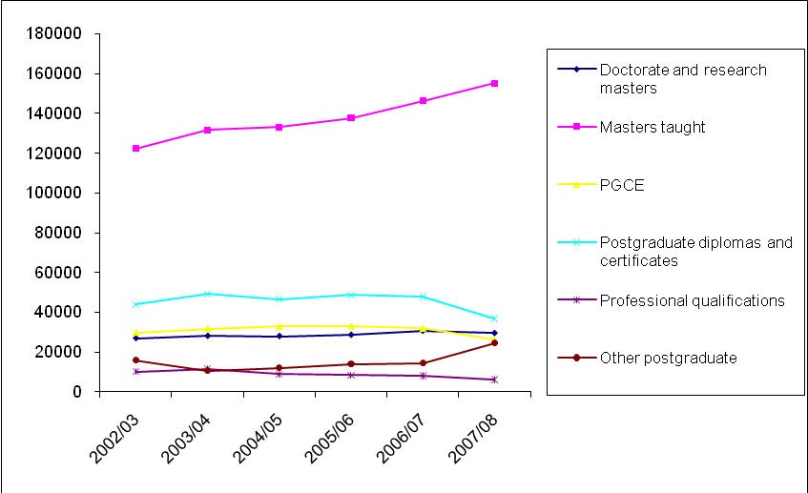
Source: Special data request from HESA commissioned by HEPI

- The steady growth in the postgraduate sector has been driven by increasing numbers of students from outside the EU as HEIs have recruited increasing numbers of international students. The story for UK domiciled postgraduates is less positive: although numbers have increased 3 per cent overall since 2002-3, they have declined in recent years, dropping by 3 per cent since a peak in 2005-6.

Table 18: Trends in number of first year postgraduates at UK HEIs
 | UK | Other EU | Non EU | Total | % UK | % overseas
2002-3 | 173,722 | 20,758 | 54,637 | 249,117 | 70 | 30
2003-4 | 181,006 | 20,193 | 61,757 | 262,956 | 69 | 31
2004-5 | 175,164 | 22,838 | 63,463 | 261,465 | 67 | 33
2005-6 | 184,086 | 22,936 | 63,382 | 270,404 | 68 | 32
2006-7 | 183,319 | 23,533 | 72,316 | 279,168 | 66 | 34
2007-8 | 179,321 | 23,018 | 75,933 | 278,272 | 64 | 36
% increase  2002-3 to 2007-8 | 3 | 11 | 39 | 12
Source: Special data request from HESA commissioned by HEPI

- This decline in UK postgraduate numbers has been centred on certificates and diplomas, PGCEs and professional qualifications which are studied almost exclusively by UK domiciled students. There has been steady growth in the number of UK domiciled students starting masters courses, although the number starting out on research degrees has increased only minimally. It is not immediately clear why interest in diplomas, certificates and professional qualifications has declined. It is possible that some students who might once have taken these courses are opting for masters degrees instead, but there is no particular evidence as to whether this is happening.

Figure 8: Change in numbers of first year postgraduates by domicile between 2002-3 and 2007-8
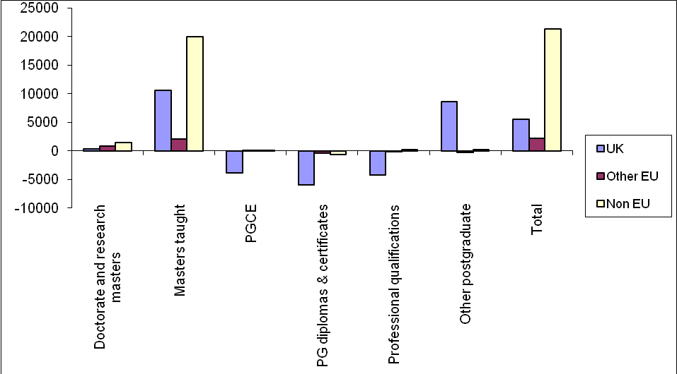
Source: Special data request from HESA commissioned by HEPI

Subject of study – STEM subjects
- Overall, the number of UK domiciled postgraduates undertaking STEM subjects has increased since 2002-3, but international student numbers have increased at a greater rate: in 2006-7, 41 per cent of STEM students were from outside the UK. Whilst medical and biosciences have seen a steady increase in students of all domicile, in computer science and engineering & technology the number of UK domiciled graduates has declined. Growth in numbers of UK domiciled mathematics and physical science students have also been small.

Table 19: Change in FTE postgraduate students studying STEM subjects at UK HEIs between 2002-3 and 2007-8 by domicile
 |  | 2002-3 | 2006-7 | % change 2002-3 to 2006-7
Medicine & dentistry | UK | 7,678 | 9,418 | 23
Medicine & dentistry | Non-UK | 2,768 | 4,128 | 49
Subjects allied to medicine | UK | 17,403 | 23,148 | 33
Subjects allied to medicine | Non-UK | 3,510 | 5,705 | 63
Biological sciences | UK | 14,290 | 16,540 | 16
Biological sciences | Non-UK | 4,740 | 6,925 | 46
Veterinary science | UK | 375 | 573 | 53
Veterinary science | Non-UK | 145 | 223 | 53
Agriculture | UK | 1,615 | 1,120 | -31
Agriculture | Non-UK | 1,208 | 1,048 | -13
Physical sciences | UK | 10,455 | 10,938 | 5
Physical sciences | Non-UK | 4,733 | 6,348 | 34
Mathematics | UK | 2,375 | 2,523 | 6
Mathematics | Non-UK | 1,843 | 2,343 | 27
Computer science | UK | 10,245 | 6,973 | -32
Computer science | Non-UK | 9,140 | 11,108 | 22
Engineering & technology | UK | 12,420 | 12,063 | -3
Engineering & technology | Non-UK | 15,880 | 19,815 | 25
Total STEM students | UK | 76,855 | 83,293 | 8
Total STEM students | Non-UK | 43,965 | 57,640 | 31
Amongst all STEM students | % UK | 64 | 59
Amongst all STEM students | % Non-UK | 36 | 41
Source: HESA Students in Higher Education 2002-3 to 2007-8

Taught masters trends
- The main driver of growth in the UK postgraduate sector has been the taught masters degree, with student numbers increasing by 27 per cent over five years. Masters students represent 56 per cent of 2007-8 first year postgraduates.

Domicile
- The greatest rate of increase has been amongst non-EU domiciled students. Part-time study for a masters degree remains overwhelmingly the domain of UK students, of whom over half study in this manner.

Table 20: Trends in taught first year taught masters students 2002-3 to 2007-8
 | 2002-3 | 2007-8 | Percentage increase
UK full-time | 29,712 | 34,238 | 15
UK part-time | 37,359 | 43,467 | 16
All UK | 67,071 | 77,705 | 16
EU full-time | 11,772 | 13,232 | 12
EU part-time | 2,049 | 2,690 | 31
All EU | 13,821 | 15,922 | 15
Non-EU full-time | 38,539 | 56,567 | 47
Non-EU part-time | 2,971 | 4,880 | 64
All non-EU | 41,510 | 61,447 | 48
Total | 122,402 | 155,074 | 27
Source: Special data request from HESA commissioned by HEPI

- The UK is second only to the USA in terms of the number of international students it attracts, with 11.6 per cent of the international student market (the USA has 19.7 per cent). This is widely attributed to courses being in English, the relatively short one year masters (as opposed to two years common elsewhere) and the international reputation of the UK for excellence in higher education and research. The fact that international student fees are very high in the UK does not seem to deter students – they may in fact be perceived to confirm the high quality of education offered (the only place with higher fees is the USA, which attracts even more international students). Lower living costs due to the shorter UK masters do, to some extent, mitigate these premium course rates. Issues which may potentially affect future demand from international students are dealt with in later sections.

Qualification on entry
- In recent years, there has been noticeable shift in grade award patterns at undergraduate level, with an increasingly large proportion of students being awarded first class and upper second class degrees. These students represent the pool from which future postgraduate students generally come, so this may have an impact on the postgraduate sector. For example, it may lead more first degree graduates to opt for postgraduate study to differentiate themselves from their peers, as the perceived value of an upper second class degree decreases in the eyes of potential employers. From a university and research council perspective, it may make it harder to identify the best students to offer postgraduate places and funding to.

Figure 9: First degree awards amongst UK domiciled students
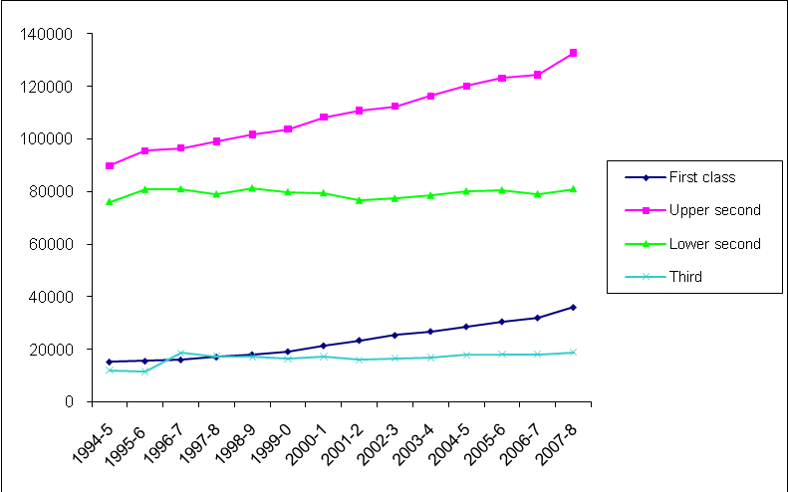
Source: HESA Students and Qualifiers Data Tables, Qualification obtained

Gender
- The balance of males and females undertaking taught masters has remained more or less unchanged over the last five years, with women consistently outnumbering men, especially amongst UK domiciled students.

Table 21: Gender trends amongst first year taught masters students
 | All domicile |  | UK domicile
 | % Female | % Male | % Female | % Male
2002-3 | 50 | 50 | 53 | 47
2003-4 | 51 | 49 | 55 | 45
2004-5 | 51 | 49 | 55 | 45
2005-6 | 51 | 49 | 55 | 45
2006-7 | 51 | 49 | 55 | 45
2007-8 | 50 | 50 | 55 | 45
Source: Special data request from HESA commissioned by HEPI

Age
- The median age of full-time taught masters starters has remained fairly steady the past few years at 23-24 years old. This in itself is an interesting result as there has been some debate on the potential effect of increasing undergraduate fees on student choices, for example whether UK domiciled students might be more likely to defer postgraduate study in order to work off some of their undergraduate student loan. The current data does not indicate any such shift has happened.

Table 22: Trends in median age of first year taught masters students
 | Full-time |  |  | Part-time
 | UK | Other EU | Non EU | UK | Other EU | Non EU
2002-3 | 24 | 24 | 25 | 34 | 30 | 32
2003-4 | 23 | 24 | 25 | 35 | 30 | 32
2004-5 | 23 | 24 | 24 | 34 | 30 | 31
2005-6 | 24 | 24 | 24 | 34 | 30 | 32
2006-7 | 24 | 24 | 24 | 34 | 30 | 30
2007-8 | 23 | 24 | 24 | 34 | 30 | 29
Source: Reanalysis of special data request by HEPI from HESA
- Focusing on trends amongst full-time UK domiciled students, who are most likely to be affected by debt issues, the distribution curve of ages in 2002-3 is almost exactly the same as in 2007-8, confirming that there has been little change in the age at which students undertake taught masters study.

Figure 10: Age of UK domiciled full-time taught masters students in 2002-3 and 2007-8 as a percentage of the cohort
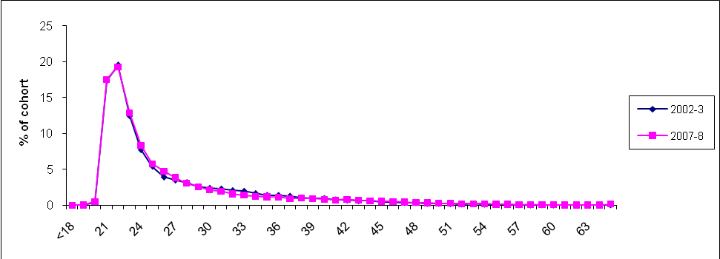Source: Special data request from HESA commissioned by HEPI

Ethnicity
- Participation amongst ethnic minorities has increased substantially in the last eight years – currently one in five UK domiciled taught postgraduate students is from an ethnic minority (but it should be noted that the large numbers of ‘not known’ in the table mean that care is needed in drawing firm conclusions). This could indicate the success of active efforts to widen participation by governments and universities, but may also be influenced by the time taken by immigrants who arrived in earlier decades to attain a level of financial stability whereby their children can consider higher education. Also, it should be noted that numbers of students whose ethnicity was not known or not sought declined over the same period by 5,080 students, which may represent a significant proportion of the 6,690 increase in students from ethnic minorities.

Table 23: Relative proportions of UK domiciled PGTs by ethnicity
 | Total of  known  ethnicity | Not known | White | Total of  ethnic  minorities | % white | % ethnic minorities
2000-1 | 52,025 | 10,030 | 43,730 | 8,295 | 84 | 16
2001-2 | 54,415 | 10,090 | 45,210 | 9,210 | 83 | 17
2002-3 | 58,780 | 8,935 | 48,615 | 10,165 | 83 | 17
2003-4 | 61,680 | 9,575 | 51,400 | 10,280 | 83 | 17
2004-5 | 61,410 | 8,035 | 50,945 | 10,465 | 83 | 17
2005-6 | 67,085 | 6,910 | 54,980 | 12,105 | 82 | 18
2006-7 | 69,030 | 5,790 | 55,795 | 13,235 | 81 | 19
2007-8 | 73,465 | 4,950 | 58,475 | 14,985 | 80 | 20

Figure 11: Ethnicity trends amongst UK domiciled taught postgraduate students
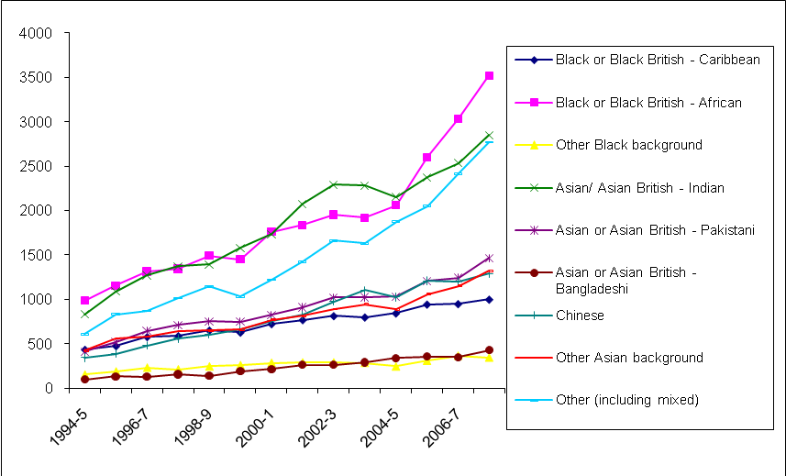
Source: HESA Students and Qualifiers Data Tables, Qualification obtained (online)

Subject of study
- Due to a change in the way HESA counted part-time students in their 2007-8 publication Students in Higher Education, the following data only compares trends in subject of study up to 2006-7.
- Business and administrative studies is the most popular subject area at taught postgraduate level, followed by social sciences. There has been growth across most subject areas with the exception of agriculture and computer science. The proportion of science, technology, engineering and mathematics (STEM) to non-STEM subjects has not changed significantly in the last five years. The slight proportional decrease probably has more to do with the increasing popularity of non-science postgraduate qualifications than a dwindling interest in sciences, as there is healthy growth amongst most STEM subjects. It will be interesting to see the long-term impact of current government policies designed to encourage science and technology enrolment amongst school leavers.

Table 24: Change in subject of study amongst FTE taught postgraduate students in all years between 2002-3 and 2007-8
 | 2002-3 | 2006-7 | % change
Medicine & dentistry | 3,015 | 4,275 | 42
Subjects allied to medicine | 10,300 | 13,865 | 35
Biological sciences | 7,910 | 10,760 | 36
Veterinary science | 55 | 155 | 190
Agriculture & related subjects | 1,485 | 1,335 | -10
Physical sciences | 4,525 | 5,755 | 27
Mathematical sciences | 1,520 | 2,215 | 46
Computer science | 14,470 | 12,735 | -12
Engineering & technology | 14,760 | 17,385 | 18
Architecture, building & planning | 4,745 | 6,520 | 37
Social studies | 17,105 | 22,275 | 30
Law | 8,645 | 9,445 | 9
Business & administrative studies | 49,025 | 59,855 | 22
Mass communications & documentation | 5,255 | 6,475 | 23
Languages | 6,565 | 7,705 | 17
Historical & philosophical studies | 5,545 | 6,845 | 23
Creative arts & design | 7,220 | 10,335 | 43
Education | 9,420 | 14,180 | 51
Combined | 180 | 215 | 19
% STEM | 34 | 32
% non-STEM | 66 | 68
Source: Students in Higher Education 2007-8

Research postgraduates trends

Domicile
- Overall, the number of students registering for a research degree has increased by 9 per cent over the last five years, with the biggest increase in numbers coming from international students. UK student numbers have increased at a lesser rate of 2 per cent, albeit from a much larger base.

Table 25: Change in first year postgraduate research student numbers by domicile and mode of study
 | 2002/03 | 2007/08 | Actual increase | % increase
UK full-time | 10,638 | 11,338 | 700 | 7
UK part-time | 5,468 | 5,092 | -376 | -7
All UK | 16,106 | 16,430 | 324 | 2
EU full-time | 2,447 | 3,131 | 684 | 28
EU part-time | 563 | 666 | 103 | 18
All EU | 3,010 | 3,797 | 787 | 26
Non-EU full-time | 6,675 | 8,443 | 1,768 | 26
Non-EU part-time | 1,165 | 832 | -333 | -29
All non-EU | 7,840 | 9,275 | 1,435 | 18
Total | 26,956 | 29,502 | 2,546 | 9
Source: Special data request from HEPI to HESA
- The UK attracts 15 per cent of the international market for research students and is considered a global leader in this area. International research students are a valuable resource – not, as with masters, because of the considerable income they provide from fees (in many cases even full overseas fees may not cover the true cost of provision of a research degree) – but because of their contribution to the UK’s research output, knowledge base, innovation and economic advancement. However, it cannot be assumed that this situation will continue. Later sections will look at potential vulnerabilities which could affect the UK’s market share of international students.
- There has been only a small increase (2 per cent) in the number of UK students starting out on doctoral degrees since 2002-3 and the number has, in fact, declined in the last year. This is despite growing numbers of first degree graduates with first class degrees and masters students, from which pool the doctoral cohort is generally drawn.

Figure 12: Trends in first year postgraduate research student numbers by domicile and mode of study
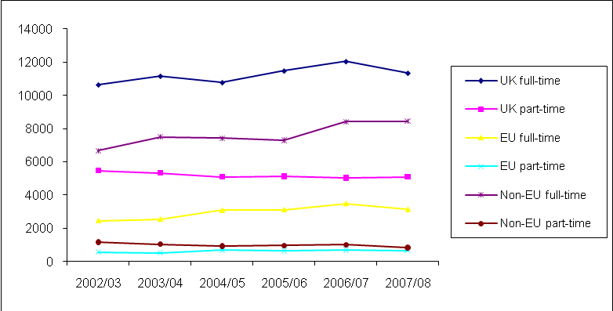
Source: Special data request from HEPI to HESA
- Although from a university finance point of view the decline in UK doctorates is mitigated by increasing numbers of international students, it will be important to gain understanding of why doctoral study does not seem to be attractive to eligible UK students. Among the possible reasons are: increasing debt encouraging potential doctoral students to defer further study and seek employment in industry; a lack of knowledge amongst students and employers about the benefits of a research degree; the perception (particularly in non-science subjects) that a PhD leads only to an academic career which may itself not be appealing. Whatever the causes, it seems that action is needed to encourage doctoral study, for example making employers more aware of the value in skills training a doctorate provides and by considering incentives to make a career in academia and research a more attractive prospect.

Gender
- Research degrees are the one area of postgraduate education where men outnumber women, though only just. This may be due to the dominance of STEM subjects at doctoral level (see Table 4), where males do still tend to outnumber females. Amongst the entire cohort, the number of females is slowly catching up with that of males, though amongst UK domiciled students the balance has been stable for the last four years, and more or less exactly matches the gender balance in the population as a whole (where males outnumber females in the young population by about 51:49).

Table 26: Trends in gender amongst first year research postgraduates
 | All domicile |  | UK domicile
 | % Female | % Male | % Female | % Male
2002-3 | 43 | 57 | 45 | 55
2003-4 | 44 | 56 | 47 | 53
2004-5 | 45 | 55 | 48 | 52
2005-6 | 45 | 55 | 48 | 52
2006-7 | 45 | 55 | 48 | 52
2007-8 | 46 | 54 | 48 | 52

Age
- There has been little change in the median age of first year full-time postgraduate researchers, although that of part-time UK and other EU students has risen during this period. The fact that amongst other EU starters median age is a year greater than in the UK is probably due to the two year masters-level courses common elsewhere.

Table 27: Median age of first year postgraduate research students (doctorate and masters by research)
 | Full-time |  |  |  | Part-time |  |  |  | Total
 | UK | Other EU | Non-EU | All | UK | Other EU | Non-EU | All | Total
2002-3 | 23 | 25 | 27 | 25 | 36 | 29 | 35 | 36 | 27
2003-4 | 24 | 25 | 27 | 25 | 37 | 31 | 35 | 36 | 26
2004-5 | 24 | 25 | 27 | 25 | 37 | 31 | 35 | 36 | 26
2005-6 | 24 | 25 | 26 | 25 | 38 | 32 | 35 | 37 | 27
2006-7 | 24 | 25 | 27 | 25 | 37 | 32 | 35 | 36 | 27
2007-8 | 24 | 25 | 27 | 26 | 38 | 33 | 35 | 37 | 27
Source: Reanalysis of special data request from HEPI to HESA
- Although the median age of full-time UK domiciled research students has remained largely unchanged, the distribution curve of ages shows that more are in fact starting doctoral study at a slightly later age. This could be evidence of an increasing need to work and pay off debts before undertaking doctoral study, or could simply reflect a cultural shift where students are more likely to take years off studying before starting a PhD.

Figure 13: Age distribution of UK domiciled full-time postgraduate research students in 2002-3 and 2007-8 as a percentage of the cohort.
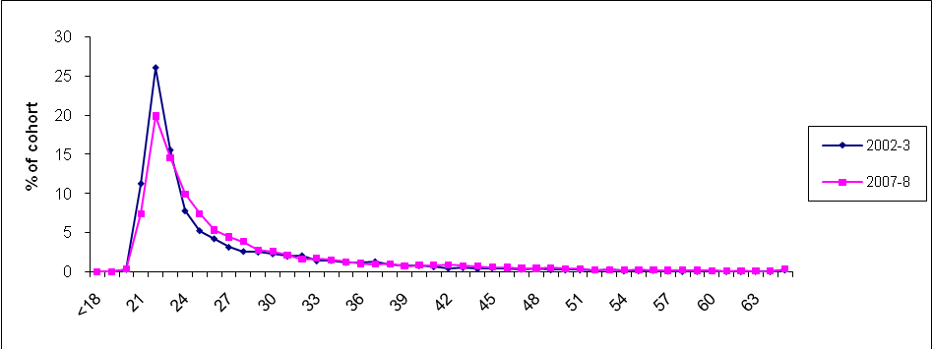
Source: Special data request from HESA commissioned by HEPI

Ethnicity
- Participation in research degrees amongst UK domiciled ethnic minorities is not as strong as in taught masters degrees, but still appears to represent an increasing proportion of the cohort. However, it is hard to say for sure, as the number of unknown ethnicity has declined by 2585 whilst the number known to be of ethnic minority origin has increased by only 825 students.

Table 28: Relative proportions of UK domiciled PGRs by ethnicity
 | Total of known ethnicity | Total not known | Total of  ethnic  minorities | White | % ethnic minorities | % white
2000-1 | 12,475 | 3,615 | 1,355 | 11,120 | 10.86 | 89.14
2001-2 | 12,345 | 3,365 | 1,415 | 10,930 | 11.46 | 88.54
2002-3 | 12,915 | 2,700 | 1,570 | 11,345 | 12.16 | 87.84
2003-4 | 13,375 | 2,640 | 1,695 | 11,680 | 12.67 | 87.33
2004-5 | 13,310 | 2,015 | 1,730 | 11,580 | 13.00 | 87.00
2005-6 | 13,855 | 2,095 | 1,930 | 11,925 | 13.93 | 86.07
2006-7 | 15,130 | 1,375 | 2,155 | 12,975 | 14.24 | 85.76
2007-8 | 14,635 | 1,030 | 2,180 | 12,455 | 14.90 | 85.10

Figure 14: Trends in participation amongst UK domiciled ethnic minorities
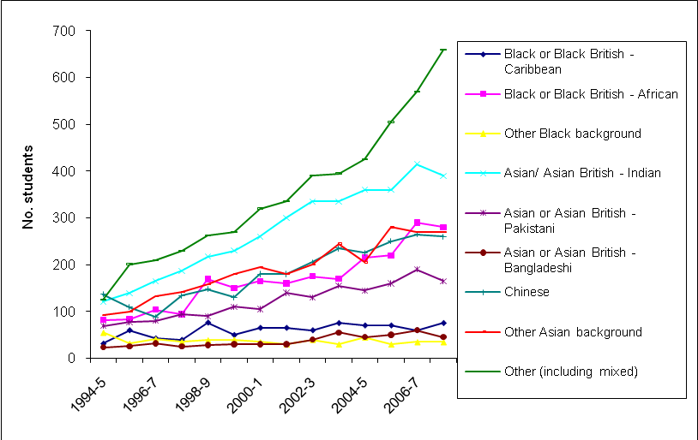

Subject of study
- As before, trends are only comparable up to 2006-7 due to changes in HESA measurements. At research postgraduate level, science subjects dominate, especially engineering and technology, biosciences and physical sciences, whilst social sciences top the non-STEM subjects. Amongst subjects with more than 1000 assumed FTE students in at least one year, growth has been particularly strong in mathematics, computer science and medicine and dentistry. Agriculture and related subjects have declined steadily over this period, although there is a possibility that certain research that once belonged in this categorization has now moved to bio-sciences. This continuing strong showing for STEM subjects very likely reflects the balance of Research Council and other support available.

Table 29: Change in subject of study amongst FTE research postgraduates in UK HEIs between 2002-3 and 2007-8
 | 2002-3 | 2006-7 | % change
Medicine & dentistry | 6,200 | 7,385 | 19
Subjects allied to medicine | 4,495 | 4,930 | 10
Biological sciences | 10,110 | 11,500 | 14
Veterinary science | 365 | 450 | 23
Agriculture & related subjects | 1,110 | 635 | -43
Physical sciences | 10,210 | 10,935 | 7
Mathematical sciences | 2,070 | 2,500 | 21
Computer science | 3,440 | 4,345 | 26
Engineering & technology | 11,495 | 12,425 | 8
Architecture, building & planning | 1,380 | 1,505 | 9
Social studies | 7,355 | 8,540 | 16
Law | 1,855 | 1,795 | -3
Business & administrative studies | 3,800 | 4,340 | 14
Mass communications & documentation | 590 | 755 | 29
Languages | 5,205 | 5,650 | 9
Historical & philosophical studies | 5,835 | 6,380 | 9
Creative arts & design | 2,505 | 2,595 | 3
Education | 3,880 | 4,125 | 6
Combined | 50 | 370 | 635
Total - All subject areas | 81,940 | 91,140 | 11
% STEM | 60 | 60
% non-STEM | 40 | 40

- Although overall trends in subject of study paint a positive picture of the UK science research base, many of the students involved, especially in STEM subjects are from overseas and not all will remain in the UK to work, representing a potential skills loss from the UK research base. A recent Research Councils UK (RCUK) report into the health of academic disciplines indicated the increasing internationalisation of higher education, with chemistry, computer science and engineering and technology all having over 25 per cent of their staff from overseas.
- The RCUK report highlighted areas of concern in filling academic posts in physics, chemistry, clinical medicine, law, health, business and management, economics, accounting and computing/ IT. In industry there are concerns over finding skilled researchers within the pharmaceutical industry, chemical industry, physical and environmental sciences. Within social sciences, there is an unmet demand for researchers with strong quantitative skills.
- To meet these needs, the research councils will channel funds into areas of strategic importance where recruitment is difficult, in order to ensure sufficient future researchers are being trained.

Section 4: Institutional differences and regional disparities
This section explores differences between institutions and regions of the UK. It shows that postgraduate researchers are concentrated in a small number of institutions, topped by Russell Group universities, whilst newer universities are successfully competing for a share of taught postgraduates who are much more evenly dispersed across the sector. It finds that older universities with an established reputation are the most successful at attracting international students, regardless of their higher fees. It discovers that many first degree graduates from 1994 Group and new universities go straight on to taught postgraduate study, but Russell Group institutions, followed by 1994 Group, see more progressing directly to research degrees. It explores how students who graduated from institutions in Scotland and Northern Ireland are most likely to stay in the region to work and that those from Northern and Midland regions of England are most likely to leave, and that London and the South East, East and South West regions all tend to see net increases in the number of postgraduate qualifiers coming to work there.

Institutional differences
- In comparing institutions, a number of definitions are used. The most simplistic split is between ‘old’ and ‘new’ universities. Institutional differences can also be explored according to institutional mission group affiliation: Russell Group, 1994 Group, University Alliance, Million Plus and Guild HE. Although this provides a greater level of detail, it excludes institutions with no affiliation (56 institutions at last count), and so should not be thought of as providing a comprehensive picture of the HE environment.
- Generally speaking postgraduate research students tend to be highly concentrated in a few institutions, whilst taught postgraduate students are more evenly distributed. The following graph ranks institutions according to the number of postgraduate research and taught students, those with the highest slice of the market share on the right. A steep curve indicates a large number of students concentrated in a few universities.
Figure 15: Percentage UK share of research and taught postgraduates completing courses in UK HEIs, 2007-8
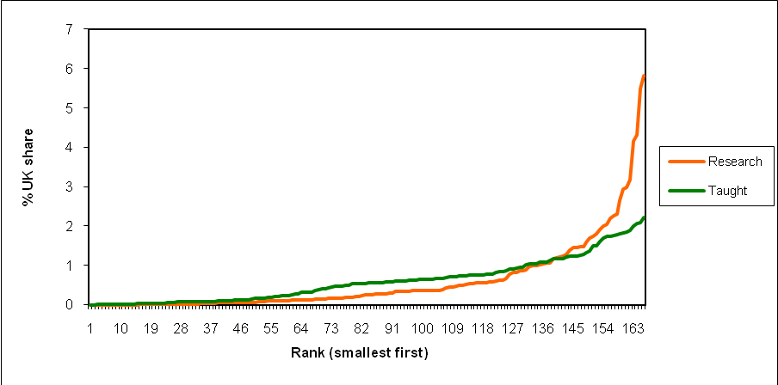
Source: HESA Students in Higher Education 2007-8 and 2001-2

- The high concentration of research students in a small number of institutions is, by and large, a result of HEFCE’s funding method, where the quality of institutions’ research output is assessed every few years through the Research Assessment Exercise (RAE) and institutions which are performing well are rewarded with more funding in future years. This makes it difficult for newer universities to compete, especially in the sciences where establishing laboratories for world-class research would be beyond their budget. Unsurprisingly, Russell Group universities, which are the oldest and tend to have the best-developed facilities, top the list of institutions with the most postgraduate researchers. However, the latest RAE identified ‘pockets of excellence’ particularly in non-science subjects in many of the newer universities, which may consequently increase postgraduate numbers in future years. The gap between Cambridge and the other universities has become less marked since 2000/1 narrowing from 44 per cent more postgraduate researchers than the next institution (Oxford) to 11 per cent.

Table 30: Ten institutions with the most postgraduate research students
2000-1 |  |  |  | 2007-8
 | No. students | Assumed FTE | % UK share |  | No. students | Assumed FTE | % UK share
Cambridge | 6,020 | 4,900 | 6.13 | Cambridge | 4,905 | 4,628 | 5.81
Oxford | 4,230 | 3,648 | 4.56 | Oxford | 4,405 | 4,370 | 5.49
UCL | 4,305 | 3,095 | 3.87 | Manchester | 3,720 | 3,435 | 4.31
Birmingham | 3,525 | 2,618 | 3.27 | UCL | 2,810 | 3,315 | 4.16
Nottingham | 3,075 | 2,215 | 2.77 | Imperial | 2,820 | 2,540 | 3.19
Manchester | 2,610 | 2,163 | 2.7 | Nottingham | 2,625 | 2,380 | 2.99
Imperial | 2,440 | 2,128 | 2.66 | Edinburgh | 2,565 | 2,335 | 2.93
Sheffield | 2,755 | 2,113 | 2.64 | Birmingham | 2,530 | 2,110 | 2.65
Edinburgh | 2,580 | 1,998 | 2.5 | Leeds | 2,060 | 1,833 | 2.3
Leeds | 2,470 | 1,913 | 2.39 | Sheffield | 2,005 | 1,800 | 2.26

- Taught postgraduate study relies more heavily on fee income from students and attracts a broader range of non-STEM subjects, allowing newer universities to compete for a share of the increasing market for masters courses. Thus taught postgraduates students are more evenly spread amongst institutions than research postgraduates, with 1994 Group and new universities appearing among the largest providers. The market is much more competitive: the following table shows that the top ten institutions for postgraduate taught student numbers have shifted significantly since 2000-01.

Table 31: Ten institutions with the most postgraduate taught students 2000-1 and 2007-8
2000/1 |  |  |  | 2007-8
 | No. students | Assumed FTE | % UK share |  | No. students | Assumed FTE | % UK share
Open Uni | 18,200 | 9,100 | 4.8 | Birmingham | 5,950 | 4,660 | 2.21
Leicester | 7,345 | 4,280 | 2.26 | Leeds | 5,100 | 4,400 | 2.09
Westminster | 6,030 | 3,900 | 2.06 | Manchester | 5,400 | 4,348 | 2.07
UCL | 4,565 | 3,888 | 2.05 | LSE | 4,380 | 4,195 | 1.99
Leeds | 4,320 | 3,370 | 1.78 | Open Uni | 7,890 | 3,955 | 1.88
Warwick | 5,375 | 3,313 | 1.75 | UCL | 4,695 | 3,885 | 1.85
Birmingham | 5,510 | 3,130 | 1.65 | Nottingham | 4,275 | 3,860 | 1.83
City | 4,785 | 2,990 | 1.58 | Westminster | 5,025 | 3,810 | 1.81
Strathclyde | 4,815 | 2,810 | 1.48 | Warwick | 5,485 | 3,730 | 1.77
Nottingham | 3,805 | 2,698 | 1.42 | Northumbria | 5,060 | 3,705 | 1.76
Source: HESA Students in Higher Education 2007-8 and 2001-2

Importance of international students to individual institutions
- The older established universities tend to attract the most international students, in spite of their higher fees. The fees shown in the following table only give a rough indication, as even amongst classroom based subjects fees may vary between departments.

Table 32: Fees at ten institutions where overseas postgraduates represent the highest proportion of their total postgraduate student population in 2007-8 (institutions with 500+ postgraduate students only)
 | Overseas PG as % of total student body | Overseas fees: classroom based subjects | Overseas fees: science/ lab based
Cambridge | 43 | 11,097 | 13,095
Oxford | 37 | 12,775 | 14,315
Cranfield | 36 | No info | No info
St Andrews | 34 | 10,950 | 13,200
Imperial College | 34 | 15,800 | 15,800
LSE | 31 | 12,936 | 16,686
SOAS | 31 | 10,920 | 11,460
Essex | 29 | 9,450 | 9,450
UCL | 26 | 12,440 | 16,220
London School of Hygiene and Tropical Medicine | 26 | 14,160 | 15,960
Source: HESA Students in Higher Education 2007-8 and Mike Reddin’s Public Goods website for fees

Which institution’s graduates are most likely to proceed to postgraduate study?
- Overall, there has been an increase in the proportion of first degree graduates progressing to taught postgraduate study within six months of graduation. 1994 Group and Russell Group universities dominate the top ten institutions for the number of undergraduate students proceeding directly to postgraduate taught degrees within six months of graduating from their first degree. SOAS and Royal Holloway have consistently topped these tables.

Table 33: 10 HEIs with the highest percentage of first degree graduates progressing to taught postgraduate study within 6 months (HEIs with 50+ students progressing to PG study)
2002-3 | % progressing to PGT | 2007-8 | % progressing to PGT
SOAS | 22.2 | SOAS | 20.9
Royal Holloway | 18.2 | Royal Holloway | 17.7
LSE | 16.5 | Lancaster | 16.1
Essex | 15.4 | Heriot-Watt | 16.1
Wales (Aberystwyth) | 14.9 | UCL | 16.1
Teesside | 14.7 | Oxford | 15.7
Goldsmiths | 14.2 | Kent | 15.7
St Andrews | 14.0 | LSE | 15.3
Kent | 13.8 | Goldsmiths | 15.3
UCL | 13.6 | St Andrews | 15.1
% all England students | 7.7 | % all England students | 8.8
Source: HESA DLHE 2002-3 and 2007-8

- On average, students at 1994 Group universities are most likely to go on to taught postgraduate study. Guild HE institutions include many of the music conservatoires and art colleges where students in these more practice-based courses are less likely to pursue a masters course immediately after graduating.

Table 34: Percentage of first degree graduates progressing to taught postgraduate study within 6 months, 2007-8
 | % progressing to PGT
1994 Group mean | 12.8
Russell group mean | 10.6
University Alliance mean | 7.0
Million Plus mean | 8.1
Guild HE mean | 3.7
Source: HESA DLHE 2007-8 and individual institutional affiliation websites

- Unsurprisingly, given their performance in the Research Assessment Exercises and their strength in STEM subjects, Russell Group universities are dominant amongst universities which see a high proportion of first degree graduates proceed directly to postgraduate research degrees – shown in Table 35. Overall, the percentage of first degree students progressing directly to a research degree in England has declined slightly, though whether this is due to relatively less interest amongst a much larger first degree cohort, or because students are increasingly likely to take a masters degree first is impossible to say.

Table 35: 10 HEIs with highest percentage of first degree graduates progressing to research postgraduate study within 6 months (HEIs with 30+ PGR destinations only)
2002-3 | % progressing to PGR | 2007-8 | % progressing to PGR
Imperial | 11.9 | Imperial | 11.3
Cambridge | 9.4 | Cambridge | 10.7
Oxford | 7.8 | Oxford | 10.3
York | 6.4 | Bath | 6.6
Bath | 6 | UCL | 5.7
Manchester | 5.7 | York | 5.4
St Andrews | 5.6 | Strathclyde | 5.4
Kent | 5.4 | St Andrews | 5.2
Dundee | 5.2 | Durham | 5
Glasgow | 5.2 | Bristol | 5
% all England students | 2 | % all England students | 1.9
Source: HESA, DLHE 2007-8

Retention of postgraduate qualifiers within the territories of the UK
- In all regions, postgraduates are more likely to work in their region of study after graduating than to seek employment elsewhere. There has been an increase in ‘stayers’ in the English regions and Scotland, indicating that there may be a better choice of graduate jobs available in these regions than in 2002-3. There are slightly fewer ‘stayers’ in Northern Ireland and Wales, although the former still retains nine out of ten postgraduates.

Table 36: Percentage of postgraduate qualifiers in employment who are employed in their territory of study six months after graduation (‘stayers’) and those employed elsewhere (‘leavers’)
 | 2002-3 |  | 2007-8
 | Stayers | Leavers | Stayers | Leavers
English Regions (mean) | 58 | 42 | 61 | 39
North Ireland | 92 | 8 | 90 | 10
Scotland | 86 | 14 | 91 | 9
Wales | 67 | 33 | 66 | 34
UK mean | 62 | 38 | 65 | 35
Source: HESA DLHE 2002/3 and 2007/8
- As is shown in the table below, most regions ‘import’ more postgraduate qualifiers from institutions based elsewhere in the UK than they did in 2002-3 with the exception of Scotland, which imports slightly fewer. Now, as then, Scotland, Wales and Northern Ireland import fewer students than the English regions, although this disparity is in large part due to movement between the English regions. The overall increase in both ‘stayers’ and ‘imports’ would seem to indicate that there were more jobs available in all regions in 2008 than in 2003.

Table 37: Percentage of postgraduate qualifiers in employment who are employed in an area in which they did not study, six months after graduation
 | 2002-3 imports | 2007-8 imports
Across English regions | 37 | 33
North Ireland | 15 | 25
Scotland | 14 | 10
Wales | 22 | 23
UK mean | 33 | 34
Source: HESA DLHE 2002-3 and 2007-8

Retention of postgraduate qualifiers within the English regions
- Comparing the numbers of leavers with the numbers of ‘imports’ shows which regions experience a net decrease of postgraduate qualifiers, and which regions attract more than they educate. The Northern and Midlands regions show an overall decrease in postgraduate qualifiers, indicating that they are not able to provide enough graduate or postgraduate level jobs for the numbers they educate. Meanwhile, the Eastern and Southern regions, including London, experience a net increase in postgraduate qualifiers, indicative of more high-level job opportunities available in the South.
- However, comparison with Scotland and Northern Ireland indicates that this ‘North-South divide’ only applies to the English regions: both Scotland and Northern Ireland had more imports in 2008 than leavers, indicating that they have very healthy graduate and postgraduate level job opportunities.

Table 38: Percentage of postgraduate study and employment in the English regions: stayers, leavers and imports
 | Stayers | Leavers | Imports
North East | 66 | 34 | 18
North West | 71 | 29 | 17
Yorkshire and The Humber | 64 | 36 | 27
East Midlands | 46 | 54 | 37
West Midlands | 52 | 48 | 32
East of England | 55 | 45 | 63
London | 72 | 28 | 34
South East | 60 | 40 | 74
South West | 62 | 38 | 41
Source: Reanalysis of data from DLHE 2007-8
Section 5: Costs and benefits
The following section explores the source of funding and fees for postgraduate study. It shows that the majority of taught postgraduate students are privately funded, but that the majority of research postgraduates receive public funding or an institutional waiver and that the number of publicly funded places has increased since 2004-5. It shows that fees for taught postgraduate study have increased steadily, with those for international students increasing at the biggest rate. It explores the benefits conferred by a postgraduate degree, showing that qualifiers attract bigger salaries and are more likely to enter the professions than first degree graduates. It points out that many recruiters look for more than just qualifications and discusses the importance of emphasising transferable skills from postgraduate study in job interviews. Finally, it looks at the importance of international students to university finance.

Taught postgraduate study
87. There are two principal means by which UK HEIs generate revenue from teaching students:
  - Subsidy from the relevant funding council, the level of which is linked to student numbers.
  - Fee income paid either by the student or a third party (often another government source such as the UK research councils).

Funding council subsidy
- In England, HEIs receive grants from the Higher Education Funding Council for England (HEFCE). The funding formula is complex, based, amongst other things, on the number of undergraduate and taught postgraduate UK and EU domiciled students, the subjects they are studying (with medicine and lab-based subjects attracting greater funding) and London weighting. Targeted funds are also allocated to support key policies, such as widening participation, increasing access to part-time courses, and so on. HEFCE’s funding calculations are based on the assumption that a year’s postgraduate and undergraduate tuition cost about the same on average, and so they provide equal funding for teaching the same subject across institutions.
- For postgraduate courses with regulated fees, such as PGCE and some professional qualifications, the funding method is the same as for undergraduate students: universities are assumed to charge a standard fee which is topped up by HEFCE. Since 2006, universities have been allowed to charge ‘top-up fees’ of up to £3000 (at 2006 prices) for undergraduate and fixed fee postgraduate courses. The majority of HEIs have, unsurprisingly, charged fees to the full amount permitted.
- For taught postgraduate degrees such as masters, fees are not regulated. HEFCE assumes institutions will recover the full cost of a classroom-based subject entirely through fees, which it calculated at £3,964 in 2008 (although many institutions charge more than this). However, in recognition of the greater cost of provision of science and medical courses, HEFCE tops up the masters fee income according to subject so that the additional expense is not passed onto students. It is assumed that international students from outside the EU will meet the full cost of all courses through fees – HEFCE makes no contribution to the cost of these students’ fees, regardless of the subject studied.
- The funding situation in Scotland is somewhat different as undergraduate courses are fully funded, although taught postgraduate students are still subject to fees.

Fee income
- Where fees are unregulated, as they are in the majority of taught postgraduate courses, institutions are free to charge what the market will bear. Fees for the great majority of taught postgraduate students are met either from private sources (usually the student or his or her family or employer) or from sponsors within the wider public sector (such as the UK research councils or the NHS for subjects relating to medicine).
- At taught postgraduate level, the majority of students (three fifths) are privately funded, and less than a third receive public funding.

Table 39: Source of fees for home and EU domiciled taught postgraduate students in English institutions (non-dormant students) 2007-8
Funding source | Percentage
Institutional waiver | 3.8%
Public | 30.5%
Private | 60.4%
International | 0.4%
Other | 2.6%
Not known | 2.4%
Source: Special request to HEFCE from HEPI

- In recent years there has been a decrease in the numbers of publicly funded taught postgraduates, forcing more students to find private sources of funding. Since 2001, the number of publicly funded taught postgraduates has dropped by 11.7 per cent, whilst the number of privately funded students has increased by 11.6 per cent. The number of institutional waivers has increased by 35.6 per cent, although from a very low base: such funding remains rare at taught postgraduate level.

Figure 16: Source of fees for UK and EU domiciled taught postgraduate students as a percentage of each cohort from 2001-2 to 2007-8 (not including those writing up)
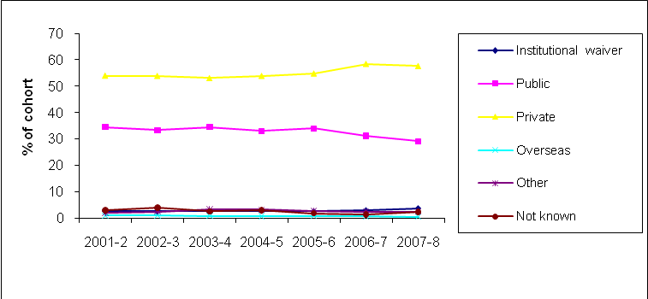
Source: HEFCE

Fee levels
- As taught postgraduate fees are not subject to government caps, they often provide a significant source of income for universities. Institutions are able to set a realistic price for the cost of provision, and in many cases achieve a surplus.
- While masters fees have increased steadily across HEIs in the past eight years, fees for international students have increased at a faster rate than those of UK and EU domiciled students. Although institutions must set fees with an eye to what the market will bear, it is safe to assume that in many cases, fees for international students provide a profit.

Figure 17: Average fee levels for a one year masters course
Source: Mike Reddin’s Public Goods website

Costs of provision to institutions
- There is very little data available on the cost of taught postgraduate degrees to institutions. HEFCE’s published TRAC(T) data does include calculations of the cost of the subject-related part of teaching, but it takes undergraduate and taught postgraduate students together: it is not possible to disaggregate the data to get a figure for the cost of taught postgraduate students alone.
- As described above, it is generally assumed that departments usually recoup the full costs of provision to publicly funded students (UK and EU) through fees, and probably exceed it with fees from international students.

Research degrees
- As with taught postgraduate courses, research degrees are funded by a mixture of private and public funds.

Funding Council subsidy
- In England, public funds for research are provided jointly by HEFCE and the research councils. HEFCE supports the research infrastructure, including academic staff salaries, premises, libraries and central computing costs, while the research councils award funding to specific projects, programmes and individuals.
- The level of HEFCE funding is based on the volume of research taking place (measured by academic staff and researcher numbers) and on the quality of research being carried out, which is assessed every few years through the Research Assessment Exercise (RAE).

Fee income
- Institutions also charge fees for postgraduate research degrees. The UK government, through the research councils, is the most important sponsor of research students’ fees. Research councils and other sponsors also sometimes contribute towards the training costs incurred by institutions through grants designed to enable institutions to provide specific training for the students whose fees and maintenance costs they support.
- Individual students are much more likely to be funded for research degrees than at taught postgraduate level. Over half of all UK and EU students have their fees covered, either through public funding or by an institutional waiver.

Table 40: Source of fees for UK and EU domiciled postgraduate research students (non-dormant students) 2007-8
Funding source | Percentage
Institutional waiver | 18.9%
Public | 34.1%
Private | 38.5%
International | 1.8%
Other | 4.9%
Not known | 1.7%
Source: Data provided by HEFCE to HEPI

- Public funding for research postgraduates has increased in recent years, and after a dip between 2001-2 and 2004-5.

Figure 18: Source of fees for UK and EU domiciled research postgraduate students
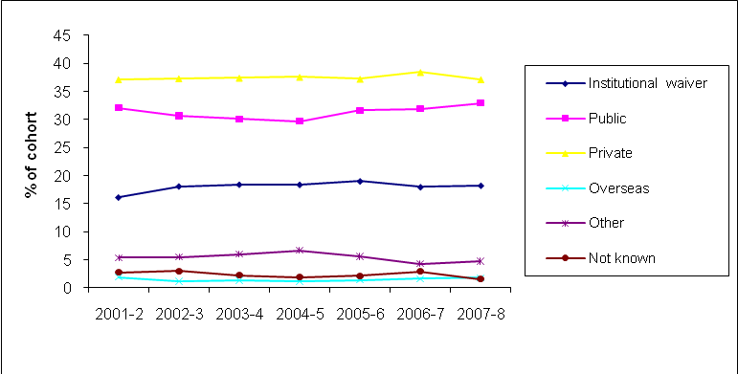
Source: Data provided by HEFCE to HEPI

Costs of provision
- A 2005 study commissioned by HEFCE showed that postgraduate research students cost departments considerably more than they receive in funding. Taking into account the time of academic staff, consumables and estates costs, the entire, systematic cost of a research degree was calculated as £17,461 p.a. for library-based courses, £23,815 for part-laboratory courses and £29,106 for laboratory-intensive and clinical subjects. Current funding for each student varies from institution to institution, but the report found that the actual costs were in the region of 10 per cent higher than the total funding received for each student, and even fee income from international students did not fully cover the real cost of provision.
- However, the report recognised that postgraduate research students confer a range of benefits upon their departments which cannot be measured financially. Such students are seen as an important stimulus and contribution to the research environment: they contribute to academics’ own research and to externally funded projects, they may undertake teaching roles, they increase the numbers of papers given and articles published and help improve departments’ scores in the RAE, potentially attracting higher funding from HEFCE.

Benefits of postgraduate education
Salary
- A postgraduate degree confers a clear economic advantage, with postgraduates attaining significantly higher salaries than those with only first class degrees. The difference is to some extent attributable to the fact that the majority of postgraduate qualifiers are older and likely to have gained greater workplace experience, which would add a premium to their salaries, but even three and a half years after graduation, they still have a clear advantage.
- However, since 2002-3, the postgraduate premium has decreased, the income of the lowest-graded leavers having increased at a faster rate than that of postgraduates. This may indicate that a postgraduate qualification such as a masters no longer carries the weight it used to, as increasing numbers of postgraduate qualifiers compete for jobs in UK workplaces. Such a situation would be of no small concern: if students are increasingly expected to take postgraduate qualifications to differentiate themselves from their peers, whilst the financial returns to this study are decreasing (and fees increasing), it may become increasingly difficult for those from less economically secure backgrounds to consider this course. However, as indicated above, the data on the social backgrounds of postgraduate students are particularly poor, and there is no evidence on the basis to judge whether or not this is occurring.

Table 41: The postgraduate premium: salaries postgraduates and first degree leavers obtaining employment six months after graduation, from those who graduated in 2007-8
 | 2002-3 |  | 2007-8 |  | Percentage  increase  in salary  2002-3 to 2007-8
 | Mean salary of those in full-time employment six months after graduation | Post-graduate premium (%) | Mean salary of those in full-time employment six months after graduation | Post-graduate premium (%) | Percentage  increase  in salary  2002-3 to 2007-8
Postgraduate | £20,951 | 0 | £24,442 | 0 | 17
First class | £17,756 | 18 | £21,286 | 15 | 20
Upper second | £15,981 | 31 | £19,198 | 27 | 20
Lower second | £15,219 | 38 | £18,224 | 34 | 20
Third class | £15,180 | 38 | £18,479 | 32 | 22
Source: Reanalysis of data from DLHE commissioned from HESA by HEPI

- The Destination of Leavers from Higher Education (DLHE) longitudinal study of students who graduated in 2004-5 shows that 3.5 years after graduation, postgraduate salaries are generally higher than those of first degree qualifiers, and significantly more are in the highest salary band of £50,000 plus.

Figure 19: Postgraduate and first degree leaver salaries in 2008, 3.5 years after graduation in 2004-5
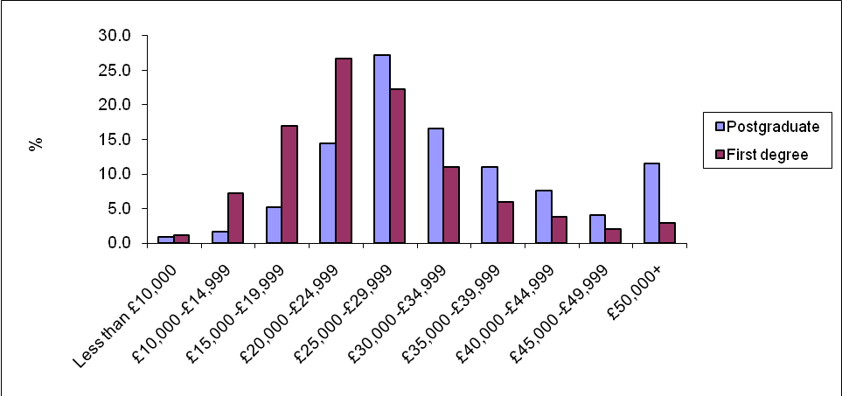
Source: DLHE Longitudinal Study 2004-5 cohort
- Analysis of salary according to mode of study indicates that those studying for both undergraduate and postgraduate qualifications part-time draw higher salaries after graduation. There are several possible reasons for this. Those studying part-time tend to be older, and so are automatically likely to be in a higher salary band. Also, many part-time students will already be working when not studying, picking up vital workplace experience which is often of as much value to employers as a qualification. A number of part-time students, especially those in science, technology or engineering, will already be in employment and undertaking further job-related postgraduate qualifications as part of their career development programme, guaranteeing a fast return on salary increases. Finally, it should be borne in mind that he total for postgraduates includes salaries of MBA students, who doubtless disproportionately influence the figures.

Table 42: Median salary 3.5 years after graduation in 2004-5
 | Salary
Postgraduate F/T | £27,000
Postgraduate P/T | £38,000
First degree F/T | £24,000
First degree P/T | £28,500
Source: HESA DLHE longitudinal 2004-5 cohort

Professional employment opportunities
- The type of work obtained by graduates is another key indicator of the value of qualifications. A higher degree is a huge advantage in entering the professions. A postgraduate degree fast-tracks a large proportion straight into the professions within six months of graduating. Within 3.5 years after graduating in 2004-5 a remarkable 94 per cent of postgraduates had obtained work in the highest three occupational categories, compared to 78 per cent of first degree graduates.

Figure 20: Standard occupational class of postgraduate and first degree qualifiers who entered employment six months after graduation
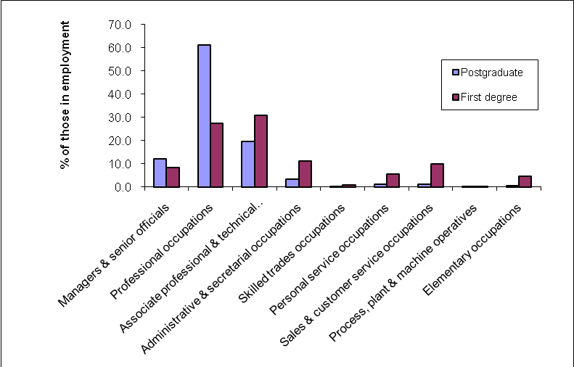
Source: HESA, DLHE 2007-8

Figure 21: Standard occupational class of postgraduate and first degree qualifiers who were in full-time employment 3.5 years after graduation in 2004-5
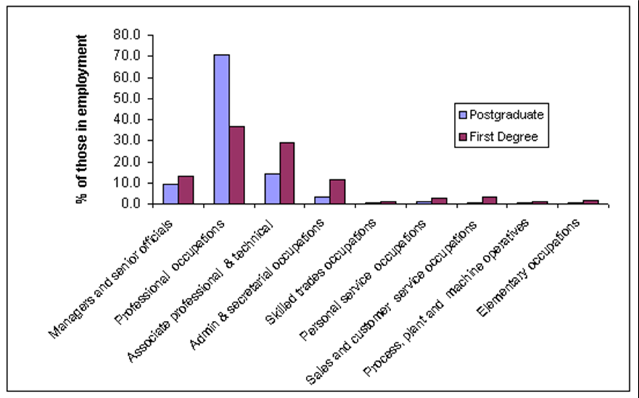
Source: DLHE Longitudinal 2004-5 cohort
Relative benefits of qualifications and work experience
- While the statistics show a clear advantage to postgraduate education in terms of both salary and entry to the professions, there is some indication from employers that a postgraduate qualification, especially in the arts and humanities, is not in itself enough to confer special status on applicants.
- Graduate recruiters place a strong emphasis on workplace skills, such as team work, communication and leadership skills, and a postgraduate qualification, unless directly related to the applicant’s field of work (usually technical) is often considered secondary to work experience.
- A poll by the Association for Graduate Recruiters of its members, including blue chip companies and many of the UK’s top 100 graduate recruiters, indicated that recruiters are more interested in work and skills experience than a higher degree qualification. For example, when asked what advice they would give to first degree graduates who were postponing their job search for a year, pursuing a postgraduate qualification was bottom of the list, whilst activities to gain real work experience were far more heavily encouraged.

Figure 22: Advice regarding the postponement of job search
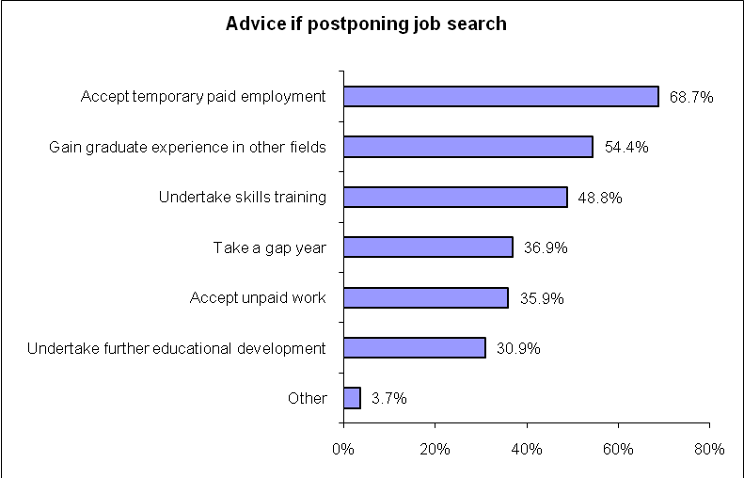
Source: Result of poll conducted by the Association of Graduate Recruiters
- In particular, going straight on from a first degree into a non-job related masters is not always seen as a good move. A qualitative report from HECSU which traced the progression of 24 UK masters students indicated that in non-technical subjects, although a masters degree did confer long-term benefits, it did not provide a direct advantage in gaining graduate-level employment, as the following quote illustrates:
“If I did it again, I think a better thing to do actually would have been to perhaps not do the MA immediately after finishing the undergraduate course… some people would say it actually positively does not help you because you become over-qualified for certain jobs where you haven’t got any sort of specific skills. They just think you’re going to be a bit know it all and you don’t really want that.”
- Experiences of other students in the study also indicated that although a postgraduate qualification was an advantage in getting to the interview stage, work experience and transferable skills were far more important during the interview. On the other hand, most students did feel that their masters qualification was an advantage over a first degree in allowing them to cherry pick the most interesting jobs.

Costs and benefits of international students
- International students from outside the EU form a major part of the UK’s higher education landscape and have been responsible in a large part for the continued expansion of the UK HE sector. Numbers of EU students have also grown, though at a lesser rate.

Table 43: Trends in the number of first-year postgraduates at UK HEIs by domicile
 | 2002-03 | 2003-04 | 2004-05 | 2005-06 | 2006-07 | 2007-08 | % increase 2002-3 to 2007-8
UK | 173,722 | 181,006 | 175,164 | 184,086 | 183,319 | 179,321 | 3
Other EU | 20,758 | 20,193 | 22,838 | 22,936 | 23,533 | 23,018 | 11
Non EU | 54,637 | 61,757 | 63,463 | 63,382 | 72,316 | 75,933 | 39

- There are a number of benefits international students bring to the UK. Some are easy to quantify in terms of economic benefits: fee income, spending on living costs and taxes from those who stay on to work in skilled, graduate-level jobs fall into this category. Others have no readily quantifiable economic value, but are important nonetheless, such as creating a multi-cultural learning environment, increased opportunities for international research collaborations and future goodwill of UK graduates in influential posts abroad.
- In 2007-8 international students brought in around 33 per cent of the total course fee income universities received, and 8 per cent of universities’ total income. These data represent all students in higher education, as HESA cannot provide disaggregated data for undergraduate and postgraduate fee income. EU students pay the same fees as UK students, and are subsidised by the UK government.

Table 44: Income and expenditure of UK HEIs
 | Course Fee Income |  | Total Course Fee Income  (£'000s) | Total Income  (£'000s) | Total Expenditure  (£'000s)
 | UK and EU  (£'000s) | Non-EU  (£'000s) | Total Course Fee Income  (£'000s) | Total Income  (£'000s) | Total Expenditure  (£'000s)
2002-03 | £2,324,815 | £1,085,437 | £3,410,252 | £15,561,971 | £15,351,955
2003-04 | £2,452,202 | £1,275,358 | £3,727,560 | £16,867,041 | £16,625,712
2004-05 | £2,563,641 | £1,395,773 | £3,959,414 | £17,993,162 | £17,779,680
2005-06 | £2,718,486 | £1,499,348 | £4,217,834 | £19,503,112 | £19,312,168
2006-07 | £3,270,707 | £1,712,730 | £4,983,437 | £21,289,853 | £21,047,481
2007-08 | £3,890,171 | £1,880,101 | £5,770,272 | £23,439,626 | £22,884,979
Source: Special request from HESA on behalf of HEPI

- There are also, of course, costs involved in provision for international students. There are certain student support services, such as help settling into the UK and additional tuition for academic English, which institutions must meet, though this is easily done through fees. Whilst a few overseas masters students receive UK subsidies in the forms of grants, scholarships and fee waivers, this is comparatively rare – the vast majority are funded from abroad, either privately or with scholarships from their own countries.
Section 6: International standards and quality assurance
The following section deals with issues that have the potential to affect the UK’s higher education sector’s competitiveness in a global market. It looks at nomenclature of qualifications, alignment with the Bologna Process and its implications, and discusses the need for clear quality assurance processes.
- In order to maintain the excellent performance of the UK higher education sector, particularly with regard to attracting international students, it is essential to ensure that the high quality of UK qualifications is maintained, and that the nature of those qualifications is clear and transparent to students from a broad range of backgrounds and educational needs.
- To this end, it is important to ensure the nomenclature used to describe postgraduate qualifications is consistent and easily translatable into internationally recognised standards. Also, the quality assurance processes used to ensure that these standards are being met at an institutional level must be transparent, reliable and accessible.

Nomenclature of qualifications
- The diversity of the market for postgraduate education is huge, and UK HEIs have shown great success at meeting these varied demands, offering courses that range from pure academic pursuits to professional accreditations. In the face of such diversity, consistent and readily-understandable course definitions are needed if students are to find the best course to meet their needs.
- The qualification levels defined by the Quality Assurance Agency (QAA) (see Table 1) provide a basic guide to the level of intellectual attainment expected of students. However, they use a very broad brush to describe a great deal of diversity – for example, Level 7 (formerly ‘masters’) includes masters mostly examined by teaching (MA, MSc) and masters mostly examined by research (MPhil, MRes); professional masters courses (MPharm, MEng); teaching qualifications (PGCE) and shorter courses such as diplomas and certificates.
- So the QAA definitions cannot be relied upon to explain what a course actually delivers in terms of knowledge, depth, experience or methodology. This, then, falls to individual institutions, where there are a great number of inconsistencies in how courses are described. The term ‘masters’ is particularly confusing, with some Scottish universities using MA to describe an undergraduate qualification and Cambridge issuing a non-academic Masters to first degree graduates for a fee.
- Such institutional quirks aside, there remains huge variety within masters degrees: some are designed to develop professional practice, whilst others aim to train the kind of research skills needed for a PhD. Some aim to deepen students’ knowledge within a subject they have already studied, whilst others are accessible to those with no prior knowledge of the topic. The previous HEPI review of postgraduate education (2004) proposed a nomenclature which reflects the function of study, such as ‘professional masters’, ‘research training masters’ and ‘conversion masters’ – a recommendation which remains pertinent.
- Another issue with the definition of masters qualifications is that masters examined mainly by research are classified by the QAA alongside taught masters, even though classifications such as MPhil are considered the first step on the doctoral process and, indeed, many students aiming for a PhD are registered as MPhils for their first two years. There may be an argument for reclassifying such degrees as shorter qualifications at level 8 (doctoral). This is supported by the fact that the national Higher Education Statistics Agency (HESA) makes just this separation in their disaggregation of postgraduate students, offering statistics for ‘Higher degree (research)’ which includes MPhils and ‘Higher degree (taught)’ which includes MAs, MScs and so on.

International standards: the Bologna Process
- In 1999, ministers from 29 European countries signed the Bologna Agreement to reform higher education over a ten year period, establishing an international set of standards and nomenclature by which to compare qualifications offered by different countries. Compliance with the Bologna Process is important in ensuring ongoing competitiveness with European universities, and for providing globally recognised standards.
- In 2008, the QAA completed the process of aligning the Framework for Higher Education qualifications in England, Wales and Northern Ireland (FHEQ) with the framework for the European Higher Education Area (FQ-EHEA). The Scottish FHEQ completed this process in 2006. The resulting framework provides information to prospective students and future employers about the value of UK qualifications and how they map onto those offered elsewhere.
- The Bologna Process has brought major changes to the higher education landscape in Europe. Countries have an incentive to show they are Bologna-compliant because it is important for their own citizens seeking work abroad to have internationally recognised qualifications, and in order to attract international students, who need reassurance that the courses offered are equivalent to those elsewhere. The UK faces a particular challenge in respect to its relatively shorter courses, such as the one year masters. While shorter courses are attractive in terms of saving international students money, there is a need to provide assurance that the depth and quality of training provided is equivalent. This has, by and large, been successfully achieved at an official level through the Bologna Process, with the status of UK qualifications being formally recognised, although the onus remains on universities to continue to provide this reassurance in the face of increasing competition from institutions abroad.
- As fees for UK qualifications continue to rise, students are increasingly likely to question whether they are receiving ‘value for money’ and current government policy is moving towards providing students with more quantitative data on what their courses deliver, such as lecture and academic contact hours and average salary on graduation. The UK’s pedagogic approach tends to place greater emphasis on developing students’ independent research skills than imparting knowledge from the front of a classroom. In practice, this can translate as less time in lectures and (in theory) more in the library, which can come as a surprise to those (especially international students) accustomed to a more teacher-led approach. The ability to teach students to think for themselves is one of the highlights of UK higher education, and as teaching and academic contact hours seem likely to be increasingly scrutinised by prospective students, it will be important for universities to find ways to emphasise educational nuances which are not easily quantifiable.

Quality assurance
- Higher education institutions are individually responsible for setting the academic standards of their own degrees. The Quality Assurance Agency is an independent agency, funded by subscriptions from HEIs to provide external audits assessing how well institutions fulfil their responsibilities, recommend improvements and publish reports of their findings. The QAA is not a regulatory body and has no statutory powers. It aims to ensure institutions have effective processes in place to secure their self-defined academic standards, but does not directly judge the standards themselves.
- The quality assurance processes currently provided by the QAA are generally considered rigorous and efficient by the universities it serves, and as a body, it is highly regarded internationally. The fact that it has a ‘light touch’ in terms of regulation is in many ways well-suited to a diverse higher education environment, where there is no centralised curriculum. However, at present it is not concerned with the appropriateness of the standards being achieved, and as the recent ‘Students and Universities’ report by the Department of Innovation, Universities, Science and Skills pointed out, there is no body in the UK that can provide assurance about this.
- This is potentially difficult, especially given the generally shorter courses in this country than most others. Not only is it important to reassure international students that all UK qualifications represent appropriate standards of education, but it is important for the career prospects of all graduates seeking employment in the UK. Although many employers declare that workplace skills are as important as academic qualifications, the fact remains that employers tend to look on the CVs of those who graduated from prestigious institutions with greater favour than those with equivalent or better qualifications from others. Without the ability to assess or at least describe standards at a national level, it is hard to see how this situation can change.
- The Innovation, Universities, Science and Skills (IUSS) Select Committee Report recommends that the QAA should be reformed and given the remit to assess standards as well as processes, and that it should be assured greater independence from the institutions it audits. It would be important to avoid the QAA coming to represent an ‘Ofsted for universities’, and to ensure that any new system should not lead to a loss of autonomy for institutions or place a greater burden of bureaucracy upon academics, but such an arrangement would help create confidence in the standards of qualifications.

Section 7: Future demand
- Previous sections have shown that overall, there has been a healthy 12 per cent growth in postgraduate education since 2002-3, with taught masters representing the biggest growth area, especially amongst international students from outside the EU. The number of UK domiciled postgraduate students has grown slightly overall since 2002-3, but has been in decline since 2005-6. This decline has been caused by dwindling numbers taking PGCEs and other certificates, diplomas and professional qualifications, whilst the number of UK domiciled taught masters students has been increasing steadily.
- This section will examine the factors which may affect postgraduate student numbers in the future, and the effect this may have on academic staffing. It also looks at how the global higher education landscape is changing and how UK HEIs are rising to meet this challenge.

UK demand
- The number of postgraduates is affected by two factors: the number of undergraduate qualifiers and the level of inclination amongst those with undergraduate degrees to go on to further postgraduate study.
- HEPI’s latest report on future demand for higher education assessed likely changes to the numbers accessing higher education to 2029, based primarily on population change, but suggesting upper limits if policies on increasing participation and widening access are successful. The government has a long-term aim to increase the number of 18-30 year olds who have participated in some form of higher education to 50 per cent, and has committed to making progress towards that target by 2010. The figure currently stands at 43 per cent (49 per cent for females and 38 per cent for males).
- The projection for 2020 shows that, based on population size alone, numbers would drop off without concerted government action to counteract this. Such action is already taking place, with a focus on improving numbers attaining five or more grade A – C GCSEs, and on encouraging such students to stay on to take A-levels or equivalent qualifications, thus widening the pool of potential higher education participants. The requirement for students to stay in some form of education or training until the age of 18 should have a positive impact on higher education uptake. HEPI’s upper-end predictions also take into account what would happen if participation amongst males reached the same level as that amongst females, and if participation in all regions is brought up to the national average.

Table 45: Indicative projection of student numbers accessing higher education for the first time
 |  | Estimated student FTE in 2007-08 | Total FTE 2020-21 | Total FTE 2028-29 | %  increase  to 2020 | %  increase  to 2028
Base projection | Full-time | 857,448 | 822,453 | 928,411 | -4 | 8
Base projection | Part-time | 171,046 | 180,720 | 184,984 | 6 | 8
Base projection | Total | 1,028,494 | 1,003,173 | 1,113,394 | -2 | 8
High variant | Full-time | 857,448 | 943,286 | 1,119,336 | 10 | 31
High variant | Part-time | 171,046 | 180,720 | 184,984 | 6 | 8
High variant | Total | 1,028,494 | 1,124,007 | 1,304,319 | 9 | 27
Source: HEPI ‘Demand for Higher Education to 2029’

- The government’s targets and HEPI’s predictions deal only with undergraduate level participation, whether for a first degree or other shorter courses such as undergraduate certificates and diplomas. It might be assumed that increasing numbers of undergraduates will lead to a greater proportion going on to postgraduate study. This is known as the ‘differentiation hypothesis’ where as more people have undergraduate degrees, an increasing proportion will proceed to postgraduate study in order to differentiate themselves from the crowd and gain a competitive advantage in the job market.
- It is not entirely clear that this is happening. For example, comparing the numbers graduating from undergraduate courses with the numbers starting postgraduate education, there appears to be no correlation: undergraduate participation has increased markedly since 2002-03 whilst numbers of postgraduate starters stayed relatively static.

Figure 23: UK domiciled undergraduate qualifiers and postgraduate starters
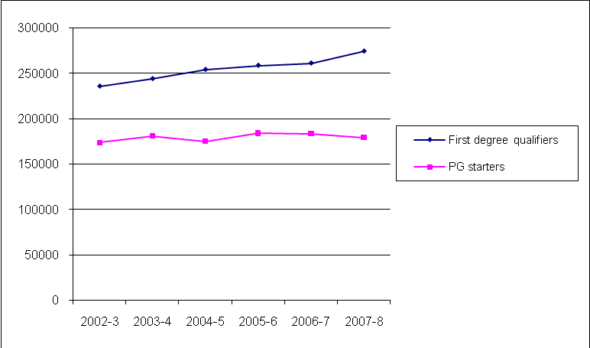
Source: HESA Students in Higher Education
- HESA’s Destination of Leavers from Higher Education (DLHE) provides a useful, but imperfect marker of student activity, as it only measures activity six months after qualifying. Examining these data also shows that the proportion of undergraduate qualifiers going directly on to postgraduate study has increased only very slightly.

Table 46: Percentage of undergraduate qualifiers going on to postgraduate study within six months of graduation
 | 2002-3 | 2003-4 | 2004-5 | 2005-6 | 2006-7 | 2007-8
Undergraduate qualifiers of known destination | 213,330 | 217,970 | 218,733 | 220,993 | 221,835 | 241,093
All PG destinations | 34,280 | 36,140 | 35,665 | 36,148 | 37,268 | 40,170
% undergraduate qualifiers progressing to postgraduate study | 16.1 | 16.6 | 16.3 | 16.4 | 16.8 | 16.7
Source: HESA DLHE 2002-3 to 2007-8
- However, looking at only undergraduate and postgraduate numbers uses too broad a brush to be able to be able to identify trends with any confidence. Postgraduates are mostly drawn from those who have first degrees rather than other undergraduate qualifications. As seen earlier in this report, issues like government funding and recruitment drives can have a big effect on numbers undertaking certain postgraduate qualifications such as PGCEs; such trends do not necessarily correlate to the overall demand for postgraduate education. Meanwhile, the number undertaking research postgraduate degrees has been more or less static, suggesting that increases and decreases at other levels have little effect.
- Therefore, it makes sense when considering change in postgraduate numbers based on past trends to examine the steadiest and most common form of qualification: the taught masters degree, and its relationship to the number of first degree graduates. Table 47 below shows that for the last six years, the proportion of first year taught masters starters to first degree qualifiers has been fairly steady, averaging at 28.2 per cent. Overall, since 2002-3, the numbers of both have increased by around 16 per cent. From these figures, we can see that whilst numbers have increased, there seems to have been no significant change in the proportion of first degree qualifiers going on to postgraduate study.

Table 47: UK domiciled first degree qualifiers and first year taught masters
 | 2002-3 | 2003-4 | 2004-5 | 2005-6 | 2006-7 | 2007-8 | % change
First degree qualifiers | 235,620 | 243,905 | 253,958 | 258,490 | 261,048 | 274,173 | 16.4
Taught masters starters | 67,071 | 70,408 | 68,482 | 72,835 | 73,704 | 77,705 | 15.9
% taught masters students compared to first degree qualifiers | 28.5 | 28.9 | 27.0 | 28.2 | 28.2 | 28.3
Source: HESA Students in Higher Education 2002-3 to 2007-8

- However, looking at the Destination of Leavers data, there has, in the last four years, been an increase in the proportion progressing to postgraduate taught study within six months of graduating from a first degree. This does not in itself indicate that more first degree students are going for postgraduate study generally, only that they are slightly more likely to do so directly after qualifying.

Table 48: Percentage of first degree qualifiers going on to postgraduate study within six months of graduation
 | 2002-3 | 2003-4 | 2004-5 | 2005-6 | 2006-7 | 2007-8
First degree qualifiers of known destination | 186,188 | 191,315 | 192,573 | 192,795 | 193,025 | 202,505
% to higher degree (research) | 2 | 2 | 1.8 | 1.7 | 1.8 | 1.8
% to higher degree (taught) | 6.8 | 6.8 | 6.6 | 6.8 | 7.2 | 7.6
% to postgraduate diploma or certificate | 5.4 | 5.6 | 5.6 | 5.5 | 5.5 | 5.4
% to professional qualification | 3.8 | 4 | 4.1 | 4.3 | 4.4 | 4
% to all PG destinations | 18 | 18.4 | 18.1 | 18.3 | 18.8 | 18.8

- From these data then, it would seem that as the number of undergraduate qualifiers increases, postgraduate numbers will increase, but it is safe to assume that they will do so at the same proportion they have in previous years, unless other factors, such as ‘graduate’ jobs starting to require a postgraduate degree as a basic requirement at entry level, come into play. This report has not looked into whether such a thing is happening yet, but it may be a worthwhile area for future study, as it seems likely that as the number of first degree graduates (not to mention the proportion with upper seconds and firsts) increases, that employers will increasingly require a more exclusive marker of academic attainment.
- Early reports in from universities are showing record levels of recruitment amongst both undergraduate and postgraduate UK domiciled students as a result of a recession-bitten job market: many more school leavers are opting for university and many new graduates staying on to do a masters to avoid unemployment. Future reports should expect to see a spike in student numbers in 2009-10 and possibly beyond, followed by a dip in subsequent years, as those who, under normal circumstance, might have waited a few years before taking a postgraduate degree opt for one during the recession.

Effect of student debt
- It is difficult to say whether there have been any effects of increasing student debt on uptake for postgraduate education. Whilst many students cite concern over costs as a reason for not undertaking postgraduate study, there is no evidence that such attitudes are affecting their behaviour, and indeed there is evidence at undergraduate level of a discrepancy between what students and potential students say and what they do.
- The initial introduction of fees at undergraduate level in 1996 does not, on the surface, seem to have had a deleterious effect on taught postgraduate numbers which have increased steadily according to HESA’s statistics. It may be too early to see if the new fee regime introduced in 2006 has any effect on postgraduate numbers. Although there has been a reduction in the number of UK postgraduates, specifically in certificates, diplomas, PGCEs and professional qualifications (though not masters) this decline began before the new fee arrangements.
- Given that masters fees are not capped, grants at this level are few and far between and low-interest student loans are not readily available, there is a worry that students will be facing increasingly large debt as a result of undertaking postgraduate study. A National Postgraduate Committee report found that that 58.1 per cent of undergraduates who were not intending to undertake postgraduate study had been deterred by the cost. There is a possibility that students from poorer economic backgrounds may be deterred altogether by the prospect of increasing their already considerable debt from undergraduate study, a situation which would effectively undermine much of the good work done in widening participation up to undergraduate level across socio-economic groups. Heeding the Milburn report’s call for targeted financial support packages for postgraduate students from average and less well-off families and support for part-time students would help more such students contemplate postgraduate education.

EU demand
- EU postgraduates represented 13 per cent of all UK first year postgraduates in 2007-8, a figure which has changed little since 2002-3. The UK is the top destination country amongst EU students studying abroad. The main factor which has affected EU student numbers in recent years was the accession of new countries to the EU: Malta, Cyprus, Estonia, Latvia, Lithuania, Poland, Czech Republic, Slovakia, Slovenia and Hungary in 2004, followed by Romania and Bulgaria in 2007. Students from these countries who would previously have paid full-price international student rates became eligible for the same subsidised rates as UK students, and numbers of EU domiciled students increased sharply.

Figure 24: Other EU domiciled first year postgraduate students
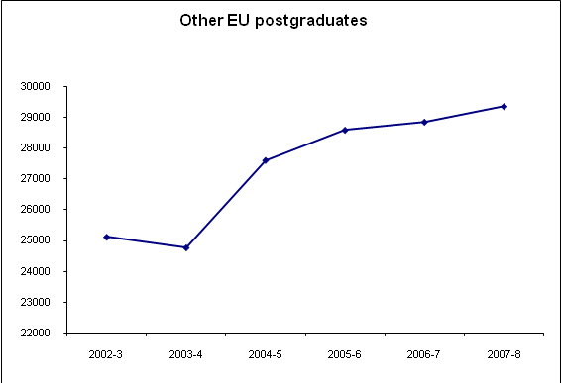
Source: HESA Students in Higher Education
- Further expansions may include Macedonia, Croatia and Turkey (already official candidates), Albania, Montenegro and Iceland, although there is no timetable in place for the next wave of accessions. When it does happen, it is almost certain to further increase EU student numbers. For example, in Turkey 19.9 per cent of all students studying abroad go to the USA, compared to 3.8 per cent coming to the UK. In the 2004 accession countries, a similar pattern was prevalent before they joined: now the UK is their destination of choice. Should Turkey join the EU, it is to be expected that many of the students currently going to the USA will choose the UK or other EU institutions instead.
- Although the UK remains the European destination of choice, competition from other EU countries offering courses taught in English or more favourable fee terms means the UK will face increasing competition for students in the future. For the moment, growth in participation in higher education, particularly amongst accession countries, has ensured the number of postgraduates (and undergraduates) seeking places in the EU is increasing steadily and the growth in numbers choosing the UK shows no sign of diminishing.

International student demand
- The UK is second only to the USA in terms of the number of international students it attracts, with 11.6 per cent of the international student market (the USA has 19.7 per cent). This is widely attributed to courses being in English, the relatively short one year masters (as opposed to two years common elsewhere) and the international reputation of the UK for excellence in higher education and research. The fact that international student fees are very high in the UK does not seem to deter students – they may in fact be perceived to confirm the high quality of education offered (the only country with higher fees is the USA, which attracts even more international students). Lower living costs due to the shorter UK masters do, to some extent, mitigate these premium course rates.
- However, the market is increasingly competitive: more European countries are delivering courses in English and some do not charge fees, while others offer attractive funding packages for international students. Other English speaking countries such as Canada and New Zealand are attracting more students, and emerging economies in Asia are improving the quality of their provision and competing on price. Given the importance of international students to university finances, and the advantages of attracting top level applicants for the continuing strength of the UK research base, the UK HE sector must continue actively to market itself as a world leader. Expansion of overseas provision documented in section 2 of this report will provide a good way to ensure the UK retains a share of the global market.
- The British Council’s report ‘Vision 2020’ attempted to quantify how demand for UK higher education from international students may change. Globally, it predicted compound annual growth in demand for international student places of 6.0 per cent from 2.1 million in 2003 to 5.8 million in 2020.
- The report explored the effect on demand for UK higher education from international students in a number of scenarios. The base scenario, based on expected demographic, economic and participation changes, predicted demand for UK higher education from all non-UK students (EU and beyond) would increase by 4.7 per cent, but that due to increased competition from elsewhere, this would represent a reduction in market share. It indicated there would be greater growth in demand for postgraduate places (5.7 per cent) than undergraduate (3.5 per cent) and that the greatest growth in demand would be for taught postgraduate degrees (6.3 per cent).
- The optimistic scenario assumed the UK would improve performance in areas regarded to be of importance to international students, such as quality of education, employment prospects and affordability, with the potential to increase demand by 8 per cent. The pessimistic scenario assumed the UK would experience a decline in its attractive attributes, especially quality, leading to a sharp decline of over 30 per cent by 2010, followed by a gradual increase to 2020. Five years on, that scenario has clearly not come to pass. It also explored what would happen if fees continued to rise unchecked – as suggested by earlier results, this would not instantly result in a dip in international student numbers, as initially higher price would be seen as a mark of greater quality, but numbers would eventually drop to previous levels.
- If overseas postgraduate numbers do continue to increase, HEIs will be under pressure to improve and expand provision of both academic staffing and non-academic facilities for international students, such as help settling into a new country, writing academic English courses and so on. But given that international students are self-funding and usually represent a profitable source of income to HEIs, finding resources for this should not be a problem.
- The UK Higher Education International Unit’s report looking at postgraduate researchers highlights the dangers of relying on students from only one country. The UK’s market share largely consists of students from China, the USA, Greece, Germany, India, Malaysia and Italy, with students from these countries representing around 40 per cent of all international postgraduate research students in 2006-7, with China alone providing 10 per cent. Whilst the report noted positive growth in recruitment from the USA, Germany, India, Pakistan and the Middle East, there have been declines in students from China, Greece, Mexico, Hong Kong, Japan, South Korea and Singapore. Given the heavy reliance particularly on China and Greece, significant ongoing decline from these countries will have a noticeable effect on international student numbers. The report also noted over-reliance on particular countries in a few subject areas: USA students in humanities and arts, and Chinese students in engineering and technology.

Sastry, T. ‘Postgraduate Education in the United Kingdom’. HEPI, 2004.
Late in the process of writing this report, a small data error was identified in the data commissioned from HESA, involving 123 undergraduate students who had been listed as ‘postgraduate taught’ in 2007-8. However, as they represent only 0.04% of the 278,272 student cohort, this error would have had negligible impact on any of the analysis: the outcomes and conclusions of this report are in no way affected by the error. Nevertheless, in one or two cases, such as the analyses of age, where the impact was greater, the analyses have been recalculated.
http://www.qaa.ac.uk/academicinfrastructure/FHEQ/EWNI08/default.asp
See PGCE qualification title statement www.qaa.ac.uk/academicinfrastructure/FHEQ/ PGCEstatement.asp for the difference between honours and masters level PGCEs.
HESA data on student qualification aim are an imperfect guide to demand for short programmes such as postgraduate certificates because students do not always have the same aims at the point at which these are recorded as they do when they decide to enter the institution.
http://www.qaa.ac.uk/academicinfrastructure/FHEQ/PGCEstatement.asp
HESA Students in Higher Education 2007-8
Special commission from HESA by HEPI. In the recently corrected data, this figure is 278,149.
It is common for postgraduate certificates and diplomas to be offered in the same subjects as taught masters degrees – the difference between the various qualifications being the amount of credit accumulated and often the requirement of a substantial dissertation on masters programmes. This means that some of those registered as masters students may leave with diplomas and certificates whereas some who register for diploma courses may upgrade to masters programmes.
Calculated for this report according to following formula: full-time student = 1, part-time student = 0.5
Milburn, A. (Chair) et al, ‘Unleashing Aspiration: The Final Report of the Panel on Fair Access to the Professions’. The Cabinet Office Strategy Office, 2009.
‘Male and female participation and progression in Higher Education’. HEPI, 2009.
‘Education at a Glance 2009: OECD Indicators’. OECD, 2009.
In Scotland students finish school aged 17, but undergraduate courses in Scottish universities take four years so the earliest common age to enter postgraduate education remains the same.
Statistics for Scotland, Wales and Northern Ireland are available separately but for the purpose of this report are not included.
Stuart, M. et al, ‘Widening participation to postgraduate study – decisions, deterrents and creating success’. Higher Education Academy, 2008.
Allen, J. et al, ‘The market failure of postgraduate education: Financial and funding related issues’. National Postgraduate Committee and Prospects, 2006.
Milburn, A. (Chair) et al, ‘Unleashing Aspiration: the final report of the Panel on Fair Access to the Professions’. The Cabinet Office Strategy Unit, 2009.
2007-8 was the first year for which HESA required all institutions to submit data on overseas provision.
Gill, J., ‘Malaysia: full of Western promise’. The Times Higher Education, 27 August 2009
Baty, P., ‘Global ambitions drive UK institutions.’ The Times Higher Education,,27 October 2009
Due to changes in HESA data definitions, comparisons from Students in Higher Education can only be made up to 2006-7.
‘Education at a Glance 2009: OECD Indicators’. OECD, 2009. These figures refer to all higher education participants, including undergraduate.
Cemmel, J. and Bekhradnia, B. ‘The Bologna process and the UK’s international student market’. HEPI, 2008.
www.hesa.ac.uk, ‘View statistics online’ page.
Excluding those who are writing up but not engaged in active study.
Numbers rounded to nearest 5.
Thrift, N. ‘Research Careers in the UK: A Review’. DIUS, 2008.
JM Consulting, for HEFCE, ‘Costs of training and supervising postgraduate research students’ (2005).
‘Health of Disciplines: Annual report 2008 to the UK Research Base Funder’s Forum’. RCUK, 2008.
Full lists of institutions belonging to each affiliation can be found on that group’s website: www.russellgroup.ac.uk; www.1994group.ac.uk; www.millionplus.ac.uk; www.university-alliance.ac.uk; www.guildhe.ac.uk.
Soon to be replaced by the Research Excellence Framework (REF).
For example, see Frean, A. ‘RAE: Former polytechnics give Oxford a run for its money in rankings’. The Times, 18 December 2008.
This figure is calculated using a value of 1 for a full-time student and 0.5 for a part-time student.
Fees for Oxford and Cambridge include college fees.
Not including students who studied in one English region and found work in another.
See note 36.
See note 36.
See www.sfc.ac.uk for more details on the Scottish Funding Council.
This study was unable to find any more precise data about the source of private funding, i.e. how many students fund themselves, how many access career development loans and how many are sponsored by employers.
http://www.publicgoods.co.uk. Reddin is an independent researcher who contacts institutions requesting information on fees. In the latest survey, 179 institutions provided data. The averages used here are mean figures, but given that some institutions quote a huge range of fees but have very few (if any) students on the highest priced courses (sometimes as high as £18000), these averages should be considered as skewed. They are useful for year-on-year comparisons, or to see trends between home/ EU and overseas rates, but cannot be taken as reliable absolute figures. The fact that the only person compiling useful comparative data on university course fees across institutions is a private individual doing it as a public service is puzzling. Institutions provide information to HESA on their overall fee income, but are not asked about the price of individual courses.
This will change to the Research Excellence Framework (REF) for future assessments.
JM Consulting Ltd, ‘Costs of training and supervising postgraduate research students: A report to HEFCE by JM Consulting Ltd.’ HEFCE, 2005.
It should be noted that for the purposes of the JM Consulting study, the researchers incorporated many factors, such as estates and administration costs, into their estimates which HEFCE do not take into account in their funding allocation formula, hence the much higher calculation of annual cost of provision. It would be interesting to see the results, were the same methodology applied to undergraduate and taught postgraduate students.
Employment classifications are based on the Office of National Statistics’ Standard Occupational Classification 2000 (SOC2000) model.
Bowman, H. et al, ‘Employability and career progression for full-time UK masters students.’ Higher Education Careers Service Unit (HECSU), 2005.
Emery, F. and Metcalfe, J., ‘Promoting the UK doctorate: opportunities and challenges’. UUK/ Vitae, 2009.
‘Higher ambitions: The future of universities in a knowledge economy’. Department for Business, Innovation and Skills. www.bis.gov.uk/policies/higher-ambitions
‘Students and Universities: Eleventh Report of Session 2008-9. House of Commons Innovation, Universities, Science and Skills Committee.
For example, Williams, P. (Chief Executive, QAA), ‘IUSS Reaction: Right questions, wrong answer’.
Bekhradnia, B., Bailey, N., ‘Demand for Higher Education to 2029’. HEPI, 2009.
This figure is known as the Higher Education Initial Participation Rate. More information can be found at http://www.dcsf.gov.uk/rsgateway/DB/SFR/s000839/index.shtml
Lipsett, A., ‘Huge increases in demand for postgraduate degree courses’. The Guardian, 17 February 2009.
Allen, J. et al, ‘The Market Failure of Postgraduate Education: financial and funding related issues’. National Postgraduate Committee, 2009.
See for example “Awareness, take-up and impact of institutional bursaries and scholarships in England” published by OFFA in December 2009, where students from Russell Group universities are quoted as saying that the availability and size of bursaries affected their choice of university, which was taken by the researchers as evidence that bursaries were an effective instrument in achieving fair access. Yet the statistics show that the introduction of bursaries has had no impact on the likelihood of students from poor backgrounds opting for more selective institutions.
Allen, J. 2009.
Milburn, A. et al, ‘Unleashing Aspiration: The Final Report of the Panel on Fair Access to the Professions’ 2009.
Special data request from HESA by HEPI.
‘Education at a Glance 2009: OECD Indicators’. OECD, 2009.
Aston, L., ‘Projecting demand for UK Higher Education from the Accession Countries’. HEPI, 2004.
‘Education at a Glance 2009: OECD Indicators’. OECD, 2009.
Cemmel, J. and Bekhradnia, B., ‘The Bologna process and the UK’s international student market’. HEPI, 2008.
For example, Sillitoe, W., ‘Nordic pair eye a slice of rich markets overseas abroad market’. The Times Higher Education, 2 April 2009.
Böhm, A. et al, ‘Vision 2020: Forecasting international student mobility – a UK perspective’. British Council 2004.
Kemp, N. et al, ‘The UK’s competitive advantage: The market for international research students’. UK Higher Education International Unit, 2008.

